**Title**

Contents

Cards Microservice Implementation 2

Right Sizing Microservices 40

Sizing and Identifying the Service Boundaries 44

Bank Application 44

Migration Use Case 46

Strangler Fig Pattern 49

Deployment, Portability & Scalability 52

Containers and VMs 54

Docker Architecture 59

Docker - Installation and Docker Hub 62

Three Approaches for Docker Image generation 71

## Cards Microservice Implementation

### Project Structure

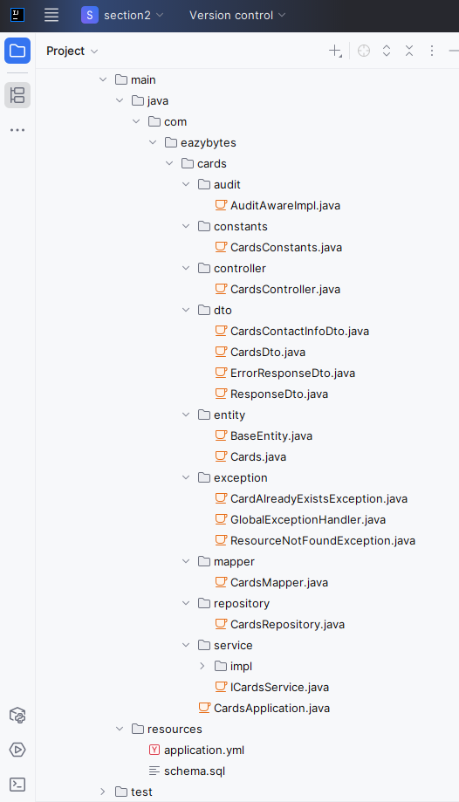

### pom.xml

<?xml version="1.0" encoding="UTF-8"?>

<project xmlns="http://maven.apache.org/POM/4.0.0"

xmlns:xsi="http://www.w3.org/2001/XMLSchema-instance"

xsi:schemaLocation="http://maven.apache.org/POM/4.0.0 https://maven.apache.org/xsd/maven-4.0.0.xsd">

<modelVersion>4.0.0</modelVersion>

<parent>

<groupId>org.springframework.boot</groupId>

<artifactId>spring-boot-starter-parent</artifactId>

<version>3.4.1</version>

<relativePath/> <!-- lookup parent from repository -->

</parent>

<groupId>com.eazybytes</groupId>

<artifactId>cards</artifactId>

<version>0.0.1-SNAPSHOT</version>

<packaging>jar</packaging>

<name>cards</name>

<description>Microservice for Cards</description>

<url/>

<licenses>

<license/>

</licenses>

<developers>

<developer/>

</developers>

<scm>

<connection/>

<developerConnection/>

<tag/>

<url/>

</scm>

<properties>

<java.version>17</java.version>

</properties>

<dependencies>

<dependency>

<groupId>org.springframework.boot</groupId>

<artifactId>spring-boot-starter-actuator</artifactId>

</dependency>

<dependency>

<groupId>org.springframework.boot</groupId>

<artifactId>spring-boot-starter-data-jpa</artifactId>

</dependency>

<dependency>

<groupId>org.springframework.boot</groupId>

<artifactId>spring-boot-starter-web</artifactId>

</dependency>

<dependency>

<groupId>com.h2database</groupId>

<artifactId>h2</artifactId>

<scope>runtime</scope>

</dependency>

<dependency>

<groupId>org.projectlombok</groupId>

<artifactId>lombok</artifactId>

<optional>true</optional>

</dependency>

<dependency>

<groupId>org.springframework.boot</groupId>

<artifactId>spring-boot-starter-validation</artifactId>

</dependency>

<dependency>

<groupId>org.springdoc</groupId>

<artifactId>springdoc-openapi-starter-webmvc-ui</artifactId>

<version>2.8.1</version>

</dependency>

<dependency>

<groupId>org.springframework.boot</groupId>

<artifactId>spring-boot-starter-test</artifactId>

<scope>test</scope>

</dependency>

</dependencies>

<build>

<plugins>

<plugin>

<groupId>org.springframework.boot</groupId>

<artifactId>spring-boot-maven-plugin</artifactId>

</plugin>

<plugin>

<groupId>org.apache.maven.plugins</groupId>

<artifactId>maven-compiler-plugin</artifactId>

<configuration>

<annotationProcessorPaths>

<path>

<groupId>org.projectlombok</groupId>

<artifactId>lombok</artifactId>

<version>${lombok.version}</version>

</path>

</annotationProcessorPaths>

</configuration>

</plugin>

</plugins>

</build>

</project>

### application.yml

server:

port: 9000

spring:

application:

name: "cards"

profiles:

active: "prod"

datasource:

url: jdbc:h2:mem:testdb

driverClassName: org.h2.Driver

username: sa

password: ''

h2:

console:

enabled: true

jpa:

database-platform: org.hibernate.dialect.H2Dialect

hibernate:

ddl-auto: update

show-sql: true

config:

import: "optional:configserver:http://localhost:8071/"

management:

endpoints:

web:

exposure:

include: "*"

health:

readiness-state:

enabled: true

liveness-state:

enabled: true

endpoint:

shutdown:

access: unrestricted

health:

probes:

enabled: true

info:

env:

enabled: true

eureka:

instance:

preferIpAddress: true

client:

fetchRegistry: true

registerWithEureka: true

serviceUrl:

defaultZone: http://localhost:8070/eureka/

info:

app:

name: "cards"

description: "Eazy Bank Cards Application"

version: "1.0.0"

logging:

level:

com:

eazybytes:

cards: DEBUG

### schema.sql

CREATE TABLE IF NOT EXISTS `cards` (

`card_id` int NOT NULL AUTO_INCREMENT,

`mobile_number` varchar(15) NOT NULL,

`card_number` varchar(100) NOT NULL,

`card_type` varchar(100) NOT NULL,

`total_limit` int NOT NULL,

`amount_used` int NOT NULL,

`available_amount` int NOT NULL,

`created_at` date NOT NULL,

`created_by` varchar(20) NOT NULL,

`updated_at` date DEFAULT NULL,

`updated_by` varchar(20) DEFAULT NULL,

PRIMARY KEY (`card_id`)

);

### CardsApplication.java

package com.eazybytes.cards;

import com.eazybytes.cards.dto.CardsContactInfoDto;

import io.swagger.v3.oas.annotations.ExternalDocumentation;

import io.swagger.v3.oas.annotations.OpenAPIDefinition;

import io.swagger.v3.oas.annotations.info.Contact;

import io.swagger.v3.oas.annotations.info.Info;

import io.swagger.v3.oas.annotations.info.License;

import org.springframework.boot.SpringApplication;

import org.springframework.boot.autoconfigure.SpringBootApplication;

import org.springframework.boot.context.properties.EnableConfigurationProperties;

import org.springframework.data.jpa.repository.config.EnableJpaAuditing;

@SpringBootApplication

/*@ComponentScans({ @ComponentScan("com.eazybytes.cards.controller") })

@EnableJpaRepositories("com.eazybytes.cards.repository")

@EntityScan("com.eazybytes.cards.model")*/

@EnableJpaAuditing(auditorAwareRef = "auditAwareImpl")

@EnableConfigurationProperties(value = {CardsContactInfoDto.class})

@OpenAPIDefinition(

info = @Info(

title = "Cards microservice REST API Documentation",

description = "EazyBank Cards microservice REST API Documentation",

version = "v1",

contact = @Contact(

name = "Madan Reddy",

email = "tutor@eazybytes.com",

url = "https://www.eazybytes.com"

),

license = @License(

name = "Apache 2.0",

url = "https://www.eazybytes.com"

)

),

externalDocs = @ExternalDocumentation(

description = "EazyBank Cards microservice REST API Documentation",

url = "https://www.eazybytes.com/swagger-ui.html"

)

)

public class CardsApplication {

public static void main(String[] args) {

SpringApplication.run(CardsApplication.class, args);

}

}

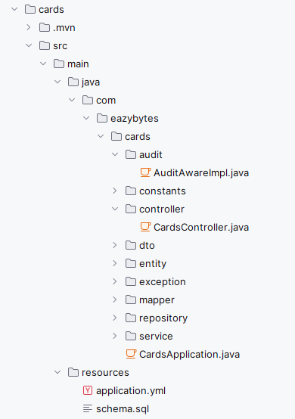

### AuditAwareImpl

package com.eazybytes.cards.audit;

import org.springframework.data.domain.AuditorAware;

import org.springframework.stereotype.Component;

import java.util.Optional;

@Component("auditAwareImpl")

public class AuditAwareImpl implements AuditorAware<String> {

/**

* Returns the current auditor of the application.

*

* @return the current auditor.

*/

@Override

public Optional<String> getCurrentAuditor() {

return Optional.of("CARDS_MS");

}

}

### CardsController.java

package com.eazybytes.cards.controller;

import com.eazybytes.cards.constants.CardsConstants;

import com.eazybytes.cards.dto.CardsContactInfoDto;

import com.eazybytes.cards.dto.CardsDto;

import com.eazybytes.cards.dto.ErrorResponseDto;

import com.eazybytes.cards.dto.ResponseDto;

import com.eazybytes.cards.service.ICardsService;

import io.swagger.v3.oas.annotations.Operation;

import io.swagger.v3.oas.annotations.media.Content;

import io.swagger.v3.oas.annotations.media.Schema;

import io.swagger.v3.oas.annotations.responses.ApiResponse;

import io.swagger.v3.oas.annotations.responses.ApiResponses;

import io.swagger.v3.oas.annotations.tags.Tag;

import jakarta.validation.Valid;

import jakarta.validation.constraints.Pattern;

import lombok.AllArgsConstructor;

import org.slf4j.Logger;

import org.slf4j.LoggerFactory;

import org.springframework.beans.factory.annotation.Autowired;

import org.springframework.beans.factory.annotation.Value;

import org.springframework.core.env.Environment;

import org.springframework.http.HttpStatus;

import org.springframework.http.MediaType;

import org.springframework.http.ResponseEntity;

import org.springframework.validation.annotation.Validated;

import org.springframework.web.bind.annotation.*;

/**

* @author Eazy Bytes

*/

@Tag(

name = "CRUD REST APIs for Cards in EazyBank",

description = "CRUD REST APIs in EazyBank to CREATE, UPDATE, FETCH AND DELETE card details"

)

@RestController

@RequestMapping(path = "/api", produces = {MediaType.APPLICATION_JSON_VALUE})

@Validated

public class CardsController {

private static final Logger logger = LoggerFactory.getLogger(CardsController.class);

private ICardsService iCardsService;

public CardsController(ICardsService iCardsService) {

this.iCardsService = iCardsService;

}

@Value("${build.version}")

private String buildVersion;

@Autowired

private Environment environment;

@Autowired

private CardsContactInfoDto cardsContactInfoDto;

@Operation(

summary = "Create Card REST API",

description = "REST API to create new Card inside EazyBank"

)

@ApiResponses({

@ApiResponse(

responseCode = "201",

description = "HTTP Status CREATED"

),

@ApiResponse(

responseCode = "500",

description = "HTTP Status Internal Server Error",

content = @Content(

schema = @Schema(implementation = ErrorResponseDto.class)

)

)

}

)

@PostMapping("/create")

public ResponseEntity<ResponseDto> createCard(@Valid @RequestParam

@Pattern(regexp="(^$|[0-9]{10})",

message = "Mobile number must be 10 digits")

String mobileNumber) {

iCardsService.createCard(mobileNumber);

return ResponseEntity

.status(HttpStatus.CREATED)

.body(new ResponseDto(CardsConstants.STATUS_201, CardsConstants.MESSAGE_201));

}

@Operation(

summary = "Fetch Card Details REST API",

description = "REST API to fetch card details based on a mobile number"

)

@ApiResponses({

@ApiResponse(

responseCode = "200",

description = "HTTP Status OK"

),

@ApiResponse(

responseCode = "500",

description = "HTTP Status Internal Server Error",

content = @Content(

schema = @Schema(implementation = ErrorResponseDto.class)

)

)

})

@GetMapping("/fetch")

public ResponseEntity<CardsDto> fetchCardDetails(@RequestHeader("eazybank-correlation-id") String correlationId,

@RequestParam @Pattern(regexp="(^$|[0-9]{10})",

message = "Mobile number must be 10 digits")

String mobileNumber) {

logger.debug("eazyBank-correlation-id found: {} ", correlationId);

CardsDto cardsDto = iCardsService.fetchCard(mobileNumber);

return ResponseEntity.status(HttpStatus.OK).body(cardsDto);

}

@Operation(

summary = "Update Card Details REST API",

description = "REST API to update card details based on a card number"

)

@ApiResponses({

@ApiResponse( responseCode = "200", description = "HTTP Status OK"),

@ApiResponse( responseCode = "417", description = "Expectation Failed" ),

@ApiResponse(

responseCode = "500",

description = "HTTP Status Internal Server Error",

content = @Content(

schema = @Schema(implementation = ErrorResponseDto.class)

)

)

})

@PutMapping("/update")

public ResponseEntity<ResponseDto> updateCardDetails(@Valid @RequestBody CardsDto cardsDto) {

boolean isUpdated = iCardsService.updateCard(cardsDto);

if(isUpdated) {

return ResponseEntity

.status(HttpStatus.OK)

.body(new ResponseDto(CardsConstants.STATUS_200, CardsConstants.MESSAGE_200));

}else{

return ResponseEntity

.status(HttpStatus.EXPECTATION_FAILED)

.body(new ResponseDto(CardsConstants.STATUS_417, CardsConstants.MESSAGE_417_UPDATE));

}

}

@Operation(

summary = "Delete Card Details REST API",

description = "REST API to delete Card details based on a mobile number"

)

@ApiResponses({

@ApiResponse(

responseCode = "200",

description = "HTTP Status OK"

),

@ApiResponse(

responseCode = "417",

description = "Expectation Failed"

),

@ApiResponse(

responseCode = "500",

description = "HTTP Status Internal Server Error",

content = @Content(

schema = @Schema(implementation = ErrorResponseDto.class)

)

)

})

@DeleteMapping("/delete")

public ResponseEntity<ResponseDto> deleteCardDetails(@RequestParam

@Pattern(regexp="(^$|[0-9]{10})",

message = "Mobile number must be 10 digits")

String mobileNumber) {

boolean isDeleted = iCardsService.deleteCard(mobileNumber);

if(isDeleted) {

return ResponseEntity

.status(HttpStatus.OK)

.body(new ResponseDto(CardsConstants.STATUS_200, CardsConstants.MESSAGE_200));

}else{

return ResponseEntity

.status(HttpStatus.EXPECTATION_FAILED)

.body(new ResponseDto(CardsConstants.STATUS_417, CardsConstants.MESSAGE_417_DELETE));

}

}

@Operation(

summary = "Get Build information",

description = "Get Build information that is deployed into cards microservice"

)

@ApiResponses({

@ApiResponse(

responseCode = "200",

description = "HTTP Status OK"

),

@ApiResponse(

responseCode = "500",

description = "HTTP Status Internal Server Error",

content = @Content(

schema = @Schema(implementation = ErrorResponseDto.class)

)

)

}

)

@GetMapping("/build-info")

public ResponseEntity<String> getBuildInfo() {

return ResponseEntity

.status(HttpStatus.OK)

.body(buildVersion);

}

@Operation(

summary = "Get Java version",

description = "Get Java versions details that is installed into cards microservice"

)

@ApiResponses({

@ApiResponse(

responseCode = "200",

description = "HTTP Status OK"

),

@ApiResponse(

responseCode = "500",

description = "HTTP Status Internal Server Error",

content = @Content(

schema = @Schema(implementation = ErrorResponseDto.class)

)

)

}

)

@GetMapping("/java-version")

public ResponseEntity<String> getJavaVersion() {

return ResponseEntity

.status(HttpStatus.OK)

.body(environment.getProperty("JAVA_HOME"));

}

@Operation(

summary = "Get Contact Info",

description = "Contact Info details that can be reached out in case of any issues"

)

@ApiResponses({

@ApiResponse(

responseCode = "200",

description = "HTTP Status OK"

),

@ApiResponse(

responseCode = "500",

description = "HTTP Status Internal Server Error",

content = @Content(

schema = @Schema(implementation = ErrorResponseDto.class)

)

)

}

)

@GetMapping("/contact-info")

public ResponseEntity<CardsContactInfoDto> getContactInfo() {

return ResponseEntity

.status(HttpStatus.OK)

.body(cardsContactInfoDto);

}

}

### Entities

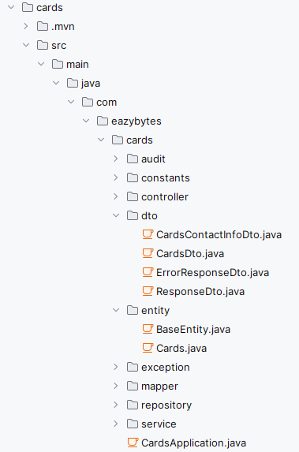

#### BaseEntity

package com.eazybytes.cards.entity;

import jakarta.persistence.Column;

import jakarta.persistence.EntityListeners;

import jakarta.persistence.MappedSuperclass;

import lombok.Getter;

import lombok.Setter;

import lombok.ToString;

import org.springframework.data.annotation.CreatedBy;

import org.springframework.data.annotation.CreatedDate;

import org.springframework.data.annotation.LastModifiedBy;

import org.springframework.data.annotation.LastModifiedDate;

import org.springframework.data.jpa.domain.support.AuditingEntityListener;

import java.time.LocalDateTime;

@MappedSuperclass

@EntityListeners(AuditingEntityListener.class)

@Getter @Setter @ToString

public class BaseEntity {

@CreatedDate

@Column(updatable = false)

private LocalDateTime createdAt;

@CreatedBy

@Column(updatable = false)

private String createdBy;

@LastModifiedDate

@Column(insertable = false)

private LocalDateTime updatedAt;

@LastModifiedBy

@Column(insertable = false)

private String updatedBy;

}

#### Cards

package com.eazybytes.cards.entity;

import jakarta.persistence.Entity;

import jakarta.persistence.GeneratedValue;

import jakarta.persistence.GenerationType;

import jakarta.persistence.Id;

import lombok.*;

@Entity

@Getter

@Setter

@ToString

@AllArgsConstructor

@NoArgsConstructor

public class Cards extends BaseEntity {

@Id

@GeneratedValue(strategy = GenerationType.IDENTITY)

private Long cardId;

private String mobileNumber;

private String cardNumber;

private String cardType;

private int totalLimit;

private int amountUsed;

private int availableAmount;

}

### DTOs

#### CardsDto

package com.eazybytes.cards.dto;

import io.swagger.v3.oas.annotations.media.Schema;

import jakarta.validation.constraints.NotEmpty;

import jakarta.validation.constraints.Pattern;

import jakarta.validation.constraints.Positive;

import jakarta.validation.constraints.PositiveOrZero;

import lombok.*;

@Schema(name = "Cards",

description = "Schema to hold Card information"

)

@Data

public class CardsDto {

@NotEmpty(message = "Mobile Number can not be a null or empty")

@Pattern(regexp="(^$|[0-9]{10})", message = "Mobile Number must be 10 digits")

@Schema(

description = "Mobile Number of Customer", example = "4354437687"

)

private String mobileNumber;

@NotEmpty(message = "Card Number can not be a null or empty")

@Pattern(regexp="(^$|[0-9]{12})", message = "CardNumber must be 12 digits")

@Schema(

description = "Card Number of the customer", example = "100646930341"

)

private String cardNumber;

@NotEmpty(message = "CardType can not be a null or empty")

@Schema(

description = "Type of the card", example = "Credit Card"

)

private String cardType;

@Positive(message = "Total card limit should be greater than zero")

@Schema(

description = "Total amount limit available against a card", example = "100000"

)

private int totalLimit;

@PositiveOrZero(message = "Total amount used should be equal or greater than zero")

@Schema(

description = "Total amount used by a Customer", example = "1000"

)

private int amountUsed;

@PositiveOrZero(message = "Total available amount should be equal or greater than zero")

@Schema(

description = "Total available amount against a card", example = "90000"

)

private int availableAmount;

}

#### CardsContactInfoDto

package com.eazybytes.cards.dto;

import lombok.Getter;

import lombok.Setter;

import org.springframework.boot.context.properties.ConfigurationProperties;

import java.util.List;

import java.util.Map;

@ConfigurationProperties(prefix = "cards")

@Getter

@Setter

public class CardsContactInfoDto {

private String message;

private Map<String, String> contactDetails;

private List<String> onCallSupport;

}

#### ResponseDto

package com.eazybytes.cards.dto;

import io.swagger.v3.oas.annotations.media.Schema;

import lombok.AllArgsConstructor;

import lombok.Data;

@Schema(

name = "Response",

description = "Schema to hold successful response information"

)

@Data @AllArgsConstructor

public class ResponseDto {

@Schema(

description = "Status code in the response"

)

private String statusCode;

@Schema(

description = "Status message in the response"

)

private String statusMsg;

}

#### ErrorResponseDto

package com.eazybytes.cards.dto;

import io.swagger.v3.oas.annotations.media.Schema;

import lombok.AllArgsConstructor;

import lombok.Data;

import org.springframework.http.HttpStatus;

import java.time.LocalDateTime;

@Data @AllArgsConstructor

@Schema(

name = "ErrorResponse",

description = "Schema to hold error response information"

)

public class ErrorResponseDto {

@Schema( description = "API path invoked by client" )

private String apiPath;

@Schema( description = "Error code representing the error happened" )

private HttpStatus errorCode;

@Schema( description = "Error message representing the error happened" )

private String errorMessage;

@Schema( description = "Time representing when the error happened" )

private LocalDateTime errorTime;

}

### Mapper

#### CardsMapper

package com.eazybytes.cards.mapper;

import com.eazybytes.cards.dto.CardsDto;

import com.eazybytes.cards.entity.Cards;

public class CardsMapper {

public static CardsDto mapToCardsDto(Cards cards, CardsDto cardsDto) {

cardsDto.setCardNumber(cards.getCardNumber());

cardsDto.setCardType(cards.getCardType());

cardsDto.setMobileNumber(cards.getMobileNumber());

cardsDto.setTotalLimit(cards.getTotalLimit());

cardsDto.setAvailableAmount(cards.getAvailableAmount());

cardsDto.setAmountUsed(cards.getAmountUsed());

return cardsDto;

}

public static Cards mapToCards(CardsDto cardsDto, Cards cards) {

cards.setCardNumber(cardsDto.getCardNumber());

cards.setCardType(cardsDto.getCardType());

cards.setMobileNumber(cardsDto.getMobileNumber());

cards.setTotalLimit(cardsDto.getTotalLimit());

cards.setAvailableAmount(cardsDto.getAvailableAmount());

cards.setAmountUsed(cardsDto.getAmountUsed());

return cards;

}

}

### Service and ServiceImpl

#### ICardsService

package com.eazybytes.cards.service;

import com.eazybytes.cards.dto.CardsDto;

public interface ICardsService {

/**

*

* @param mobileNumber - Mobile Number of the Customer

*/

void createCard(String mobileNumber);

/**

*

* @param mobileNumber - Input mobile Number

* @return Card Details based on a given mobileNumber

*/

CardsDto fetchCard(String mobileNumber);

/**

*

* @param cardsDto - CardsDto Object

* @return boolean indicating if the update of card details is successful or not

*/

boolean updateCard(CardsDto cardsDto);

/**

*

* @param mobileNumber - Input Mobile Number

* @return boolean indicating if the delete of card details is successful or not

*/

boolean deleteCard(String mobileNumber);

}

#### CardsServiceImpl

package com.eazybytes.cards.service.impl;

import com.eazybytes.cards.constants.CardsConstants;

import com.eazybytes.cards.dto.CardsDto;

import com.eazybytes.cards.entity.Cards;

import com.eazybytes.cards.exception.CardAlreadyExistsException;

import com.eazybytes.cards.exception.ResourceNotFoundException;

import com.eazybytes.cards.mapper.CardsMapper;

import com.eazybytes.cards.repository.CardsRepository;

import com.eazybytes.cards.service.ICardsService;

import lombok.AllArgsConstructor;

import org.springframework.stereotype.Service;

import java.util.Optional;

import java.util.Random;

@Service

@AllArgsConstructor

public class CardsServiceImpl implements ICardsService {

private CardsRepository cardsRepository;

/**

* @param mobileNumber - Mobile Number of the Customer

*/

@Override

public void createCard(String mobileNumber) {

Optional<Cards> optionalCards= cardsRepository.findByMobileNumber(mobileNumber);

if(optionalCards.isPresent()){

throw new CardAlreadyExistsException("Card already registered with given mobileNumber "+mobileNumber);

}

cardsRepository.save(createNewCard(mobileNumber));

}

/**

* @param mobileNumber - Mobile Number of the Customer

* @return the new card details

*/

private Cards createNewCard(String mobileNumber) {

Cards newCard = new Cards();

long randomCardNumber = 100000000000L + new Random().nextInt(900000000);

newCard.setCardNumber(Long.toString(randomCardNumber));

newCard.setMobileNumber(mobileNumber);

newCard.setCardType(CardsConstants.CREDIT_CARD);

newCard.setTotalLimit(CardsConstants.NEW_CARD_LIMIT);

newCard.setAmountUsed(0);

newCard.setAvailableAmount(CardsConstants.NEW_CARD_LIMIT);

return newCard;

}

/**

*

* @param mobileNumber - Input mobile Number

* @return Card Details based on a given mobileNumber

*/

@Override

public CardsDto fetchCard(String mobileNumber) {

Cards cards = cardsRepository.findByMobileNumber(mobileNumber).orElseThrow(

() -> new ResourceNotFoundException("Card", "mobileNumber", mobileNumber)

);

return CardsMapper.mapToCardsDto(cards, new CardsDto());

}

/**

*

* @param cardsDto - CardsDto Object

* @return boolean indicating if the update of card details is successful or not

*/

@Override

public boolean updateCard(CardsDto cardsDto) {

Cards cards = cardsRepository.findByCardNumber(cardsDto.getCardNumber()).orElseThrow(

() -> new ResourceNotFoundException("Card", "CardNumber", cardsDto.getCardNumber()));

CardsMapper.mapToCards(cardsDto, cards);

cardsRepository.save(cards);

return true;

}

/**

* @param mobileNumber - Input MobileNumber

* @return boolean indicating if the delete of card details is successful or not

*/

@Override

public boolean deleteCard(String mobileNumber) {

Cards cards = cardsRepository.findByMobileNumber(mobileNumber).orElseThrow(

() -> new ResourceNotFoundException("Card", "mobileNumber", mobileNumber)

);

cardsRepository.deleteById(cards.getCardId());

return true;

}

}

### Exception

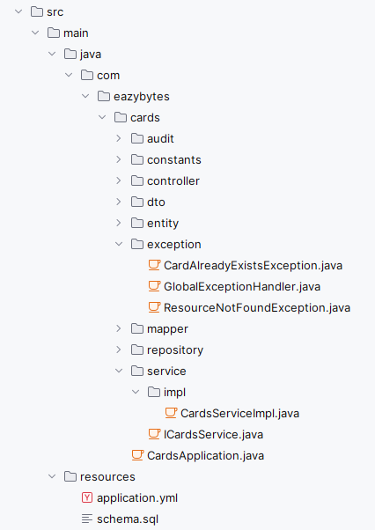

#### CardAlreadyExistsException

package com.eazybytes.cards.exception;

import org.springframework.http.HttpStatus;

import org.springframework.web.bind.annotation.ResponseStatus;

@ResponseStatus(value = HttpStatus.BAD_REQUEST)

public class CardAlreadyExistsException extends RuntimeException {

public CardAlreadyExistsException(String message){

super(message);

}

}

#### GlobalExceptionHandler

package com.eazybytes.cards.exception;

import com.eazybytes.cards.dto.ErrorResponseDto;

import org.springframework.http.HttpHeaders;

import org.springframework.http.HttpStatus;

import org.springframework.http.HttpStatusCode;

import org.springframework.http.ResponseEntity;

import org.springframework.validation.FieldError;

import org.springframework.validation.ObjectError;

import org.springframework.web.bind.MethodArgumentNotValidException;

import org.springframework.web.bind.annotation.ControllerAdvice;

import org.springframework.web.bind.annotation.ExceptionHandler;

import org.springframework.web.context.request.WebRequest;

import org.springframework.web.servlet.mvc.method.annotation.ResponseEntityExceptionHandler;

import java.time.LocalDateTime;

import java.util.HashMap;

import java.util.List;

import java.util.Map;

@ControllerAdvice

public class GlobalExceptionHandler extends ResponseEntityExceptionHandler {

@Override

protected ResponseEntity<Object> handleMethodArgumentNotValid(

MethodArgumentNotValidException ex, HttpHeaders headers, HttpStatusCode status, WebRequest request) {

Map<String, String> validationErrors = new HashMap<>();

List<ObjectError> validationErrorList = ex.getBindingResult().getAllErrors();

validationErrorList.forEach((error) -> {

String fieldName = ((FieldError) error).getField();

String validationMsg = error.getDefaultMessage();

validationErrors.put(fieldName, validationMsg);

});

return new ResponseEntity<>(validationErrors, HttpStatus.BAD_REQUEST);

}

@ExceptionHandler(Exception.class)

public ResponseEntity<ErrorResponseDto> handleGlobalException(Exception exception, WebRequest webRequest) {

ErrorResponseDto errorResponseDTO = new ErrorResponseDto(

webRequest.getDescription(false),

HttpStatus.INTERNAL_SERVER_ERROR,

exception.getMessage(),

LocalDateTime.now()

);

return ResponseEntity.status(HttpStatus.INTERNAL_SERVER_ERROR)

.body(errorResponseDTO);

}

@ExceptionHandler(ResourceNotFoundException.class)

public ResponseEntity<ErrorResponseDto> handleResourceNotFoundException(ResourceNotFoundException exception,

WebRequest webRequest) {

ErrorResponseDto errorResponseDTO = new ErrorResponseDto(

webRequest.getDescription(false),

HttpStatus.NOT_FOUND,

exception.getMessage(),

LocalDateTime.now()

);

return new ResponseEntity<>(errorResponseDTO, HttpStatus.NOT_FOUND);

}

@ExceptionHandler(CardAlreadyExistsException.class)

public ResponseEntity<ErrorResponseDto> handleCardAlreadyExistsException(CardAlreadyExistsException exception,

WebRequest webRequest){

ErrorResponseDto errorResponseDTO = new ErrorResponseDto(

webRequest.getDescription(false),

HttpStatus.BAD_REQUEST,

exception.getMessage(),

LocalDateTime.now()

);

return new ResponseEntity<>(errorResponseDTO, HttpStatus.BAD_REQUEST);

}

}

#### ResourceNotFoundException

package com.eazybytes.cards.exception;

import org.springframework.http.HttpStatus;

import org.springframework.web.bind.annotation.ResponseStatus;

@ResponseStatus(value = HttpStatus.NOT_FOUND)

public class ResourceNotFoundException extends RuntimeException {

public ResourceNotFoundException(String resourceName, String fieldName, String fieldValue){

super(String.format("%s not found with the given input data %s : '%s'", resourceName, fieldName, fieldValue));

}

}

### Constants

#### CardConstants.java

package com.eazybytes.cards.constants;

public final class CardsConstants {

private CardsConstants() {

// restrict instantiation

}

public static final String CREDIT_CARD = "Credit Card";

public static final int NEW_CARD_LIMIT = 1_00_000;

public static final String STATUS_201 = "201";

public static final String MESSAGE_201 = "Card created successfully";

public static final String STATUS_200 = "200";

public static final String MESSAGE_200 = "Request processed successfully";

public static final String STATUS_417 = "417";

public static final String MESSAGE_417_UPDATE= "Update operation failed. Please try again or contact Dev team";

public static final String MESSAGE_417_DELETE= "Delete operation failed. Please try again or contact Dev team";

// public static final String STATUS_500 = "500";

// public static final String MESSAGE_500 = "An error occurred. Please try again or contact Dev team";

}

### Repository

#### CardsRepository

package com.eazybytes.cards.repository;

import com.eazybytes.cards.entity.Cards;

import org.springframework.data.jpa.repository.JpaRepository;

import org.springframework.stereotype.Repository;

import java.util.Optional;

@Repository

public interface CardsRepository extends JpaRepository<Cards, Long> {

Optional<Cards> findByMobileNumber(String mobileNumber);

Optional<Cards> findByCardNumber(String cardNumber);

}

### Tests

#### CardsApplicationTests

package com.eazybytes.cards;

import org.junit.jupiter.api.Test;

import org.springframework.boot.test.context.SpringBootTest;

@SpringBootTest

class CardsApplicationTests {

@Test

void contextLoads() {

}

}

### Postman

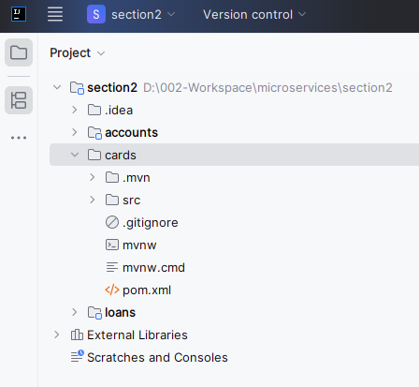 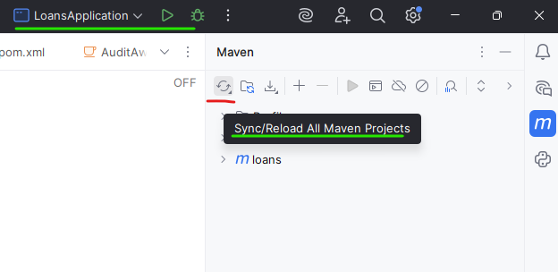

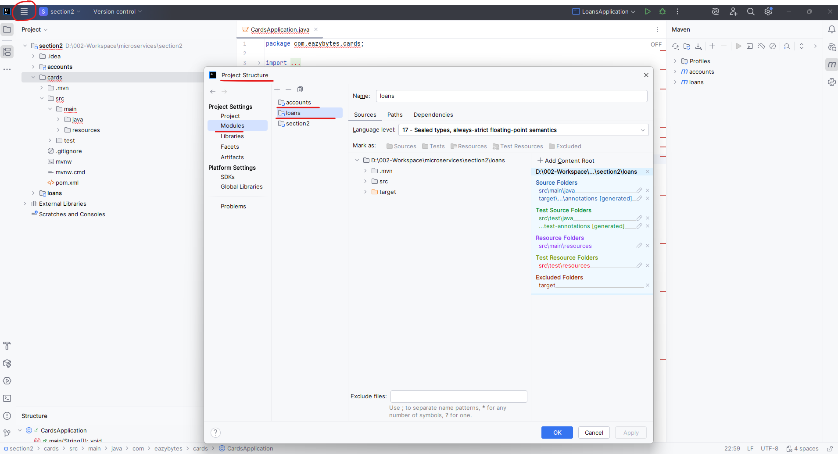

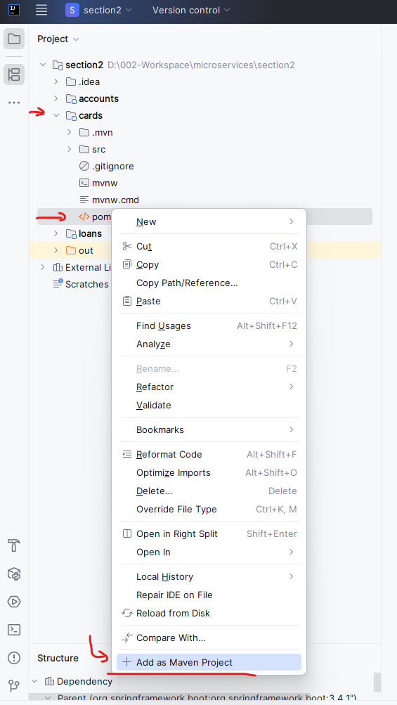

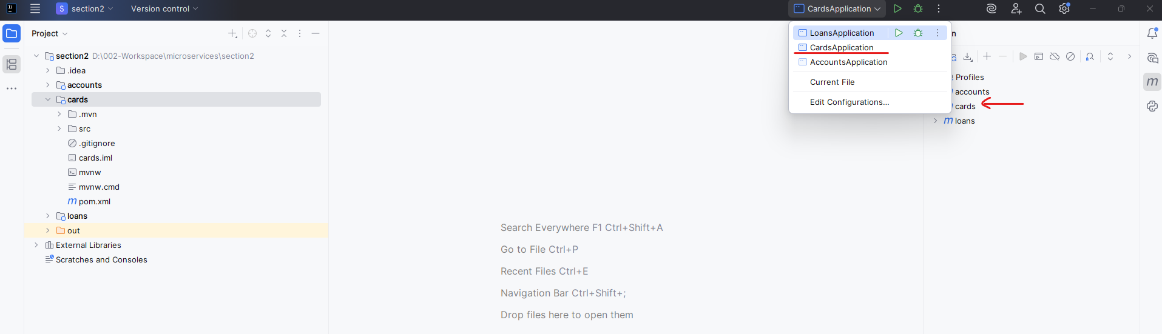

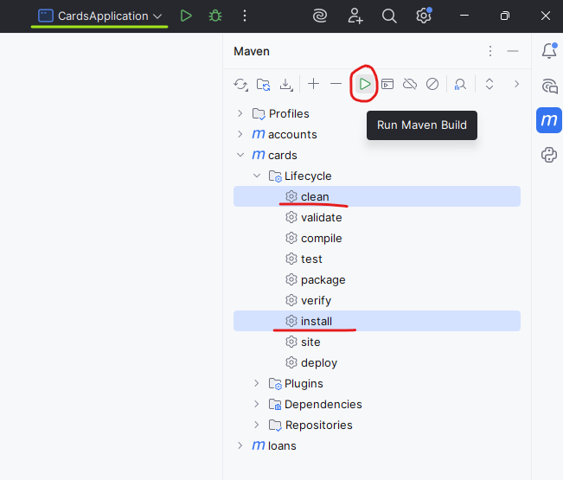

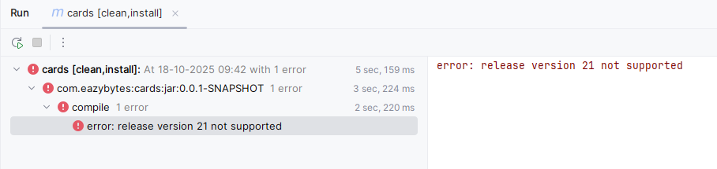

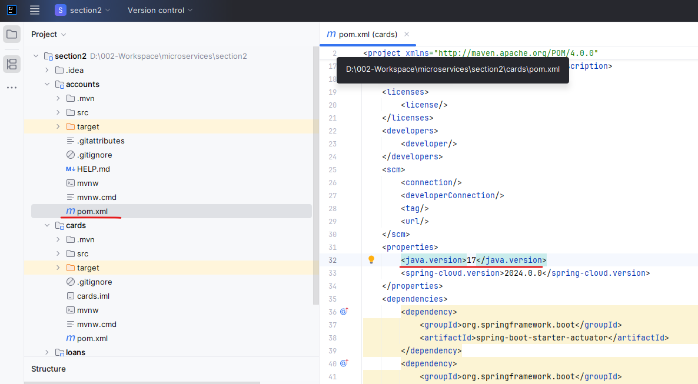

Create – Http POST

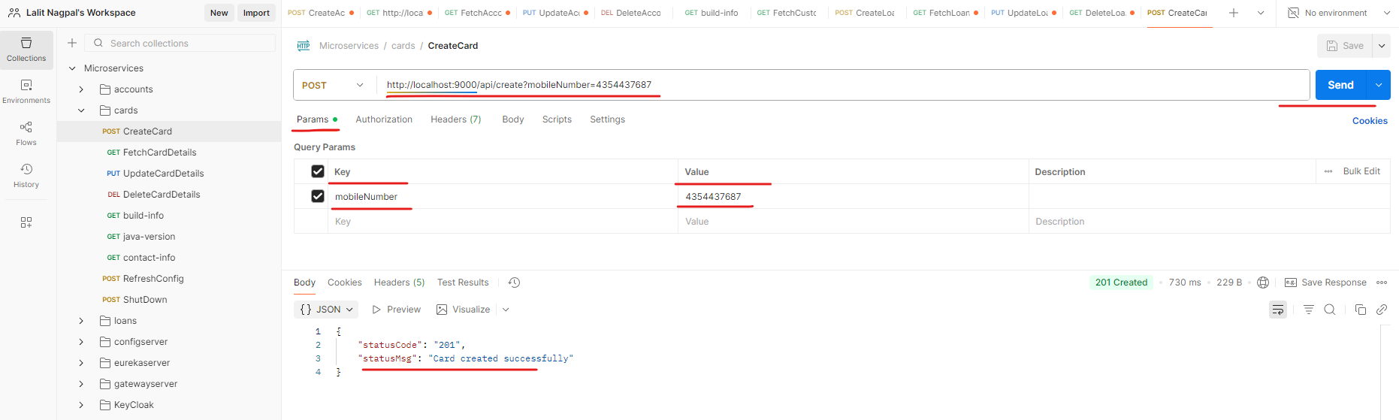

Fetch – Http Get

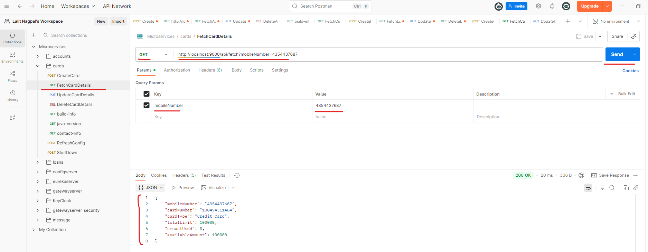

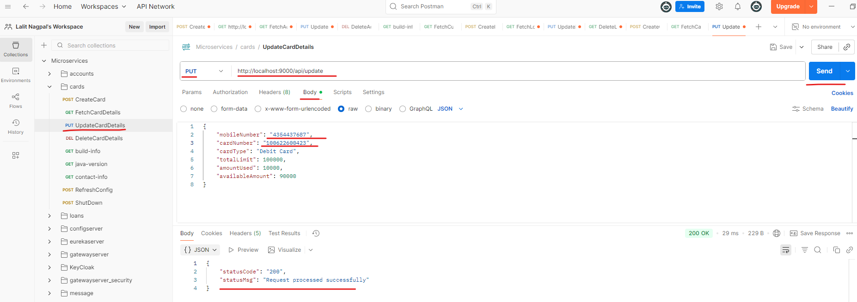

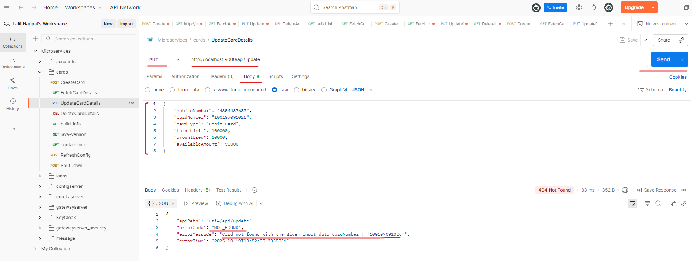

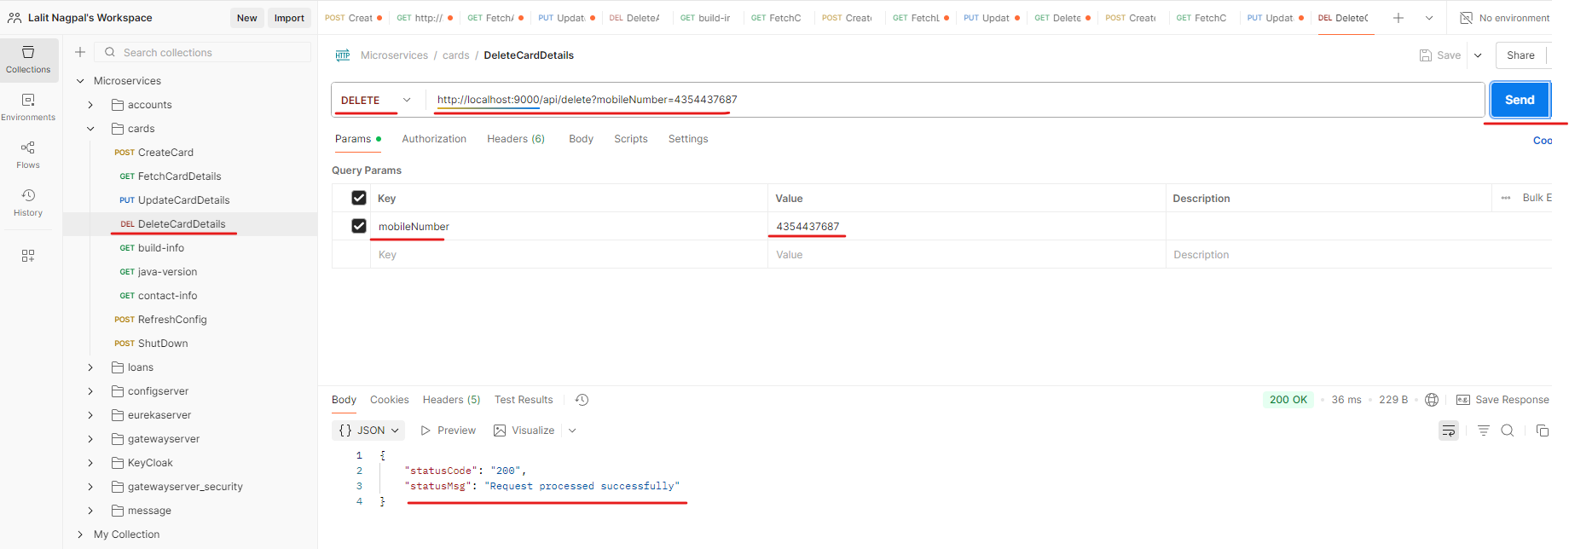

# Right Sizing Microservices

Inside the previous section we built three different type of microservices with the name accounts, loans and cards. With that, we should not be super happy because there are many other challenges that we need to overcome in order to build microservice. And now is the time to understand the next challenge that we may face inside microservices architecture.



If you have experience working in Agile and Scrum teams, we will size our user stories based upon t shirt sizing, based upon how complex the user story is, we are going to assign one of the t shirt size for the user story. The same applies for the microservices as well. This challenge 2 is about how to right size and identify service boundaries of microservices. So this is the most challenging aspect of building a successful microservice system inside any organization. Because without proper sizing and identifying the boundaries of microservices, we can't build a good microservice network inside any organization, for example any organization or any project who want to migrate to microservice from monolithic or who want to develop microservices from scratch. Frist they need to identify what is the right sizing or what are the service boundaries for their microservices. When I say right sizing, I mean your microservices should not be so big where you are not able to grab all the advantages that we have with the microservice and at the same time they should not be so small and they should not have very less business logic due to which we will end up having more number of microservices inside the organization.

If you onboard more number of microservices which are very small in nature, then definitely there will be some operational overhead to make sure all these microservices are interconnected. They are able to communicate with each other. There's going to be lot of operational overhead. That's why as an architect, as a developer or as a technical lead or as a manager, it's our responsibility to make sure our microservices are following the right sizing based upon the business needs. The very next question that you may have here is I understand what is right sizing, how to derive the sizing for my own microservices inside my own project.

For the same, there are two most commonly followed approaches or standards in the industry. The very first approach is Domain-Driven-Sizing. Since most of our business logic are enhancements driven by the business needs, we can size our define the boundaries for our microservice that are closely aligned with the domain driven and business capabilities. When I say domain driven, for example, inside the EasyBankApplication, we have various domains like Accounts, Cards, Loans, and very similarly, there can be other domains inside the easy bank. In other words, we can call these domains as departments or different verticals inside an organization. We can build microservices based upon these domains. For example, we have built three different microservices by taking these domains as an input like accounts, cards and loans. But there might be scenarios where an organization can have a big domain and a single domain, there might be a lot of products being handled or a lot of business being handled. And under that domain there will be hundreds of developers. In such scenarios, it may not be a good idea to go strictly with Domain-Driven-Sizing. That's why in such scenarios we should not blindly go based upon the domains or business capability departments or verticals inside an organization. We should discuss with all the business people, technical people, architects inside the organization who has the domain knowledge. There might be some people who might be working in the organization from many decades. We should take inputs from all those leaders and experienced people to understand what a domain is doing on day to day operations, because no single person will never know all the business happening inside the organization. That's why we need to talk with the domain experts and talking with these domain experts, business leaders, along with the technical people, clients, business analysts, product owners.

So this is going to be a super time consuming process. Definitely, It is not going to happen in a 1 or 2 days. At least, It will need 3 to 6 months of time where you will gather all the domain related information. What are the operations that are being handled by each domain? What is the team size? What are the existing applications? Once we have all this information, there will be a good brainstorming happen and inside these brainstorming sessions you will involve all the business people, technical people, business people, client people, and accordingly, a right sizing will be identified for the microservice. When you start with a size for microservice, it is obviously not going to be a right size for many organizations. Initially, they will start with some assumptions and with some sizing of the microservice. Once they get started with the microservice development and deployments, if they see a lot of operational overhead is required, that means they might have identified a lot, many microservices, which is a operational overhead in such scenarios, then definitely they will revisit their sizing and they will try to club some microservices to a larger microservice. This way this is going to be a continuous process where business will try to see if the current sizing of the microservices is fine. If not, they will try to fine tune it either by splitting the existing microservice or by clubbing the microservices.



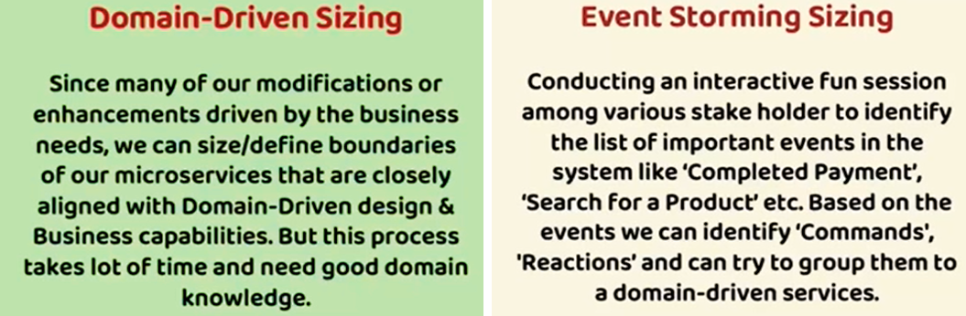

So this is one of the most common approach and this has its own advantages and disadvantages. One of the primary disadvantage is it is time consuming and it also need a lot of people who has good understanding on the business and domain to overcome these challenges, we also have other approach, which is Event-Storming Sizing. In this scenario, a facilitator is going to conduct an interactive session among various stakeholders like product owners, developers, testers, clients, business owners, business leaders. Inside these fun sessions, everyone will be provided with some sticky notes. On top of those sticky notes, they will be asked to think about an event that is possible inside a business. If you take a bank application as an example, a customer can complete the payment or he can search for a product. So these are the sample events.

Once all the possible events are identified by the stakeholders as a next step, they are going to identify what are the commands and reactions. Command is a process which will initiate the event. For example, for the completed payment event, the customer has to click on a button to initiate the payment. So that is going to be a command and the reaction can be the amount will be deducted from his account post the completion of the payment. So this way, once all the events commands reactions are identified, they will be separated and segregated based upon the domain. For example, all cards related events, commands and reactions. I can move to the cards domain. Similarly for Loans and Accounts. The advantage with this approach is you don't need experts who knows the business from many days. Anyone who is using your product on day to day basis, who is testing your product on day to day basis, they can provide their inputs. Like this is the event that I can perform inside the application. And since this is going to be a super interactive and fun sessions with lot many stakeholders, you can gather a lot of information with a very few meetings. Maybe you can conduct 5 to 6 meetings in a month and within a month you will have all the events information along with that domain mapping. Once you have all these information, it is going to be super, super easy to rightsize your microservice. You can see there is a blog from lucidchart how to perform these event storming sessions inside an any organization. We can try to refer the same for more details. This is the blog.

<https://www.lucidchart.com/blog/ddd-event-storming>

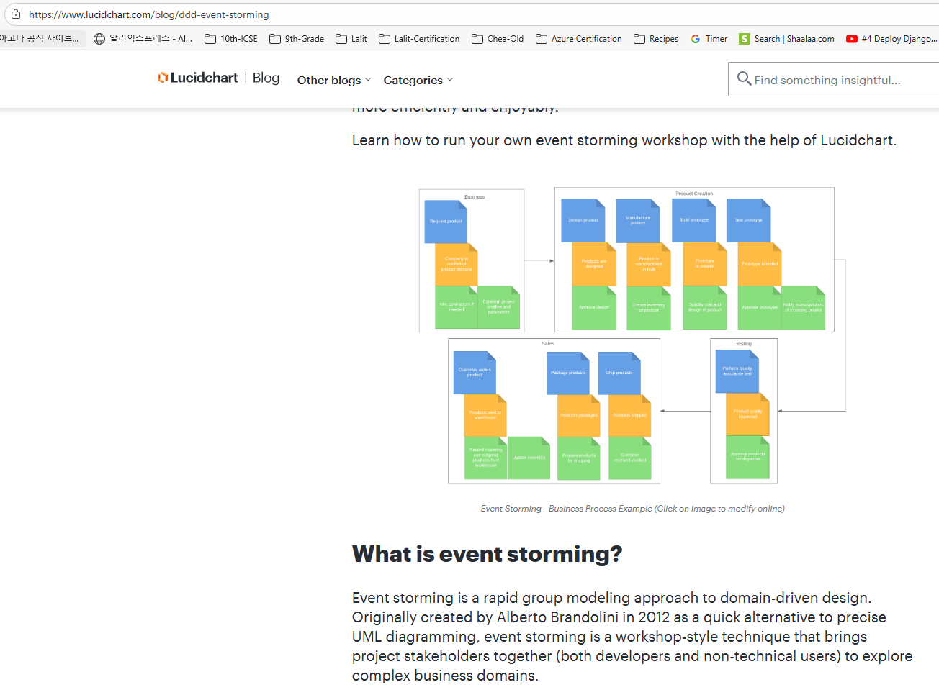

It has all the details on how someone can facilitate these events. You as a developer, you don't have to facilitate, but this is going to be a good information for you because at some day you may end up attending these kind of events or in some interview people can ask you how you have rightsized your microservice in such scenarios. All this information is going to be super helpful if you can scroll down first, we need to provide the sticky notes to the stakeholders or with the help of Lucidchart, you can make all this process digital with their website. Once the sticky notes is provided, all the stakeholders, they will provide their inputs like what are the possible events that can happen inside an application? The advantage of this process is it is going to be super fast and it is going to be straightforward and it is going to be engaging with all the stakeholders and it is going to be more effective compared to the Domain-Driven Sizing. If you can further scroll down on this page, you'll be seeing all the steps that a facilitator will follow to perform this event. Storming. First, the facilitator will try to invite all the right people, including the clients, developers, testers, managers, architects, business leaders post that they are going to provide unlimited modeling space, which means using sticky notes or any other approach.

You need to give a freedom to the stakeholders that they can mention any number of events. There can be duplicates like two different people they can propose duplicate events. That's fine because as a facilitator you should be removing all those duplicate events. With this freedom, stakeholders will try to provide all the events that they are aware inside the application. As a next step, we need to identify commands for each domain events. Once the commands are identified, We should also identify the reactions that may happen because sometimes a reaction can be act as a command for the next event. That's why identifying the events commands reactions is very important. Once all these events commands reactions are identified, you can try to segregate them based upon that domains or based upon the business or based upon the departments. So here you can see they have separated based upon business product creation, sales testing.

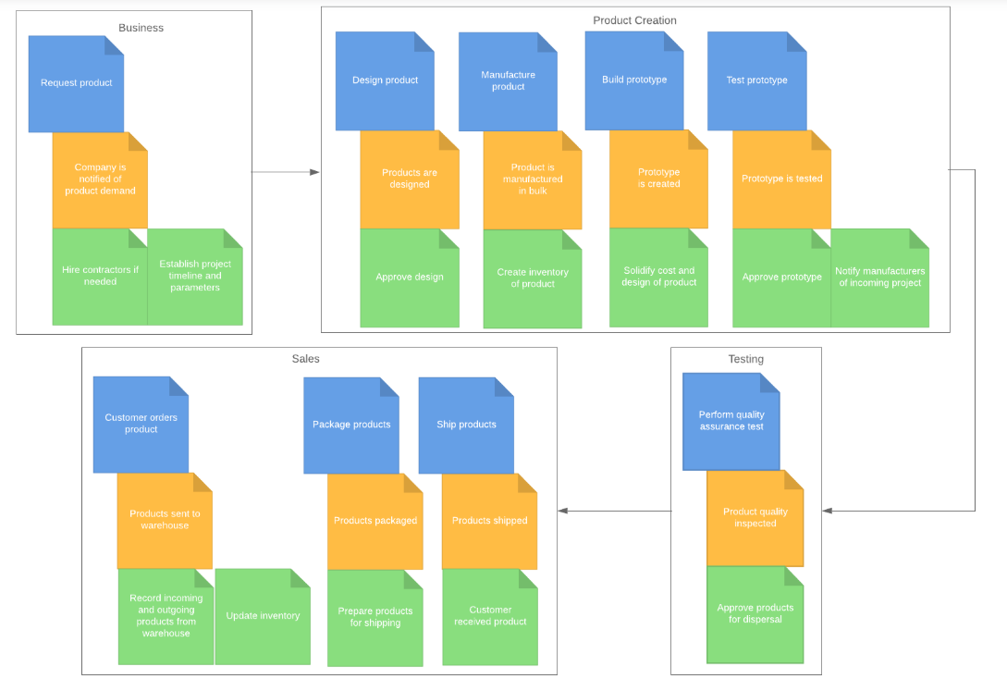

So very similarly, you can separate based upon the domains. Once you have these domain specific events, this is going to be input for your right sizing of the microservice. If you are interested, please read all the details present inside this blog. It is going to take ten minutes only. I'm going to mention this link inside the GitHub Readme document. With this I'm assuming your super super clear with the common approaches that we have to rightsize our microservices. In the next lecture, let's try to take an example of easy bank and try to rightsize our microservices.

## Sizing and Identifying the Service Boundaries

## Bank Application



Now, inside this lecture, let's try to take an example of a BankApplication that needs to migrate or built based upon a microservices architecture. So whenever someone is trying to migrate or built based upon a microservices architecture, definitely first, they need to identify the appropriate sizing for the microservices. So the CEO or the chief technology officer of the bank, he or she formed three different teams for these analysis and he or she asked them to come up with their own sizing for the microservices. Let's try to see what these three different teams, they try to come up based upon their understanding on the BankApplication. They might have used the Domain-Driven Sizing or Event-Driven Sizing. It's up to them, but let's try to see what they come up and towards the end of this lecture we will act as a CEO or the CTO of the bank and will try to select one of the sizing for our microservices.

The very first team, they came up with a sizing saying that saving account and trading account related business logic can be separated as a single microservice. So this bank application, they support both saving account and trading account. Using saving account you can save or you can store your money digitally. And similarly, with the help of trading account, you can buy and sell the stocks mutual funds. So they're trying to club both of the saving account and trading account into a single microservice. And similarly, the bank also provides cards and loans related products to the end customers. They're trying to club both these cards and loans as a single microservice. So this is what team1 came up.

Now let's see what is Team2 came up. Now Team2 recommended to have a separate microservice for the saving account and trading account. And very similarly, they also recommended separate microservice for cards and loans. So Team2 came up with four different microservices, whereas Team1 came up with two different microservices.

Now let's go and see what is Team3 came up, Team3 came up with so many microservices like one for saving account, the second one for trading account, which is very similar to team2. Now coming to the cards, since the bank application supports both debit card and credit card, they are recommending a separate microservice for debit and credit card. And inside loans also, the bank is going to offer many types of loans like home loan, vehicle loan, personal loan for all these type of loans. Team 3 recommended separate microservices.

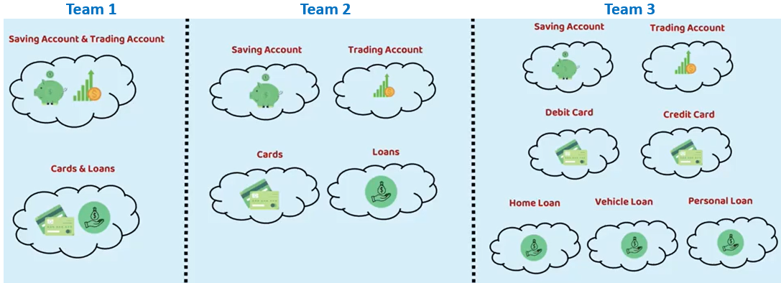

So these are the three options that three different teams presented in front of us.

So now let's try to act as a CTO or CEO. I hope you are fine to act as a CEO or CTO. Off course, every one of us aspired to become CEO and CTO someday, but for today, let's try to act in those roles.

1st Option – Team 1



So with the very first option we have drawback because they are not rightly sized. As you can see, cards and loans, they are clubbed and similarly saving account and trading account, they are clubbed. With these, there is a tight coupling between cards and loans and saving accounts and trading account. And in future when a cards team they want to enhance the microservice for their own needs, then definitely there will be some issues from the loans team. That's why this right sizing is not a good sizing, at least to me. I hope you are convinced with that.

2nd Option – Team 2

Now let's look at the second option. The second option looks most reasonable and correct sizing to me because all the business domains they are recommending as independent modules or microservice. So there is a loose coupling and at the same time, this sizing gives a flexibility to the different teams inside the organization to have their own enhancement life cycle.



And on top of this they can choose their own language, their own database.

3rd Option – Team 3

Now coming to the third approach, this also makes sense, but in order to go for this service, you should have huge functionality that separates between debit card and credit card and home loan and vehicle loan and personal loan. If the functionality is very similar, then this is not a right sizing because you will end up having too many microservice which will attract lot, many operational overheads. That's why here my choice is going to be the option two, which looks safer for me right now. Maybe in future if there are some issues like cards, we cannot put everything inside a single microservice instead, we should go for debit card and credit card microservice separately. Then obviously in future, after discussing with all the stakeholders, we can separate a single cards microservice into two microservices like debit card and credit card. So the overall summary that I'm trying to convey with this exercise is no sizing is a right sizing. Initially, and if there are some issues you should continuously follow sizing your microservices till you reach to a safer and correct sizing.

And in fact, the expectation also is not to identify the right sizing on the day one itself. Companies are organizations they will have their own learnings with their own microservices sizing post that based upon these learnings, they will always try to rightsize and identify service boundaries for their microservices. But for now, Team 2 is a winner here. As a CTO or as a CEO, this makes sense more to me because there is no separate business logic as of now inside my organization that differentiate between a debit card and credit card, home loan, vehicle loan and personal loan. There might be some minor differences, but I can handle such minor differences with the help of database columns or any other approaches just for the minute Business logic differences. We should not separate microservices and go for the approach 3.

## Migration Use Case



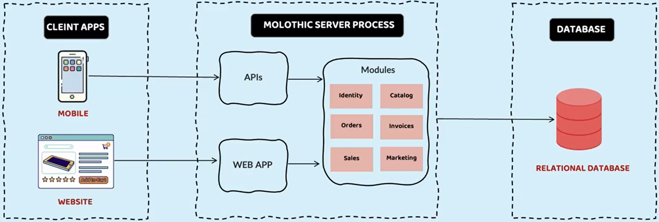

And as part of this migration use case, let's try to understand how the accurate right sizing of the microservice is going to help any organization. Like you can see here first, let's try to imagine a e-commerce startup in the initial days, they used to have a monolithic server inside the monolithic server they used to have APIs which can be consumed by client applications like mobile applications. And very similarly, they also have MVC style web application expose to their website. From their HTML website, a web app MVC path will be invoked and the same will be redirected to the backend monolithic server. And inside this monolithic server, like you can see, there are many modules that are clubbed and deployed inside a single server. And these modules like identity, which will handle the authentication and authorization. There is a catalog module which will help searching for the products inside an application. There is an orders, there is an invoices, sales, marketing, module. And very similarly there are other modules like orders, invoices, sales and marketing. You can imagine any number of modules inside e-commerce application, but for now, for simplicity, let's try to assume that these six modules are present inside this monolithic e-commerce server.

And like, you know, inside monolithic application, there is going to be a single supporting database. That's why they have a single relational database inside their database layer. I hope you are clear with this monolithic architecture of an e-commerce startup. Now let's try to see what are the problems that they are facing with this setup. In the initial days, everyone is happy because the team is very small, and the traffic and volume that is coming towards a website and mobile application is very small. So they are able to manage with the monolithic application because building, testing, deploying and troubleshooting an issue is very easy with only a single server. But later on, after a few years, this e-commerce application, it became super famous like Amazon, and they started receiving a lot of traffic, lot of data, and at the same time they are also facing lot of competition from the other competitor website. So with all this setup, they are facing lot of challenges. Let's try to understand what are those challenges. The very first challenge is the application becomes super complicated and no single person understand the entire application. Because over the years, lot of business logic added inside the same application. And many people, they left the organization and at the same time, there is lot of tight coupling between the multiple modules. With this definitely that leaders at this e-commerce application, they are scared to make any changes, making any change will attract a lot of bugs and regression issues, so they cannot really make any changes within a short period of time. Any change that they want to do, it requires months of time because along with the development, you should do a lot of testing, regression testing, performance testing.

Apart from these challenges, they are also going to face challenges during the deployment of the application. For suppose if they make a small change inside the invoice module, they need to redeploy their entire application, which is unnecessary and time consuming, and any single unstable component can crash their entire system. And off course, adapting to new technology and framework is not at all an option with these small, thick application. And since the application is not separated and loosely coupled based upon the business logic, definitely the organization cannot build isolated small teams by following agile delivery Methodology. They can't have different, different scrum teams focusing on different, different functionality because everything is tightly coupled.

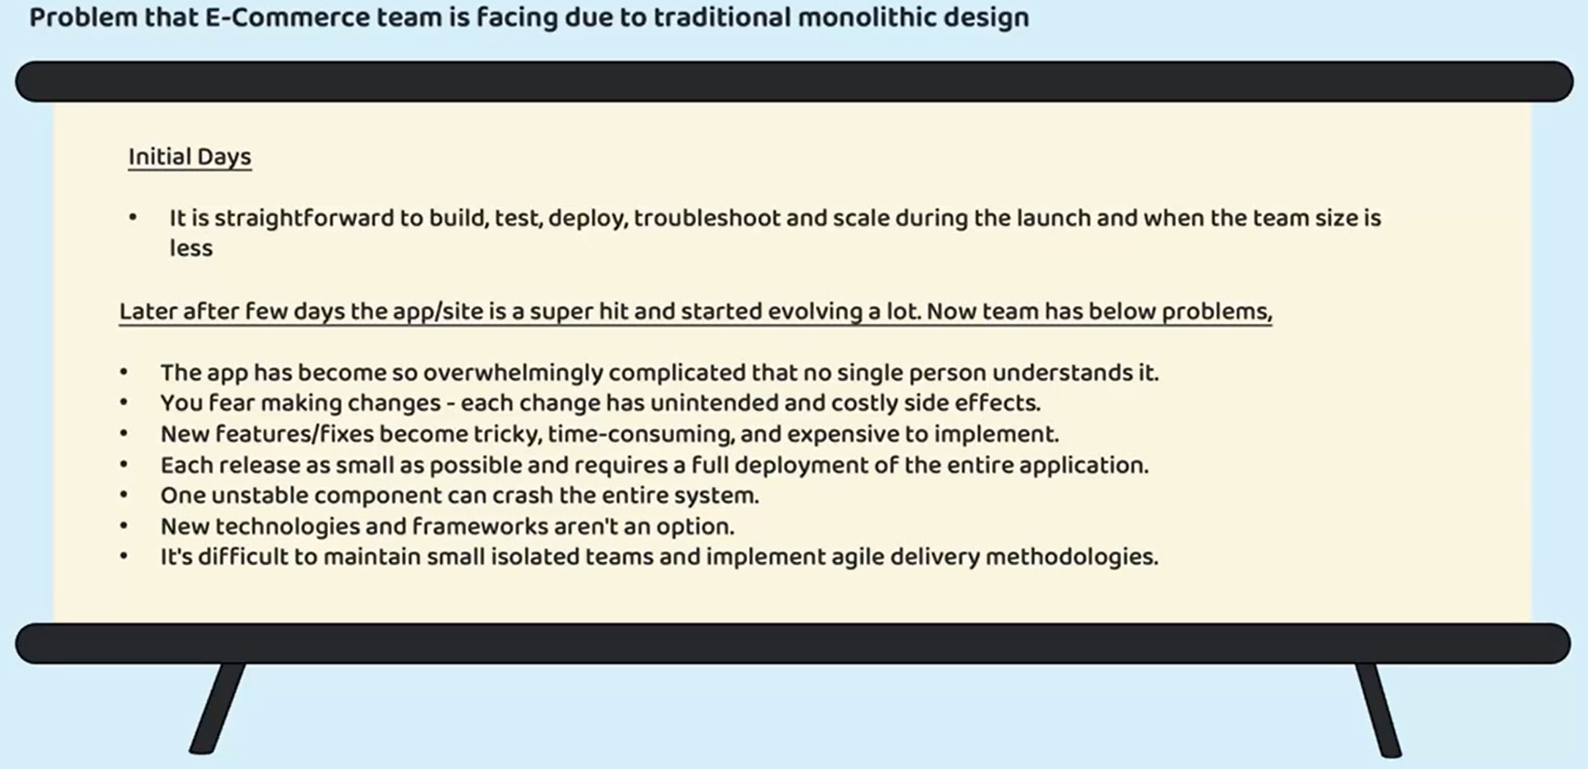

So with all these challenges, e-commerce team, they decided to migrate their monolithic application to microservices network. They have issued lot of budget, and they also provided six months time to their technical team to convert this monolithic application into a microservices application. So let's see what the team has done. Like you can see here, the technical team, they have built this architecture. On the client side there will be a mobile application and a website which is built based upon latest UI stack like Angular or React. With this, both my mobile client and angular are react based web application. They can try to consume my Rest APIs or microservices. I don't have to write separate components one with Rest API and other one with MVC pattern. I can simply expose all my business logic with the help of Rest APIs, and that's why my client applications. They can communicate with my backend with the help of API gateway.

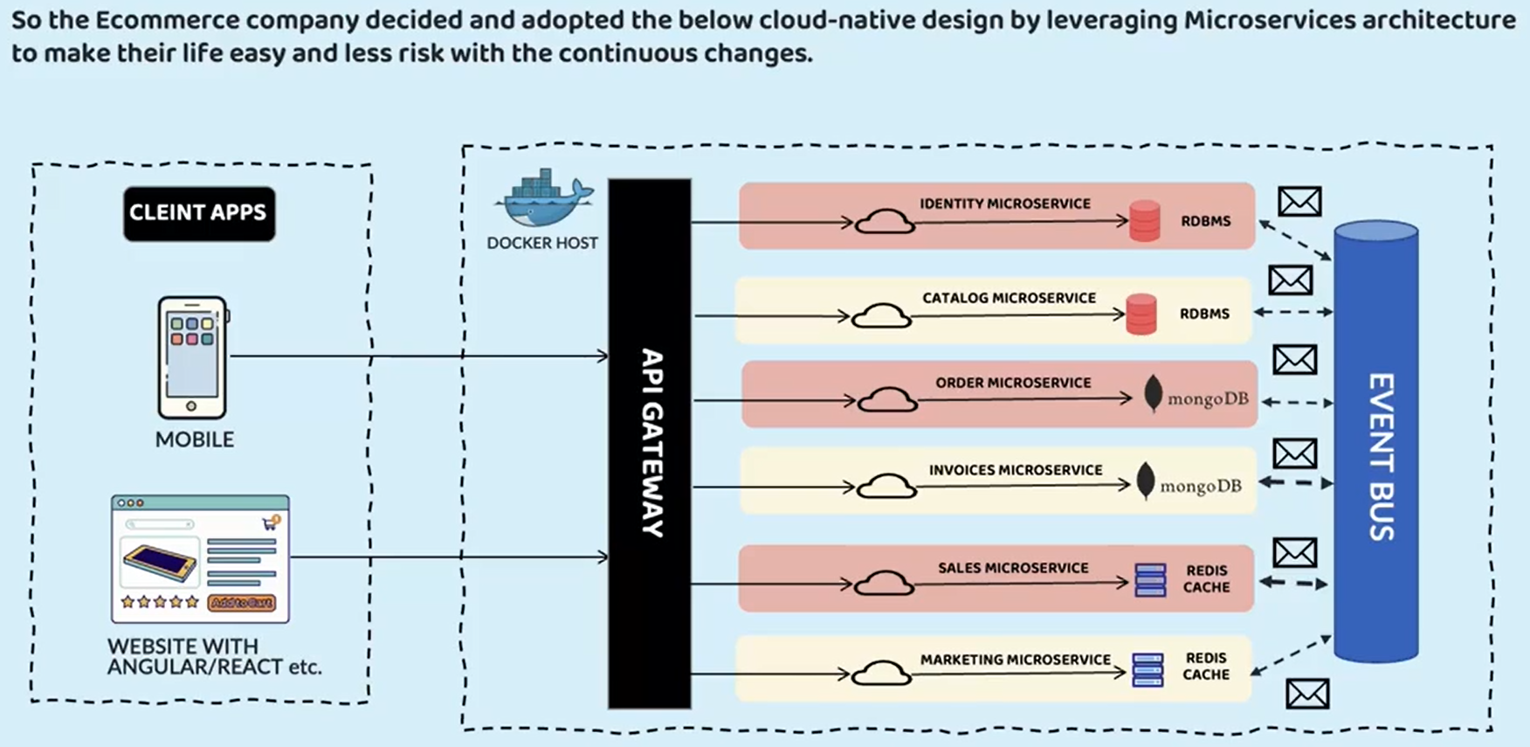

All the microservices, including the API gateway, deployed with the help of containers on the backend. What the team has done is, they have separated all the modules into independent microservices like identity microservice, catalog microservice, order, invoice, sales, marketing microservice. So anyone who wants to communicate with my microservice, first they need to talk with my API gateway. Using API gateway, my client application, they can invoke my Rest APIs or microservices. And all these microservices, including API gateway is deployed as a Docker containers inside a Kubernetes cluster. So we are going to build something very similar to this inside this course.

If you see the beauty of this microservices implementation is, each microservice, they can have their own supporting database. They can follow their own programming language or framework, for example other microservices they are using NoSQL database because they need to store a lot of data and similar for invoice microservice, whereas catalog microservice they don't have to store a lot of data that's why they are going with RDBMS and sales, marketing microservice. They are following a Redis cache database based upon their business requirements. On top of this microservice and supporting databases, the team also implemented event streaming with the help of Event Bus like Kafka, RabbitMQ. So with these products you can implement event streaming. So whenever an authentication trying to happen, you can trigger an SMS to the customer for his OTP so that you can do asynchronously with the help of event streaming. And similarly, whenever an order is confirmed, you can send an SMS or email to the customer asynchronously with the help of event streaming.

So this way, this e-commerce team, they are trying to get all the benefits with the help of these microservices architecture. Now this e-commerce organization, they can also have different agile teams, different scrum teams focusing on each of these microservices. And they can travel with their own enhancement lifecycle, with their own defects and with their own deployment lifecycle. So here you need to observe that sizing is very important. For some reason, if the e-commerce team, they have identified too many microservices, then it is going to be super, super operational overhead for them. That's why right sizing is different. Even whenever you are trying to migrate your existing monolithic application into a microservice architecture. With all these discussions, I'm assuming you are super clear about what is the importance of right sizing, what are the inputs and challenges that you need to consider while trying to right sizing your microservices?

## Strangler Fig Pattern

When someone is looking to migrate their legacy or monolithic application into the latest microservices architecture, then there is a design pattern that people can follow. This design pattern is Strangler Fig pattern. So let's try to understand what is this pattern and how it is going to help the developers and organizations to migrate into the microservices architecture.



Strangler fig pattern is a software migration pattern used to gradually replace or refactor a legacy system with a new system. In this pattern, what is going to happen ? The legacy application it is going to be replaced with a modern approach piece by piece, without disrupting the existing functionality. And here you might be wondering how this design pattern got this name, which is Strangler fig pattern. There is a very interesting story behind that.

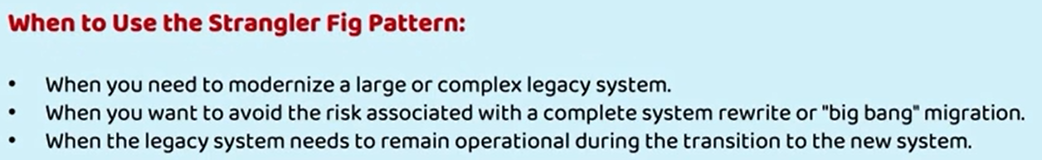

This pattern gets its name from the way a strangler fig plant grows around an existing tree by slowly replacing until the original tree is no longer needed. You can also see here I have mentioned the various stages of a strangler fig plant. This is how the strangler fig plant is going to look like. If you see just around the main tree. A new plant is trying to grow. When it grows fully, the original tree or the main tree, it is going to be completely replaced. Here in the very first stage you can see this is the original tree. To this original tree, a small plant started to grow on the sides and this small plant, it started growing onto the main tree itself. The new tree, it is trying to gradually grow and eventually only the new tree is going to be present. And the old tree, it is going to die or it is going to be completely replaced. The same strategy is organizations they are going to follow whenever they are trying to migrate their the legacy application into microservices.



Usually following this pattern is strongly recommended if you are trying to modernize a large or complex legacy system. If your legacy system is very small, then there is no need to follow these strangler fig pattern only for the complex or large legacy systems. Only this pattern is recommended. You can also follow this pattern when you want to avoid the risk associated with a complete system rewrite or a big bang migration. What is a Big Bang migration? Suddenly, on a single day, you are going to migrate from legacy system to the new system. This kind of migration system will call them as Big Bang migration. There are certain risks if you try to follow the Big Bang migration by rewriting the entire legacy system. To avoid such risk, you can follow the Strangler fig pattern at last you can also consider this pattern when the legacy system needs to remain operational during the transition to the new system. I hope you got some gist of these strangler fig pattern. Let me show you an example so that it is going to be clear for you. As you can see here, initially there was a monolithic app. Just imagine this is a bank application, inside this bank application it supports functionalities around the cards, accounts and loans. Entire functionality is present inside these monolithic app.

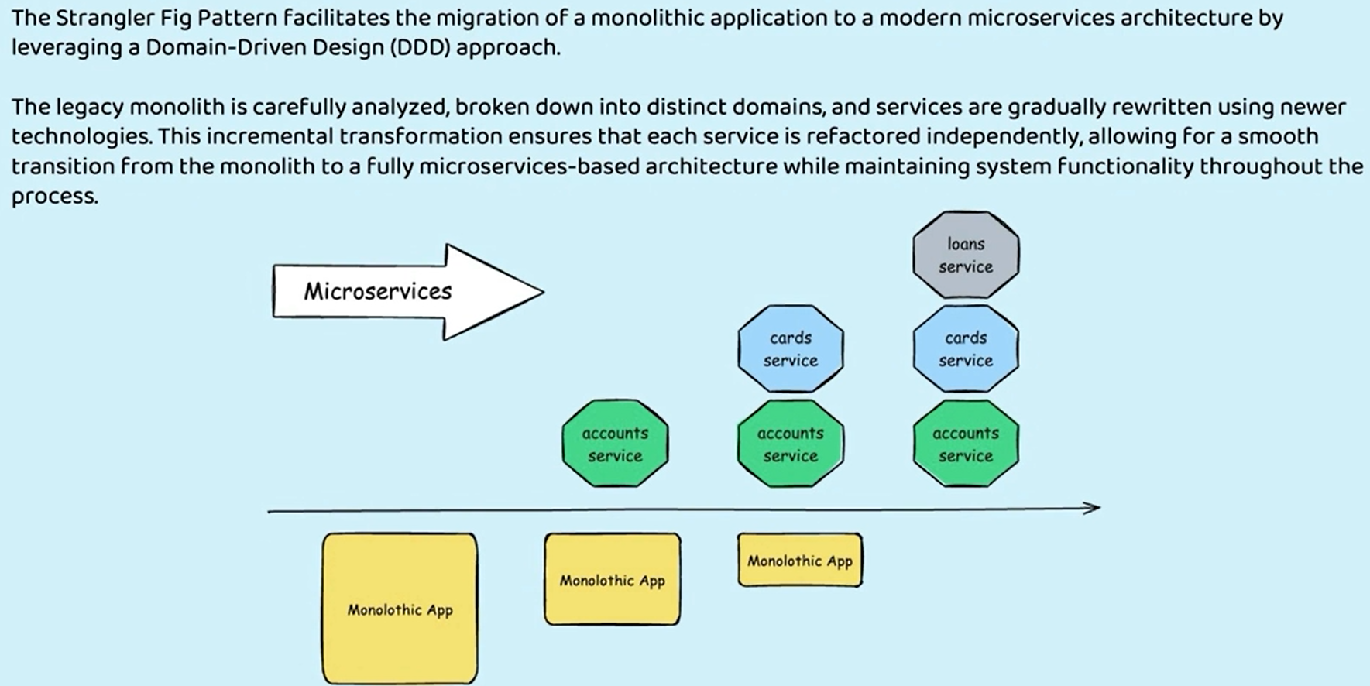

So what the development team they are going to do whenever they are following the strangler fig pattern is, first they are going to decide how to rightsize their microservice by following that domain driven design approach. As a next step, the legacy monolithic is carefully broken down into distinct domains, and services are gradually rewritten using newer technologies. As you can see here, the development team first, they have created an accounts microservice and the remaining functionality is still present inside the monolithic app. The remaining functionality is related to the cards and loans microservice. Once they feel everything around the accounts microservice is properly working in production. What they are going to do is, they are going to migrate the next component into the microservice. The next component is, cards here, once they satisfied with the deployment of cards and accounts microservice into the microservices environment, if they are happy with the results and the progress that they made, eventually they will try to migrate their loans as well. And towards the end stage you can see there is no monolithic app here. Because it is completely replaced with this approach developers team, they are going to get lot of benefits.

The very first benefit is there is, very minimal risk associated with these migration. Since the development team, they are trying to migrate only a piece of component into microservices. If there are some issues, they should be easily handled and whatever learnings they have learned during the first migration, those learnings will be used while they are migrating other components.

And the next advantage is this pattern chain allow the development team to migrate incrementally instead of going for the Big Bang migration. With the Big Bang migration, we'll have a lot of challenges. You can't roll back easily. And if there are any surprises, it's very hard to handle them for the development team. Whereas with the incremental migration, the development team will have enough opportunities to learn from their mistakes, to handle the issues and surprises. And the last advantage that developers they're going to get when they're following this pattern is, this pattern is going to help in performing testing and validations with greater efficiency. Since monolithic application is also going to be present inside this migration, they can always try to route the traffic between the microservices and legacy application. They can test by routing the traffic between the two components. If there are any issues, they can compare the results between the legacy and the microservices.

For some reason, if the microservices is not working as expected, then they can try to navigate the 100% of the traffic to the monolithic application. Here, though, I'm trying to decrease the size of the monolithic app, but in reality, the accounts code and the cards code, it is going to still be present inside the monolithic app, but it will be in the dead state because there is no traffic is coming. But development team, like I said, they have flexibility. They can redirect 50-50% of the traffic between these two components. Once they are confident that microservices is working, they can send 100% of the traffic towards a microservice. Otherwise, they can roll back the traffic back to the monolithic application. Whenever someone is following this pattern, there are four different steps that they are going to follow.

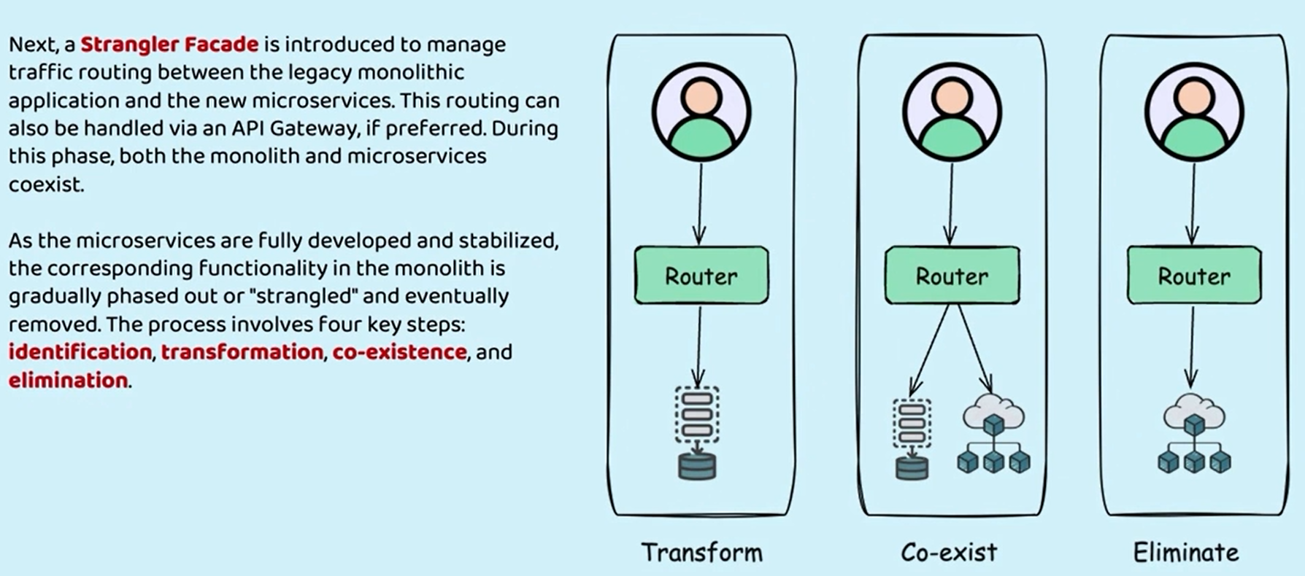

The very first one is Identification. As part of this identification process, they are going to identify how many microservices they need to do. Basically, they are going to perform the right sizing of the microservices by using the domain driven approach. The next stage is going to be the transformation where they are going to transform the components inside the legacy into the microservices. Once the transformation is successful. As you can see, both monolithic and microservices, they are going to be coexist. There will be a strangler facade introduced with the help of the strangler facade. The traffic between the legacy and the microservices can be handled. Usually this can be handled with the help of a API gateway. After the coexistence phase, at last, the elimination phase comes where they are going to completely eliminate the legacy application and the entire traffic will go to the microservices or the modern application. I hope you are clear with this pattern. Please make sure you are clear about this pattern because there is a very good chance inside the interviews, people may ask you around the migration. They can simply ask, how are you migrating your legacy into the microservice based application? The answer is very simple. You need to explain these Strangler fig pattern

# Deployment, Portability & Scalability

The new challenge that we are going to discuss inside this section is how to handle deployment, portability and scalability of our microservice. First, if you try to take that deployment, you may have a question like how do we deploy all the small microservices that we have with less efforts and cost. With monolithic application, we have only a single application or a single jar or war or ear file, which we can deploy into your web server or application server. Whereas with microservice architecture, we are going to have hundreds of microservice in any organization. So how do we deploy all those hundreds of microservices? Do we need 100 different servers and virtual machines to deploy them? Off course not. That is not going to be a viable solution.

We'll explore what are the options that we have, now after deployment if you think from portability perspective, how do we move our hundreds of microservice across environments with less effort configurations and cost? Like any web application, regardless of monolithic or microservice or any other architecture, it has to be deployed in various environment, right from the developer mission it will go into the GitHub repository or any other versioning system. From there, we need to deploy into the development environment. Once the build is stable, we need to move to the uat environment or sit environment or QA environment. Once the testing is completed, we need to deploy the same into the production replica environment. Once the pre-production testing is completed, eventually the deployment has to be done inside the production. If you see, the code has to move across many environments. With monolithic, there is only single application, single server. We can move the code by making enough configurations with very less efforts, but with hundreds of microservice who is going to take care of all the portability issues. If your application need a specific JDK version or a specific web server or a specific folder structure or specific DB configurations who are going to do all those manual work when we have hundreds of microservice. So these are another problem or another challenge that we may have.

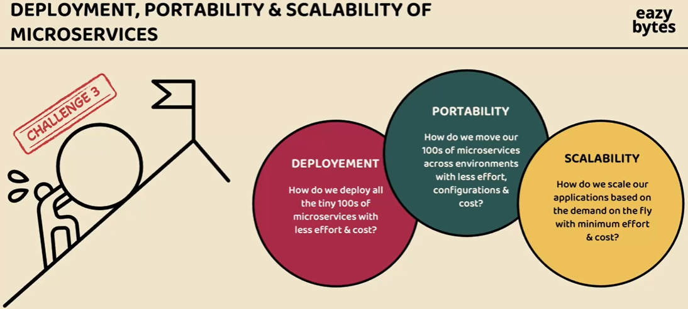

And after the portability, we also have another challenge in the form of scalability. Scaling a monolithic application is going to be super, super easy because you have only a single server. You can try to onboard one more server, which is replica of the existing monolithic server. With microservice, the story is different. We may have hundreds of microservice. How do we scale a specific microservice whenever we want based upon the traffic needs? So we need to scale the microservice on the fly based upon the demands. And at the same time, whenever we don't need, we need to scale down. So this all has to happen with the minimum effort and cost, off course, without any manual intervention. So these are the three challenges that we may face whenever we try to build microservice with a traditional monolithic mindset. So we need to change our mindset. We need to change how we package our web applications. In the traditional approach, you package your application as an war or ear or jar, and you will eventually deploy into a web server or app server. But that is not going to work. We need some new technique which we can adopt inside our microservice applications. So do you have any clue what is this new technique? Let me reveal the solution that we can use to overcome this challenge. The solution is containerization of our applications to overcome all these challenges, first, we should containerize all our microservice. Why should we containerize our applications?

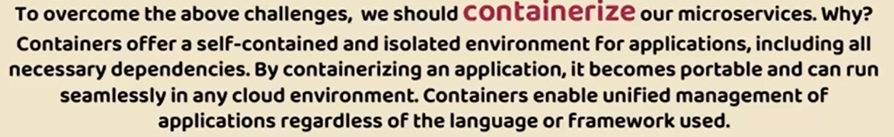

Because when we containerize our applications, we are converting a normal maven project into a container. These containers are very small in nature, which offer a self-isolated environment for applications, including all the necessary dependencies. If your microservice require a Java version or a Tomcat or DB configurations or any folder structure, you can club all those dependencies inside a container and the same container you can deploy across any environment or across any cloud environment without making any changes. I'll be showing all the benefits of this containerization in this section. So the very next question you may have is how do we containerize our Maven applications. For the same we have a solution which is Docker. You might have heard about this Docker already. So Docker is an open source platform that provides an ability to package and run an application in a loosely isolated environment called a container. You have a maven application.

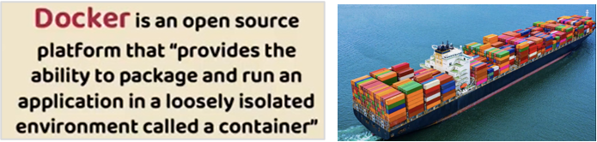

With the help of this docker, you can convert that into a Docker image and eventually you can run that image as a container inside any virtual machine or inside any cloud environment. I know you may have many questions. Inside this section, I'm going to give you a very good introduction about Docker. What is Docker? How we can containerize our applications? What are the challenges that it is going to solve with all this, this section is going to be interesting. Before I try to close this lecture, let me give a quick introduction how this containerization came into picture. You see a ship here, so I have a question here. What do you observe from this ship? If you observe this ship, it is carrying a lot of goods from one country to other country with the help of these containers. So why they are using these containers, why can't they simply carry all the goods without these containers?

Because with the help of these containers, they are able to optimize the space. They are able to provide a separate environment or separate isolated space for each of the good. Like inside a container, there can be apples which need a refrigerator, whereas inside other container there are some electronic goods which does not require any cooling or refrigerator. Similarly, in a real world web applications, every web application may have its own requirements. One microservice may want to use Java 17 version, whereas other microservice it may want to use Java 21 version. Similarly, there can be many, many different requirements for different different microservice in terms of database, in terms of framework they use, in terms of language they use. If you try to manage all these microservices inside a single virtual machine or a single jumbo server, it is going to be hell of work. And at the same time you are not optimally using all the resources of your server.

So just like how this ship is using the resources optimally with the help of this containers, the same way we are going to convert our microservices and deploy them as a containers that way inside a single virtual machine or a single jumbo server, I can deploy ten different microservice with ten different requirements because every container will have its own isolated environment. How it is going to have, how that is possible. We are going to discuss in the coming lectures, but for now I just wanted to highlight whenever you are thinking about Docker and Containers, just think about the ship. What are the advantages that it is getting with these containers? Very similarly, just like how the shipping industry is taking advantage of containers, we are also going to adopt the same container kind of concept inside microservice with the help of Docker.

## Containers and VMs

We introduced a lot of new jargons like containerization, containers and docker. Before we try to understand all these jargons and how to convert our microservices into Docker containers, first let me try to clarify a burning question that you may have, which is what are these containers and how they are different from that Traditional virtual machines. Before cloud computing days, every organization they used to buy their own hardware and using these hardware they will install the operating system. So once a hardware and operating system is installed, we can call it as a server and this server will be connected to a public network. Inside this server, the code will be deployed with the help of web server or app server, and there will be a public IP address assigned to your server. So the platform team or operations team, they will map your public IP address to your domain name and using the same domain name, my end user can access my web application from his local browser. So this is the basic and old story that you are aware.

|  |  |
| --- | --- |
|  | But with the cloud computing concept, we don't need to buy a server physically and maintain that inside our own data centers. We can buy a server virtually from the cloud providers and the cloud providers behind the scenes, they will give you a virtual machine. Why the server is called as virtual machine because you can physically see it, you can only feel it virtually and you can access it through the web internet. That's why they called as virtual machines. So let's try to understand how these virtual machines are created. Like you can see here at the bottom of this table, we have server. So this is a physical hardware.  So think like a cloud provider, like AWS, Azure or GCP. They'll have a physical hardware or a physical server available in their data centers and they can't assign a server to a single organization. Because the server capacity might be 64 GB Ram, and it also holds four terabyte of hard disk. So they can't give these entire jumbo server to a single organization because there will be very rare such instances where an organization will request for such a jumbo server. So that's why on top of this server they will use a technology or they will use a concept called hypervisor. Using these hypervisor software from the same physical hardware, they can create multiple virtual machines. You can see here from the same physical hardware, there are three virtual machines created like VM1, VM2 and VM3. |

Inside these, each virtual machines, we can install our own operating system like inside VM1, I can have a windows operating system and inside VM2 I can have Linux operating system and inside VM3 three, I can have Mac operating system. So it's up to us what operating system we want to install. With the hypervisor, while we are creating a virtual machine, we can install required operating system based upon our own requirements. So here it is very clear the resources like ram, hard disk of the physical server is virtually distributed between multiple virtual machines with the help of hypervisor concept. So now this VM1 can be given to a company one and VM2 can be given to the other company and so on. So now coming to the microservices environment, think like there is no containerization concept. We have to live with these virtual machines in such scenarios. What we have to do, suppose I have three micro services like AccountService, LoanService and CardService . So for AccountService I may need some JDK version and similarly I may need some web server or app server or Maven installed. So all the required binaries and libraries I have to manually install inside the VM1. And similarly I have to do inside the VM2 and VM three for the required binaries and libraries of LoanService and CardService. So after creating my virtual machine with the help of guest OS and after that I will install the required binaries and libraries post that only I can deploy my AccountsMicroservice or LoansMicroservice or CardsMicroservice into my virtual machine. Once this deployment is completed, anyone can access my Microservice using the public IP address. So behind the scenes, the cloud providers, they will assign a public IP address for each of the virtual machine that they are going to create. The same public IP will be mapped to your DNS name or domain name and using the same domain name or DNS name, we can access our microservice from outside the world. So this is a story with the virtual machines. And here you may have a question. What's the problem with this? I can deploy all my microservice into separate virtual machines.

There are multiple problems here. First, here, I'm trying to show you only three microservices. What if you have 100 microservices. Please don't answer like I'll create 100 virtual machines. That is going to be a super, super complex process and it is going to attract a lot of cloud Bill for your organization. So when you create a virtual machine, it's a big machine. It is as good as your laptop, which has 16 GB Ram and one terabyte hard disk inside such a big machine, if you only deploy a small microservice, do you think it is a viable solution? Off course not. And similarly, you may think like why can't I deploy AccountService, LoanService and CardService inside a single virtual machine? Even with that approach, you may face some challenges. Like your Accounts Microservice may need a Java 8 version, whereas your Loans Microservice may need a Java 17 version. And similarly Cards Microservice may need some other program language like Python. So if you try to deploy all these microservices inside a single virtual machine, you see we will face lot many problems when we have different, different requirements for different, different microservice. On top of that, we have one more problem. Like if you try to restart your virtual machine, all your AccountService, LoanService and CardService will be down, which is again a not an acceptable risk by any organization. And at the same time, in terms of scalability, suppose you want more number of AccountService instances deployed in some other virtual machine. Your Accounts Microservice is receiving a lot of traffic. All of a sudden you decided to scale up your Accounts Microservice from one instance to three instance with the virtual machine concept. By the time you create a virtual machine, by the time you install a guest operating system, by the time you complete all the binaries and libraries, installation and scale your Accounts Microservice, it is going to take at least 15 minutes of time. With such a long 15 minutes of time, you can't really call it as a real scalability. Because within that 15 minutes your traffic may get reduced. By the time you scale up your Accounts Microservice, your traffic reduced to normal traffic. And again, you decided to scale down from 3 VMs to one virtual machine. Again, deleting the virtual machine also is not a simple and easy task. It will easily take again 5 to 10 minutes. Apart from these challenges, there are many, many other challenges. If you try to deploy your microservices using a virtual machines concept. That's why whenever you are trying to deploy your microservices, please say a big no to the virtual machines..

|  |  |
| --- | --- |
| Instead, we should go for the containers. So let's try to understand how these containers are different from virtual machines. If you see at the bottom the server, the physical hardware is going to be same for the virtual machine and the containers. On top of this physical hardware as a server will install a host operating system. So here it can be an windows operating system or Linux operating system or Mac operating system. So once you have the server and host operating system, you need to install a implementation of container engine products like Docker. So once you install the Docker with the help of the Docker, you can create multiple containers  And inside these containers you can deploy AccountService, LoanService and CardService. So if you see the beauty here for the containers, there is no need of separate operating system. They will share the host operating system. So when the guest operating system is not there for containers, they are going to become lightweight and creating a container and and destroying a container or restarting a container is going to take only few seconds. So that's the very first great advantage that we have with containers compared to virtual machine. So they are lightweight and they are going to be super quick in terms of restart creation and destroying. |  |

Now the other advantage that we have with containers is, inside the same virtual machine or inside the same server, they can have a separate isolated environment. So think like all these three containers are deployed inside a same virtual machine or inside a same server. But the advantage with containers is inside the container1, I can have Java eight version and inside the container2 I can have Java 17 version and inside the container3 I can have different language which is Python installed. So that's a one more advantage. Every container will have its own isolated virtual network and virtual environment. The container 1 will not know about container 2 and its environment, and the same applies for vice versa scenario as well. Like I said before, these containers are a packed components where all the required dependencies package. Like if your Accounts Microservice need a JDK and Springboot related libraries, all of them will be clubbed and be available inside the container 1 itself.

Due to that, whenever you are trying to create new container inside another server or inside another environment. It is not going to be super, super manual setup. You don't have to install the Java, you don't have to download the spring boot libraries. You can just take the packaged component of the container to some other environment and you can convert that package to a container with a single command. So that's one advantage. So this will solve the portability issue. Now the deployment also is going to be super, super easy because these are lightweight components and restarting, creating a new container, destroying the existing containers is also going to take only few seconds and every container will have its own network, own resources, own memory, own storage, which can't be accessed by the other container until unless someone allowed it.



So on a high level, I just wanted to say the main difference between virtual machine and containers is, containers they don't need the guest operating system, not the hypervisor to assign the resources. Instead, they will use the container engine, which is Docker. I know you may have many other questions, but when we try to convert our microservices into containers, all these benefits and advantages I'll be showing you in action and that will make more sense to you about these containers. I hope you are clear about what are the differences between virtual machine and containers.

One of the question that anyone can ask you inside an interview is what is a container? A container is a loosely isolated environment inside a server or inside a virtual machine or inside your local system as well. Since you are getting an loosely isolated environment inside a machine, you can use that isolated environment to deploy your microservice by using software packages. So these software packages include all the code and all the dependencies to run your applications or microservices quickly and reliably on any computing environment. Your containers in order to run, they just need the required code and dependencies along with the computing environment. And this environment can be your local system. It can be a virtual machine inside a data center, or it can be a virtual machine inside a cloud environment. So the computing environment can be anywhere your container is going to work very similarly, like it work inside your local system. That's why, regardless of how many environments you are trying to deploy your microservice, you are going to use the same container and there won't be any manual efforts to set up your container to install the dependencies to install the required servers. So everything is going to be available inside the container itself. Like I said, all the required dependencies and libraries are available inside software packages and these packages we call them as container images.

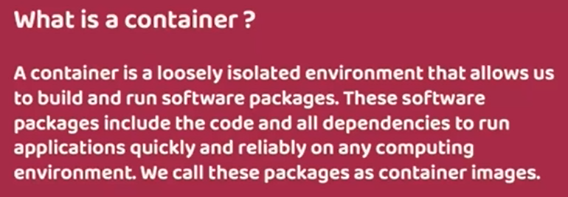

So from our microservice application we are going to generate a Docker image or container image. From the container image, we can create any number of containers. So think like this image is like your Java class, just like how your Java class is a skeleton or representation of your object. Very similarly, this container image is a representation of your container. From these container image, you can create any number of containers, just like how you can create multiple Java objects from your Java class. In other words, your Docker container is an actual running representation of your Docker image.

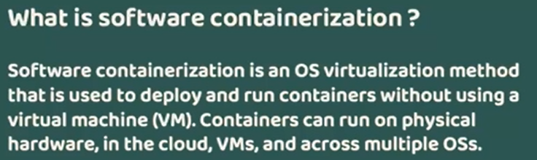

The next definition that I want to share here is what is software containerization? So using these containerization concepts only, we need to convert our microservice applications into Docker containers. So what is the software Containerization? It is an operating system virtualization methods. Like we discussed in the previous lecture, we can deploy multiple containers inside a single machine or a virtual machine and all these containers, they are going to get a virtually isolated environment and these containers, they will feel like they are running inside their own operating system. So with these containerization concept, we are virtualizing an entire operating system. Whereas with hypervisor, if you see we are virtualizing the machines, all these virtual machines like VM1, VM2, VM3, they will feel like they are all running in different, different physical hardwares, but they are not because with the help of hypervisor we are virtualizing the machines very similarly with the help of containerization, we will virtualize the operating system. So all these container 1, container 2, container 3. They are running on a same operating system which is host operating system, but they will feel like they are running in a separate, separate operating systems.

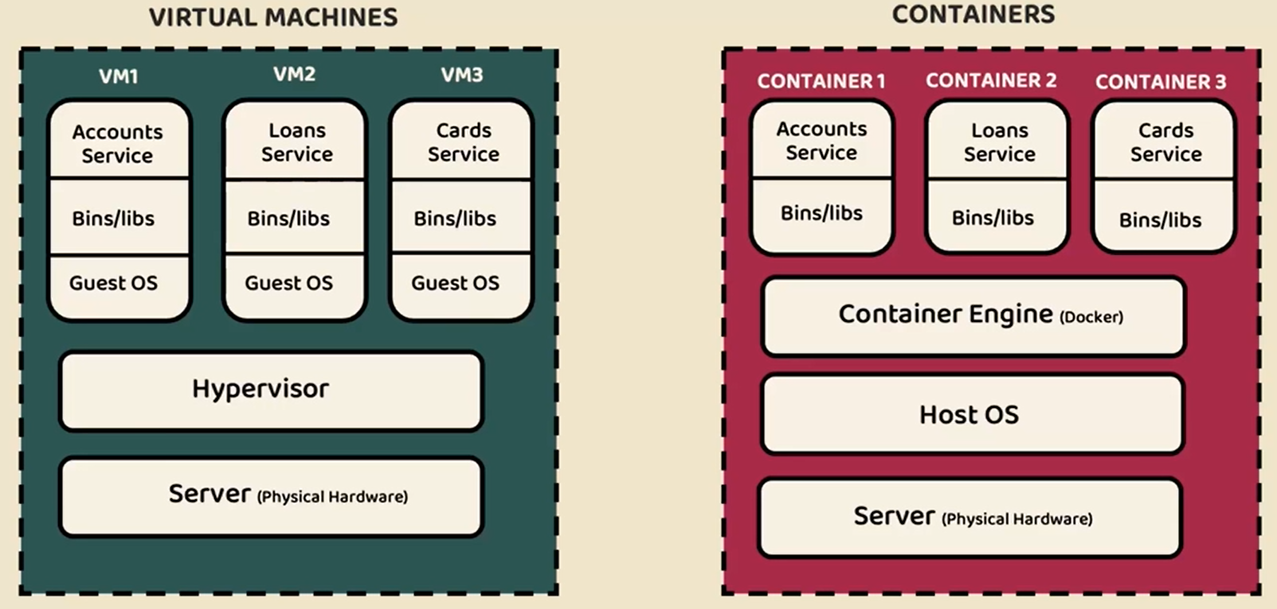

So since we are providing such kind of virtual isolated environment inside the containerization concept, the virtualization is at the operating system level, whereas inside the virtual machines, the virtualization is at the hardware level. I hope it is clear now we know what is a container, what is a software containerization? The next question is what is a docker? Docker is a open source platform or a product that enables developers to convert their web applications or to convert their application code into a Docker image using the same Docker image. And with the help of this Docker, we can automate the deployment, scaling and management of the applications. With the concept of containerization. I hope you are able to tie the strings here between these three components. So software containerization is a concept.

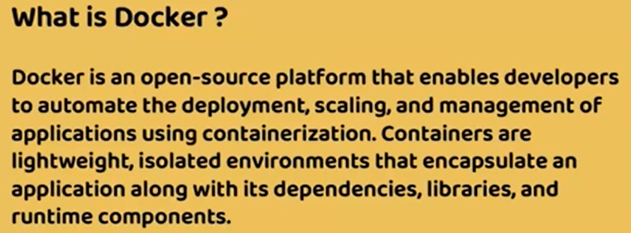

Docker is an platform which, it implements this containerization technology. So using the Docker, we are going to generate the Docker images and Docker containers from our application code. Now let's try to understand what exactly is going to happen inside the containerization concept.

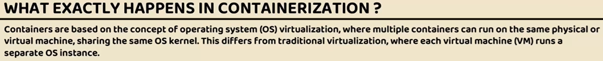

Like I said, containers, they are going to get isolated environment, how they are going to get because containers are based on the concept of operating system virtualization, where multiple containers run on the same physical or a virtual machine that shares the same operating system kernel. And this is different from the traditional virtualization that we follow whenever we are trying to create multiple virtual machines. And these virtual machines run on their own separate operating system instance, whereas with Dockers they're going to share the same operating system kernel. So inside this containerization Linux features like namespace and cgroups play a crucial role in providing the isolation and resource management.



So let's try to understand what are these namespace and cgroups.

Namespace is a concept inside Linux, which will allow for the creation of isolated environments within the same operating system. So each container will get its own set of namespace and these namespace is going to have process resource, network resource and any storage resources, communication resources and similarly user namespaces. So these namespaces ensures that process within a container are only aware of and can interact with the resources within their own specific namespace. So this provides a level of isolation from the other containers. I hope you understand it's very simple. Using namespace for a container, we are giving its own network process, storage everything. So that all the components inside the container are inside the namespace. They can interact with each other, but not other components inside other container or inside other namespaces.

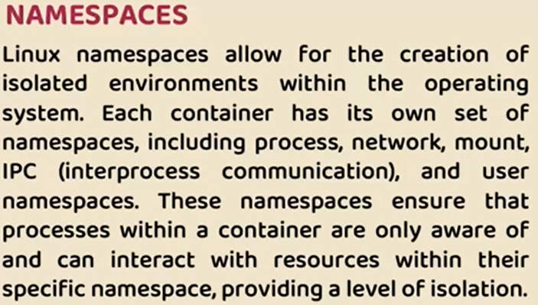 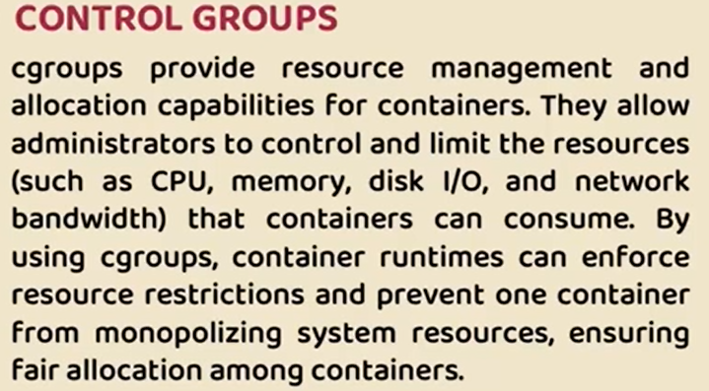

Now coming to the cgroup, what are cgroups? The cgroups also called as control groups. The reason why we call them as control groups is namespaces will provide the isolation of the resources, but someone has to control the uses of the resources by a container. So with the help of this control groups, we can administrate and control the usage of the resources like CPU, memory, disk, network bandwidth. That's where for the containers we can enforce resource restriction at runtime and try to avoid the scenarios like one container from monopolizing the system resources and ensuring fair allocation between multiple containers. Since we can deploy multiple containers inside a same virtual machine or inside a same computing system, we need to make sure every container is getting its own fair allocation. It should not be like one container is getting very less allocation, whereas other container is getting lot of memory allocation or CPU allocation. That is not fair and it may result into issues dynamically at runtime. That's why with these concepts of like namespaces and control groups, a separate isolated environment will be provided to the containers. Here you may have a question like these are the Linux features.



If these are the Linux features, then how I'm going to containerize my applications from my local system, like inside my Mac OS or inside my windows operating system. Even it is also possible your production server can be a Windows server. So in such scenarios you may have a question like these are the Linux concepts. Then how the Docker containerization or containerization concept is going to work inside my Windows operating system or Mac operating system? So let's try to understand the same.



Whenever you try to install and Docker on a Linux operating system, it is going to be pretty simple. You will receive the entire Docker engine inside your Linux operating system. However, if you try to install the same docker inside a mac or Windows operating system, you will get two separate components. One is Docker client, which is installed on your own operating system like Mac or Window Os.

|  |  |
| --- | --- |
|  |  |
| And behind the scenes there will be also a separate component installed which which is a lightweight linux based virtual machine and the Docker server component is installed inside this Linux virtual machine. This way, regardless of what is the host operating system, Docker is going to work in any kind of operating systems. As a developer or as an end user, you will get very similar look and feel when you try to use a docker on a Linux machine or in any other operating systems. I can also confirm you the same when we install the docker inside our local system. So when you install the docker inside your local system, just run the command Docker version and you will get an output like you can see on the right hand side. So here you can see there are two details are printed. |  |

The very first one is what is the client details, which is Docker CLI for DockerCLI or Docker client. You can see the OS darwin/arm64, which is inside my Mac operating system. Inside Windows you may see a different output, but coming to the server, the OS is Linux because behind the scenes, like I said, a lightweight Linux virtual machine will be installed. That's why you are able to see clear difference between Docker client and Docker server inside the same machine. I hope you are clear. What is container? What is containerization? What is Docker?

## Docker Architecture

|  |  |  |
| --- | --- | --- |
|  | What are the important components available inside the Docker and what is the internal architecture of Docker?  The very first important component that we have is Docker client. Like I said before, whenever we try to install Docker inside any system, we get Docker client and Docker server. So using this Docker client only, we need to give instructions to the Docker server on how to containerize our applications. So inside this Docker client there are two different components that we can use to issue the commands to the Docker server.  The most commonly used approach is Docker CLI. Using this command line interface, we can issue commands to the Docker server directly from your terminal or from your command line. This is very similar to GitHub CLI or any other CLI is provided by the other products.  Apart from CLI, you can also issue commands to the Docker server using APIs using this Docker remote API, we can issue commands like how to run a Docker container from a Docker image. So all such commands we can give with this remote API approach as well. But inside this course we are going to use the Docker CLI approach because that is the most commonly used approach. | |
|  |  | |
|  | | Apart from this Docker client, the next important component that we have is Docker server. In other words, we can also call this Docker server as Docker host. So when I say Docker server, don't think like this is going to be installed in some other remote machine. So both this Docker client and Docker server or Docker hosts, both of these are going to be installed inside your system. So inside this Docker server there will be a Docker daemon process that is going to run continuously, which is going to accept the commands from the client, the client like CLI, we can issue commands to this server. Like please generate a Docker image for my application. So for my application, these are the dependencies. This is the Java version that I'm using. These are the configuration that I need. So once we provide all those details, our instructions to the Docker server, it is going to convert your spring boot application or Maven application or your microservice into a packaged software which commonly called as Docker image. So image is an representation of your packaged application. So it has all the required dependencies and configurations packaged into a Docker image. |

Very similarly, we can also give commands to generate a container from a Docker image. Like you can see here, there will be images and very similarly we also have containers, so we can't generate containers without a Docker image. First we need a Docker image. When we give an instruction to the Docker server to generate a container from a Docker image, it is going to leverage the Docker image and it is going to create a running instance of your Docker image, which is your web application or your microservice in a running state. So once the container is in running state, you can obviously try to access all your REST APIs or microservice business logic through the endpoint URL by using the correct port number. Correct API path.

|  |  |
| --- | --- |
|  | So inside your Docker server only all your images and containers are going to be stored. Now this setup is going to work perfectly if you are working in your own machine. Once we generate a Docker image for our microservice, once we test that with the help of Docker container and once we feel that everything is working, we need to push the Docker images to a repository from where we can continue to the steps like deployment and running the containers inside the dev environment, environment or production environment. Just like how we store our Java code inside the GitHub repo. Very similarly, we need to store these Docker images available inside our local system into a remote repository.  That's where we have the third component available. This third component we call it as Docker Registry, Docker Company itself they provide a Docker registry with the name Docker Hub. Inside this Docker hub, you can store all your Docker images and you can make them available for public use, or you can also protect them so that only authenticated users are applications will try to download your Docker images. Just like how Docker providing Docker hub.  Very similarly, there are private registries provided by famous companies like GitHub, AWS, GCP, Azure, so most of the cloud providers and most of the version repository products like GitHub, so they have their own private registry where you can push the Docker images from your local system to this remote repositories. For example, if you are using to a great extent inside your organization, then it makes sense to push your Docker images into your private registry provided by the AWS from this private registry. |

All your deployment of the microservices will happen. Inside this course, I'm going to use the Docker hub to store all my Docker images. So I'll show you how to generate a Docker image. And once the Docker image is generated inside our local, I'll also show you how to create a running container from your Docker image. Once everything is completed, we can push these Docker images into a remote Docker hub repository. So these are the three important components available inside the Docker architecture.

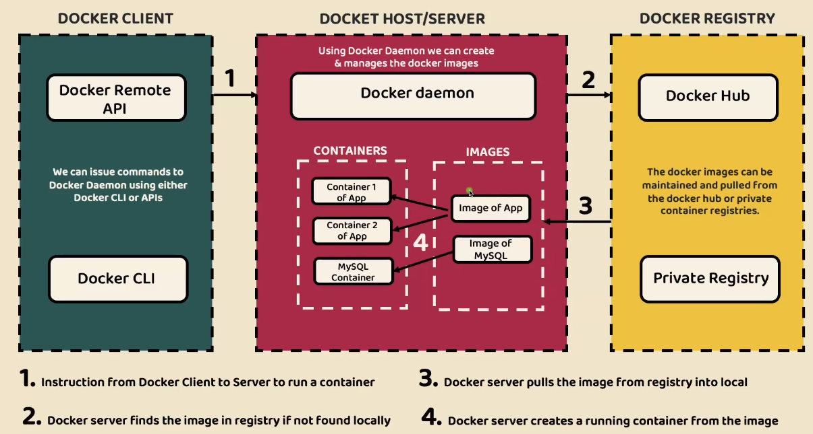

Now let me give a simple flow that will happen whenever I try to issue an instructions to the Docker server. So in the very first step, I'm going to give the instructions to the Docker server with the help of my Docker client. So the instruction may be like to run a container from a Docker image. So as soon as I give this instruction, my Docker server will validate if the Docker image is available inside my local system. If it is not there, it is going to fetch the required Docker image from the remote repository like Docker Hub. Once the Docker image is pulled into my local system using the same Docker image, a container will be created by the Docker server.

So once the container is available, it means my application is ready and I can try to use the application. These days, many of the products, they are providing everything as part of a Docker image. For example, if you want to use a MySQL inside your local system, the traditional or older approach is, you will go to the MySQL website, you will download the MySQL installation you will install inside your system. So that is very cumbersome process and a lengthy process. Instead, with the help of Docker, you can pull the image of MySQL. Once the image of MySQL is pulled from the Docker hub, you can try to run a container from the image. That means you are going to have MySQL server running inside your system. I hope you are clear with this Docker architecture. In the next lecture I'll show you how to install Docker inside a local system.

## Docker - Installation and Docker Hub

Visit [www.docker.com](http://www.docker.com)

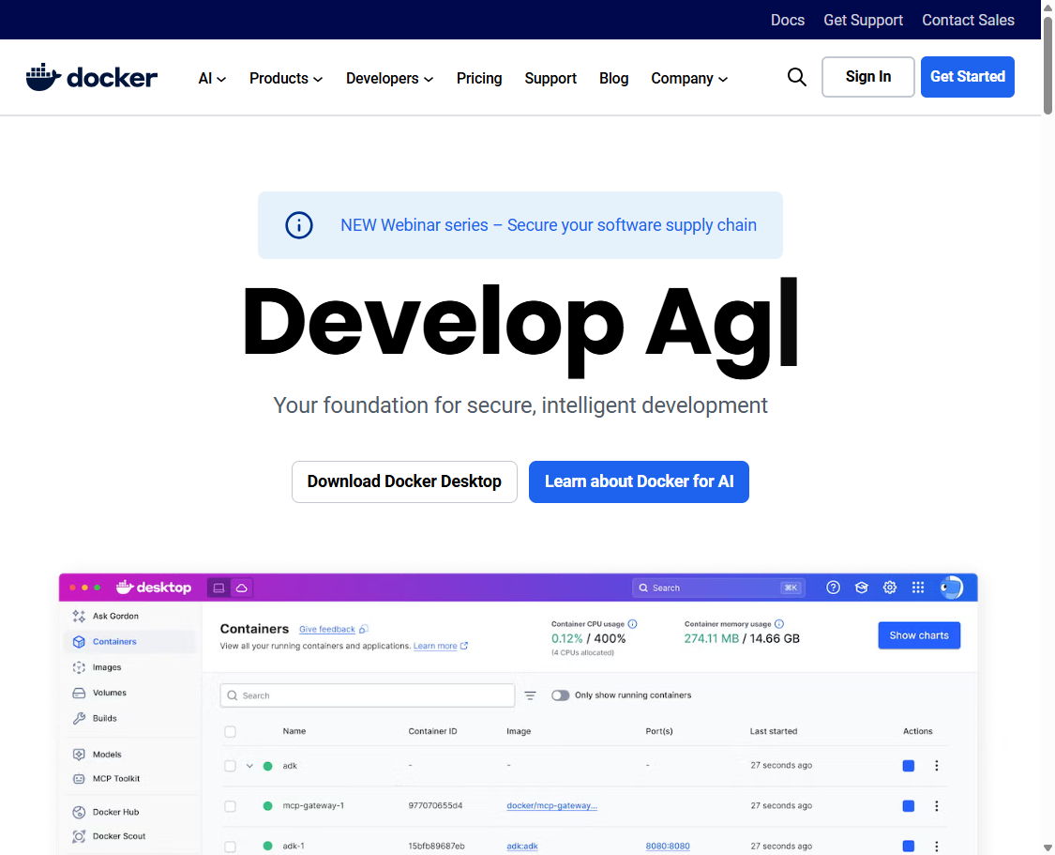

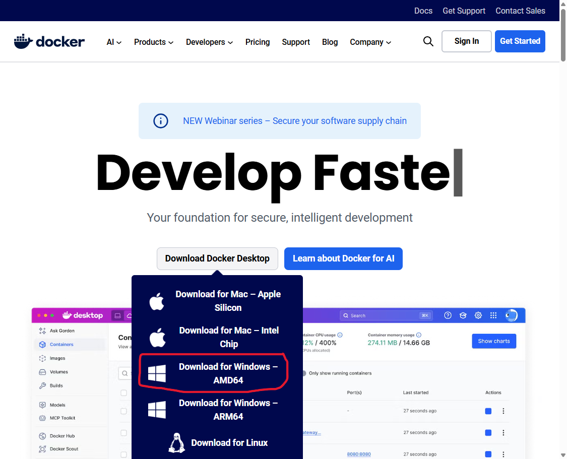

If you go into System > System Specifications – it will show a x64-based processor so you choose the AMD64 processor here. See System Type in screenshot below.

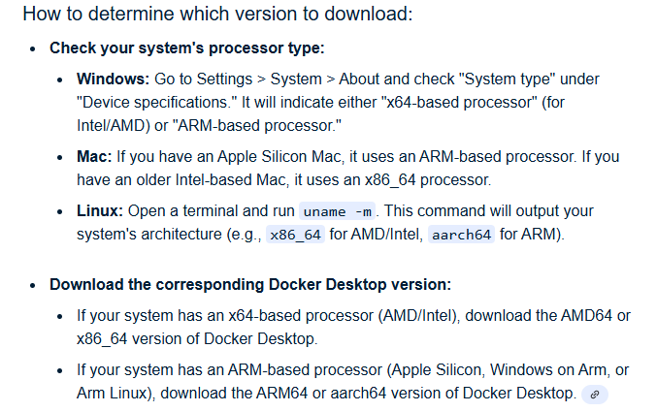

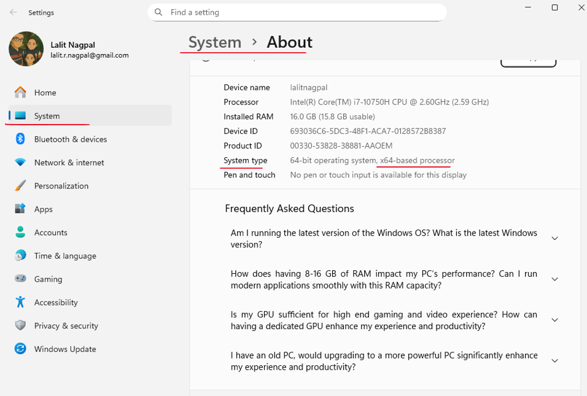

Double click, accept the default settings. I did not select install windows containers on Docker

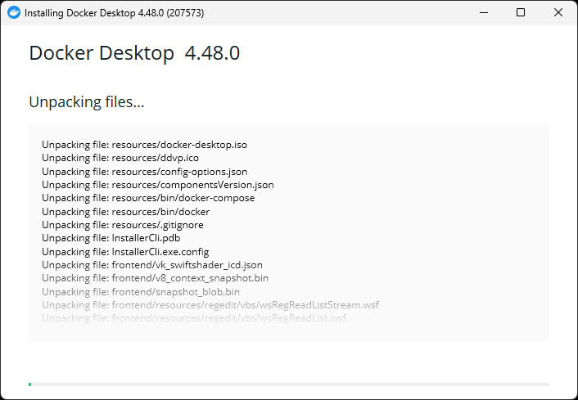

Visit hub.docker.com and register there

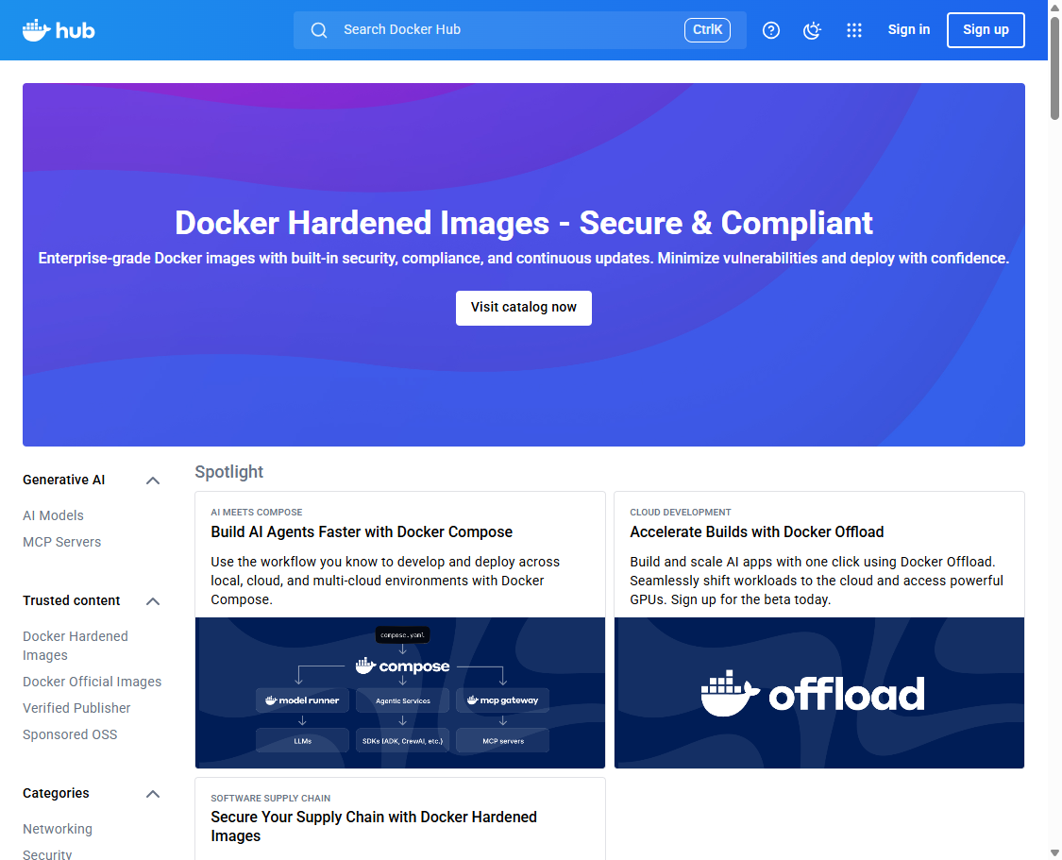

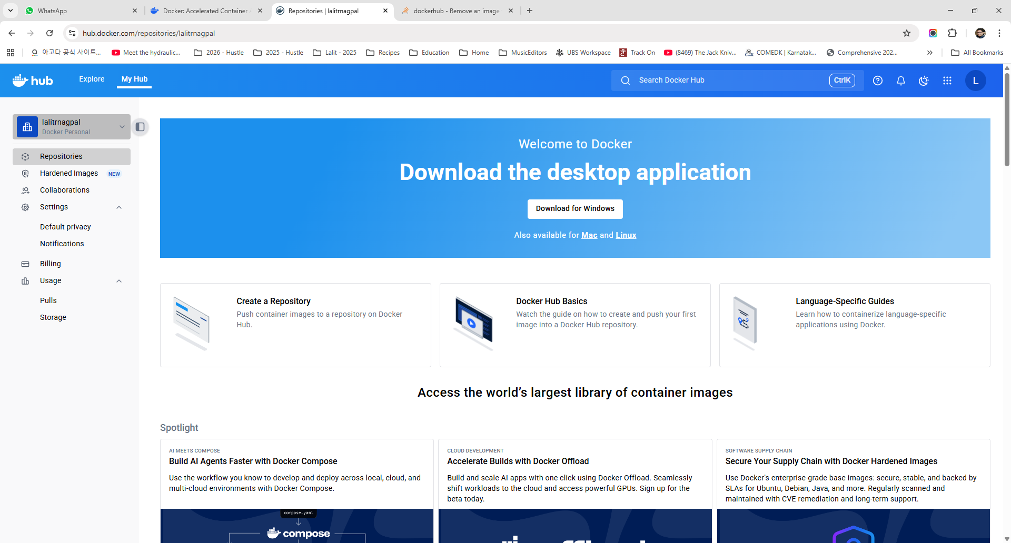

Docker Hub is a place where you can find that Docker images or you can also store your own Docker images with the public access and private access. If you want to store the Docker images with the private access, then definitely you need to upgrade your plan.

As of now, I'm using this personal plan which costs me $0.

So with this I can store Docker images in unlimited public repositories. We are good with this personal plan, but in real projects, since we want to store our Docker images in a secured manner, usually inside your organization they will provide a Docker login from any of these plans. Mostly business plan.

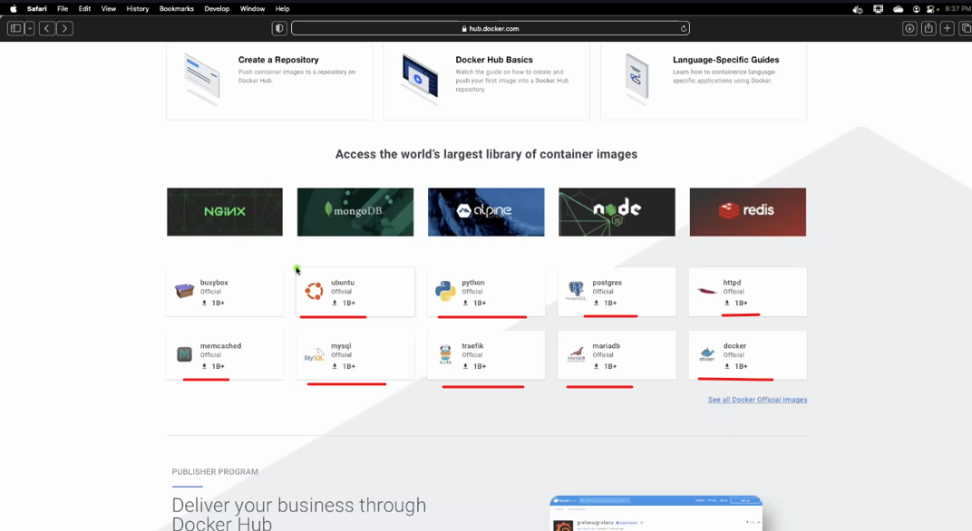

So if you try to MySQL Docker image, you can see this is the MySQL Docker image. There is also a tag docker official image 1 billion times download happen. So in order to get this Docker image inside your local system, you just need to run this command which is Docker pull MySQL will deep dive into all those commands, don't worry.

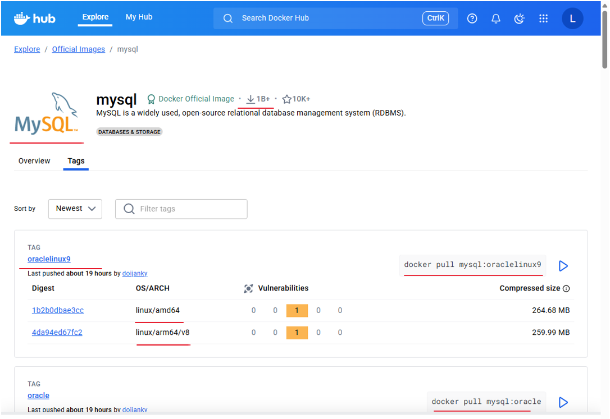

At the same time we can also find and fetch all the Docker images of other products that we want to use. If you want to use a database or if you want to use a server or if you want to use a language. So all of them are available as a docker Images inside this Docker hub. Once you install the Docker and created this Docker account, you need to click on this Docker icon available inside your local system. As of now you can see I have already logged in so I can click on this dashboard. So this is my Docker dashboard where you can see all my local Docker images, Docker containers, Docker volumes, will be using this Docker desktop a lot, but please make sure if you are not logged in already, you can click on this button at the top right corner where you can enter your credentials.

First start the docker desktop, you can see it auto logged in since I was logged-in to docker hub via the browser already.

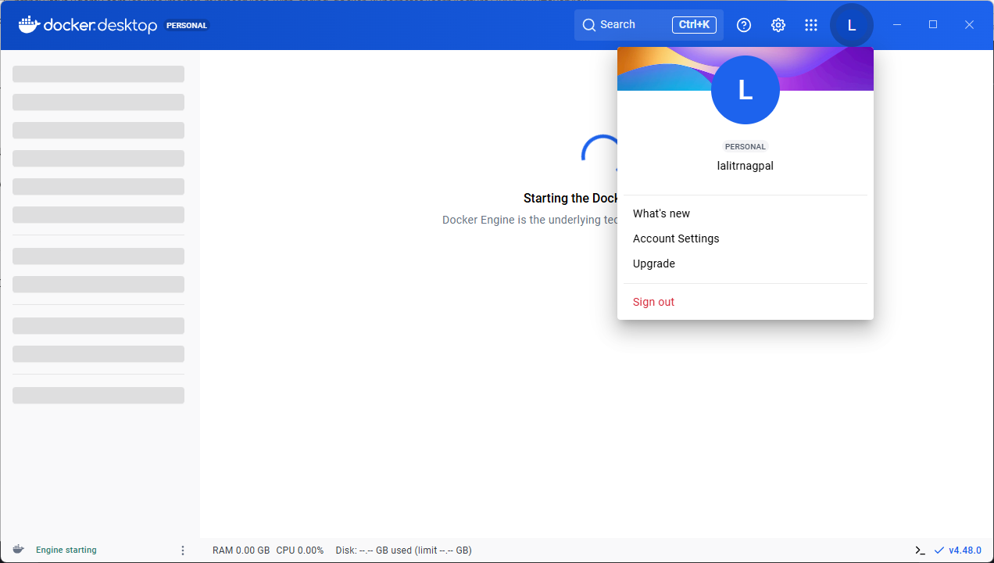

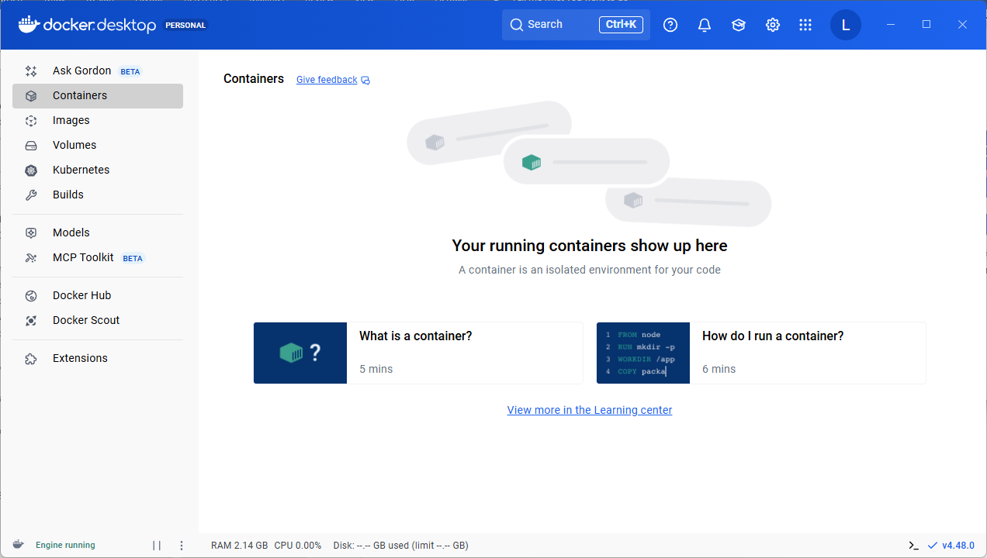

With that, your local docker is connected to the Docker hub repository that you have created with the same username, which in my case this is eazybytes. And you can also confirm the Docker installation is completed successfully or not by running a command inside the terminal. So here inside my terminal I'm running a command which is docker version. You'll be getting the version details about the client and the server.

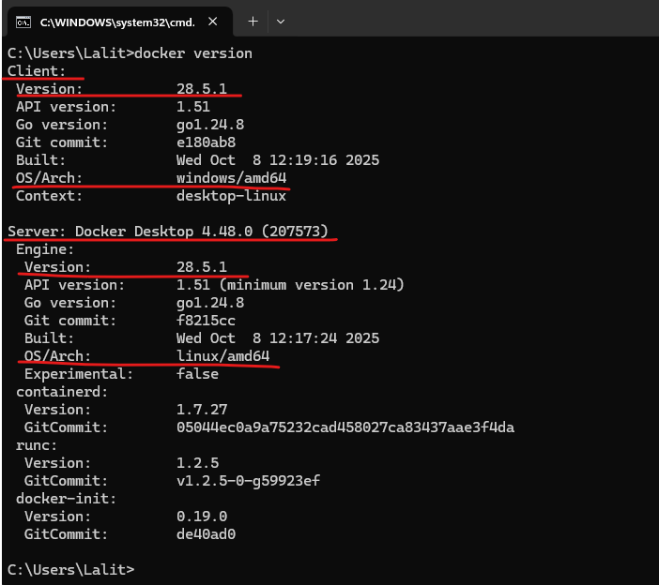

The client is using the operating system, which is Darwin, whereas the server, like we discussed it, is using the Linux. So inside my Mac operating system, whenever I try to install this Docker internally, it is going to create a small and lightweight Linux virtual machine. And inside that Linux virtual machine, the Docker server is going to be installed.

## Three Approaches for Docker Image generation



In order to generate a Docker image from a web application or a spring boot application, there are three mostly common used approaches inside the industry.

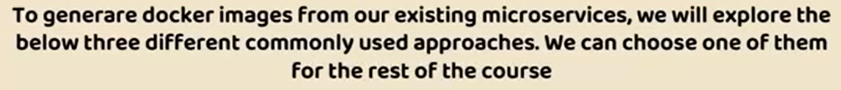

The very first approach is by following the Docker file.

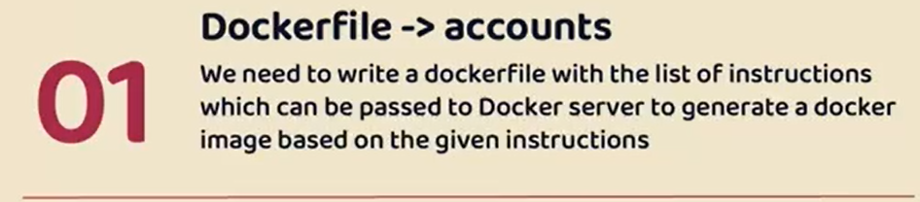

This is the most basic and the most traditional approach to generate a Docker image. Inside this approach, we need to write a set of instructions inside a Docker file and based upon these instructions, my Docker server is going to generate a Docker image. So this is the most basic approach, and this approach involves some learning curve of the Docker syntax and the Docker best practices. So I'll just give a quick introduction about this approach and using the same approach only we are going to generate a Docker image of Accounts Microservice.

The second approach that we have is Buildpacks.

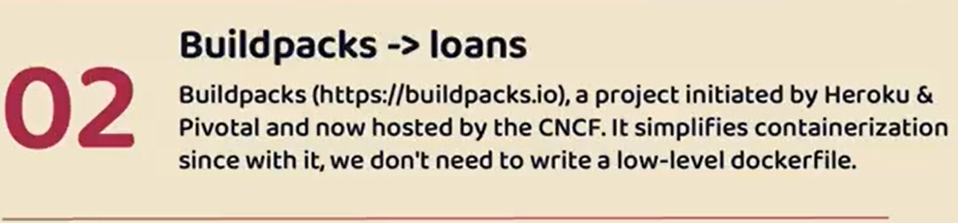

With the help of Buildpacks, we don't have to write any Docker file and we don't have to provide any instructions manually to the Docker server to generate a Docker image. Instead, with the help of a single Maven command, we can generate a Docker image and behind the scenes this maven is going to use the concept of Buildpacks. So Buildpacks is a project initiated and developed by Heroku and Pivotal based upon the best practices that they have learned over the years. So this Buildpack simplifies the containerization of our web applications. How it is going to simplify is we don't have to write any low level Docker file like in the first approach and using these approach only we are going to generate a Docker image of Loans Microservice.

Now the last approach that we have is Google Jib.

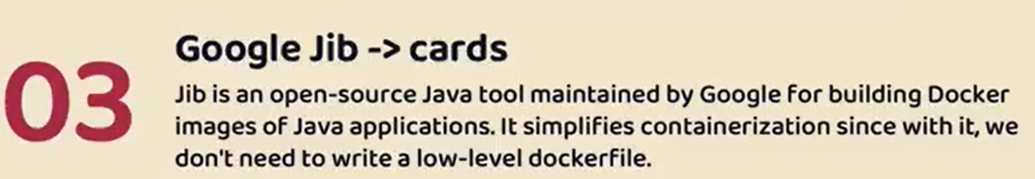

Google Jib is a product developed by the Google itself. Later on they open source this Java tool using this Java tool, and with the Maven plugin command, we can generate a Docker image of any Java application very easily without writing any low level dockerfile like in the first approach. So all these approaches, they have their advantages and disadvantages. I'm going to discuss in detail while we are discussing each of these approach. So using this Google jib approach only, we are going to generate a Docker image of Cards Microservice. Here, you may ask me a question like since there are three different approaches, is that the reason why I'm building three different microservices like Accounts, Loans and Cards? Off course not. That's simply a coincidence. I have developed three different microservices inside a BankApplication and luckily there are three different commonly used approaches to generate Docker image from a Spring boot web application. So that's why, like you can see, I have given a mapping of each approach to a microservice. But by the end of this section, like I said, we are going to select one of these approach and we are going to follow the same throughout this course.

### Dockerfile

#### Dockerfile for Accounts Microservices

Now since we are into a new section, which is section 4, I'm going to copy the same section two code and paste the same inside the same folder. Post that I'm going to rename this section 2 to section 4. . There is no code related to section 3, because Section 3 is a theory section where we have discussed about how to rightsize our microservices and how to identify service boundaries for microservices. This will give me a flexibility to upload all this code based upon section and in an incremental manner. So whatever code that you are going to find inside these Section 4 is an continuation of the previous section, which is section 2.

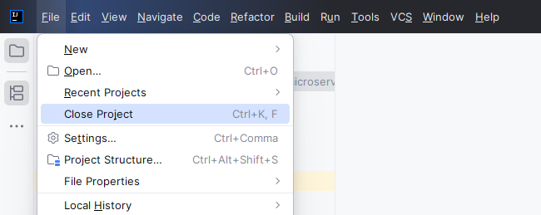

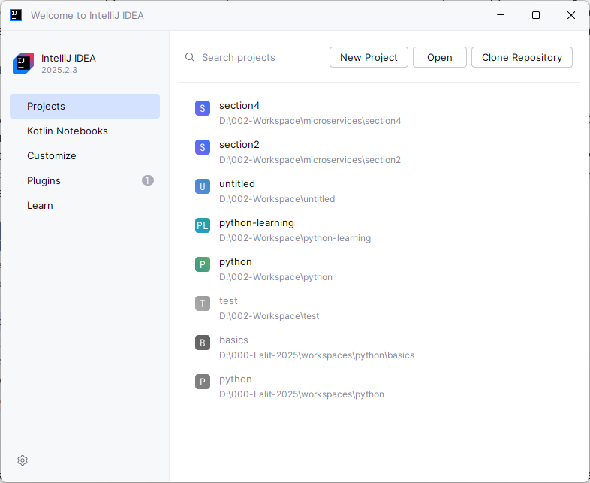

I have copied the section2 folder as section4 via explorer, it shows me the module name still as section2, so renaming that

|  |  |
| --- | --- |
| Rename the module | Check all the 3 projects build fine, they do. |

So this will allow me to upload the code at regular milestones. And this also give flexibility to the students like you to understand what changes I have done inside a specific section to overcome a challenge. So that's why I have created a new folder inside my workspace with the name section 4. Now let's try to import these into my IntelliJ idea. So here I'll click on this open option and post that I'll go to the workspace location like storage, workspaces, Micro Service and section 4. After selecting the Section four, I'm going to click on this open. This will open all three projects inside my Section 4. And these projects are accounts, loans and cards. **You can see here inside the bracket, it is showing section 2.** This is because we also copied the settings related to IntelliJ idea. So let me close this. Post that I'll go to my folder location here under the section 4 if I try to look for the hidden folders, there is a hidden folder with the name .idea which has settings from the previous section. So I'm going to delete this folder. Now if I try to open this section four inside my IntelliJ idea, it is going to create new settings for this folder. So let me click on this open and I'll make sure I'm selecting Storage, Workspace, Microservice, section4 and clicking on this open.

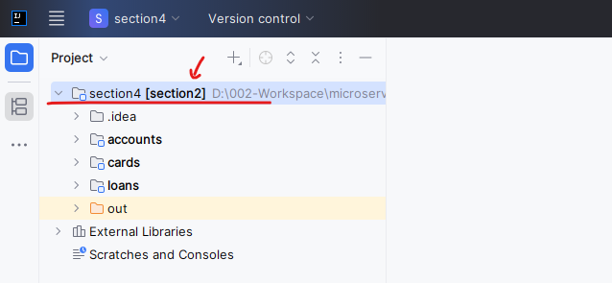

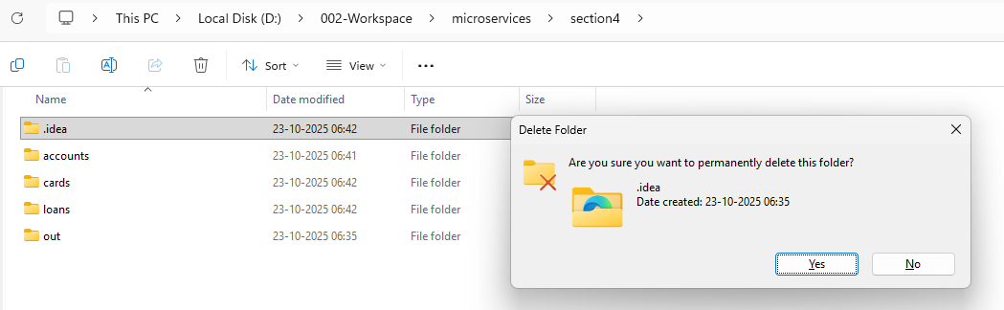

Now, we should not be having any problem. It will also ask you to load all the maven build scripts like you can see, so please make sure you are clicking on this load button. Then only it is going to recognize all your projects as a maven project and you should be able to see all those Maven projects under this Maven tab.

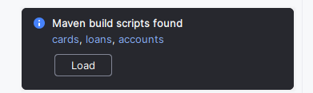

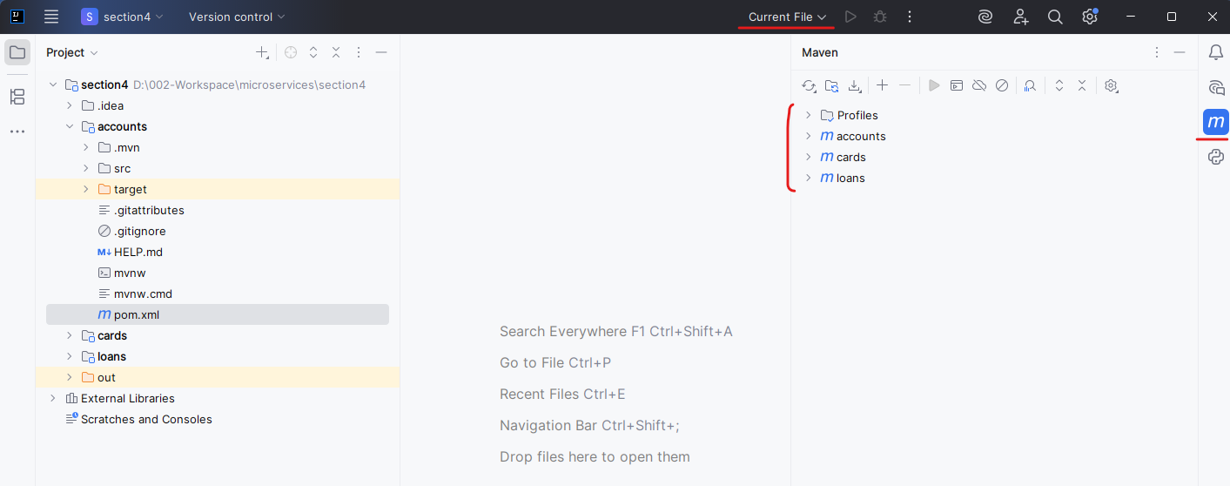

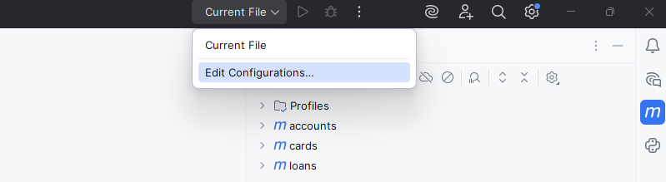

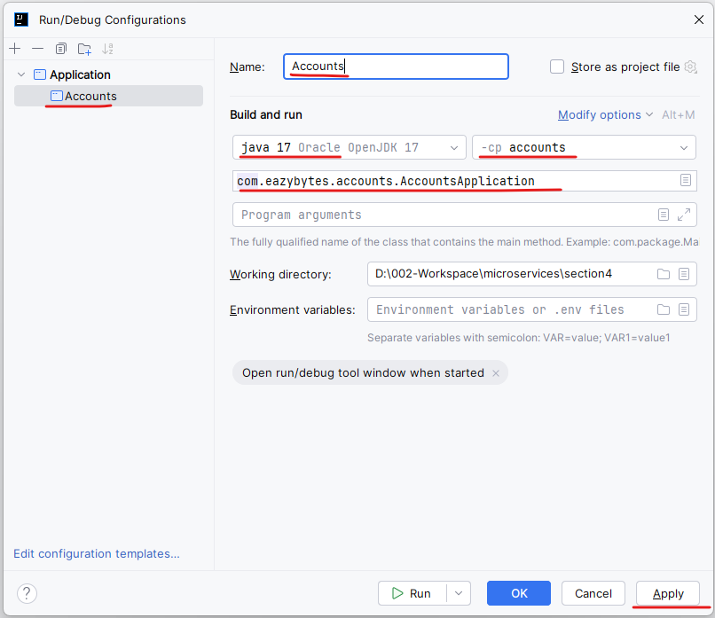

So there are three different Maven projects with the name account, cards and loans. Now, as a next step, since we are trying to focus on accounts microservice to generate a Docker image with the approach 1, I will go to the accounts microservice and open the pom.xml. Here you need to make a small change just after this version. Please make sure you are mentioning the packaging as jar. So since we want to generate Docker images for our accounts microservice or any other microservice, we need to make sure we are mentioning this packaging as jar. This tells to my maven that I want to package my web application in a jar format. Similarly, we can also package in a War format by giving war, but jar is a good format that we can follow whenever we want to generate a Docker image. So that's why I'm going with this jar.

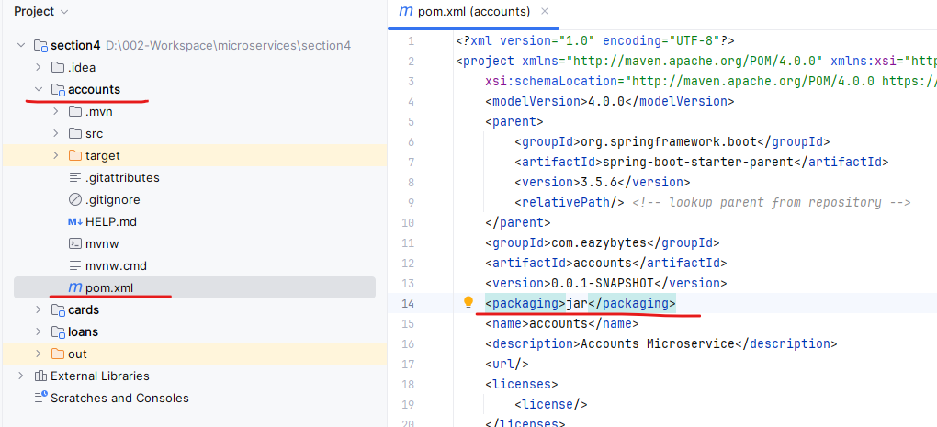

Once we make these changes as a next step, let me show you few Maven commands and Java commands that will help you to understand how our applications are going to be compiled, once we are clear with these maven commands and how the packaging of the spring boot application is going to happen using the same knowledge, we are going to provide the instructions inside a Docker file. So first I'll go to my target folder of accounts microservice. First, I'll try to delete all the existing compiled classes of accounts Microservice. As of now you can see there is no jar file inside the target folder. There are only compiled classes and folders available, so let me try to delete the content inside the target folder.

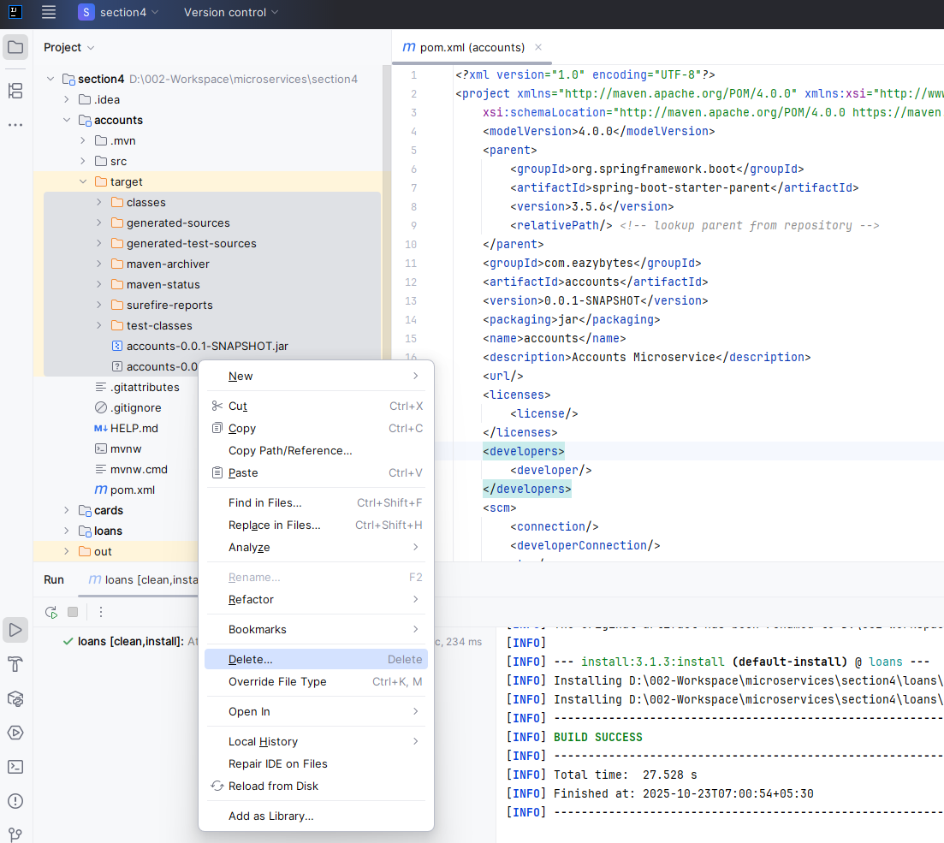

|  |  |
| --- | --- |
|  | Now I'll go to my folder location. Here I'll open the section 4 and right click on this accounts and open my terminal at this folder by choosing this option new terminal at folder. So you can see right now my terminal opened at accounts folder. |

If I try to run the PWD command which will print the present working directory. So this is the present working directory and a section 4 I have accounts microservice. In other words, you need to open your terminal or command line under the folder location where your pom.xml is present.

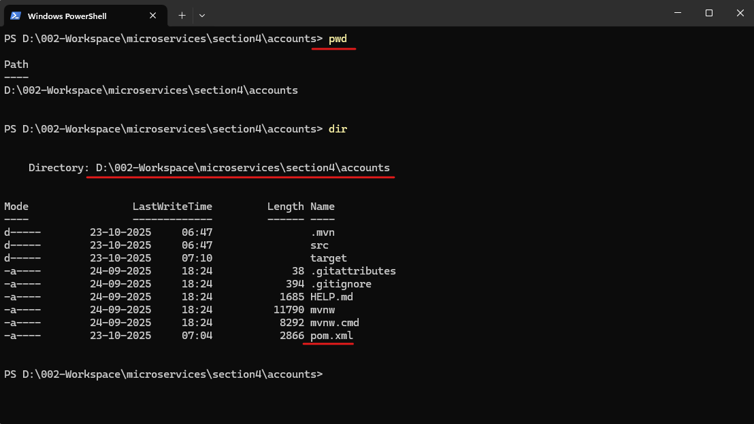

If you see under my accounts microservice there is a pom.xml file is available. That's why I'm trying to open the terminal inside my accounts folder. So now I'll run a maven command, which is mvn clean install. But before that, please make sure Maven is installed inside your system and you have set up the Maven home path. Since this is very basic, I'm not covering about how to install Maven and set up the Maven home path. This is very similar to Java installation and setting the Java home path in order to confirm whether the Maven is installed inside your system or not, you can run a command which is mvn - version. This will give you which version of Maven is installed inside your system. So like you can see Apache Maven 3.8.6 is installed inside my system.

PS D:\002-Workspace\microservices\section4\accounts> mvn --version

Apache Maven 3.9.11 (3e54c93a704957b63ee3494413a2b544fd3d825b)

Maven home: C:\software\apache-maven-3.9.11

Java version: 17, vendor: Oracle Corporation, runtime: C:\software\open-jdk-17

Default locale: en_IN, platform encoding: Cp1252

OS name: "windows 10", version: "10.0", arch: "amd64", family: "windows"

PS D:\002-Workspace\microservices\section4\accounts>

So regardless of what version you are using, please make sure this output is printed. Now as a next step, I'm going to run a command which is Maven clean install using this command. I'm telling to my maven to compile my spring boot application with the name account. So inside this accounts folder there is a file called pom.xml. If you can go to the pom.xml towards the end If you go there is a build related configurations that are available. There is a spring boot maven plugin is already configured inside our pom.xml, so please make sure these configurations are available. Now, if I try to run this maven clean install behind the scenes, my maven is going to compile my accounts microservice and it will also do a small basic unit testing. And if the unit testing is successful, it is going to generate a jar. If you see it has done some unit testing and there are no errors. That's why my build is successful.

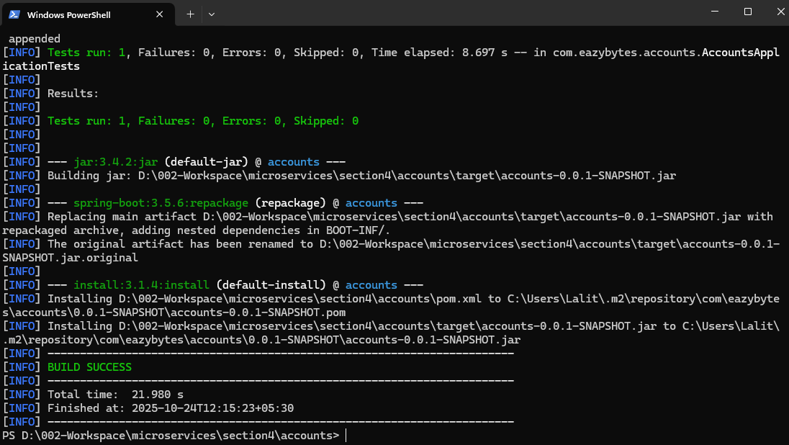

Now if I try to go and check my accounts target folder under this target folder, you'll be able to see a jar generated with the name accounts-0.0.1-snapshot. So this is a jar of around 54 MB. We call this jar as a fat jar inside spring boot because inside this fat jar it is going to have all kind of dependencies except Java runtime. So it will have all the spring boot libraries, it will have embedded Tomcat server. So all the dependencies related to accounts microservice is going to be available inside this jar except Java libraries. You may have a question here like how this name is coming.

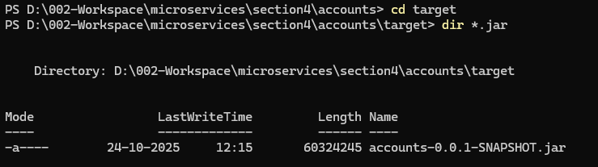

If you go to your pom.xml here, the artifactId is accounts. The version comes by default 0.0.1-snapshot. If needed you can change this value. So based upon the combination of this artifactId and version, the jar name will be derived. Please make sure you're also following the same artifact like me, so that any issues that you may face, you can always try to compare my code with your code. And if you still not able to identify the root cause of your issue, you can always share your code with me. And if you follow the same naming conventions like me, then my job is going to be super, super easy and I can respond to you as soon as possible.

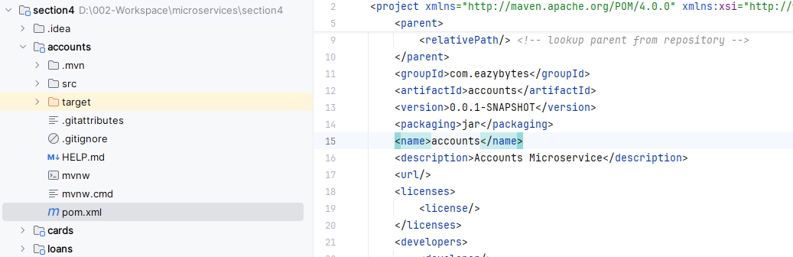

So now we have the jar generated for this spring boot application. My entire spring boot application are my entire microservice application with the name accounts is right now available in the format of this jar present inside the target folder. Now, with the help of this jar, I can try to start my spring boot application using a maven command. For the same, first, let me clear the console and I'll run a command which is mvn spring-boot:run. When I try to issue this command, which is spring-boot:run behind the scenes inside my pom.xml since I have a plugin with the name Spring Boot Maven plugin, this plugin is looking for a jar inside my target folder and using the same jar. It is going to start my web application.

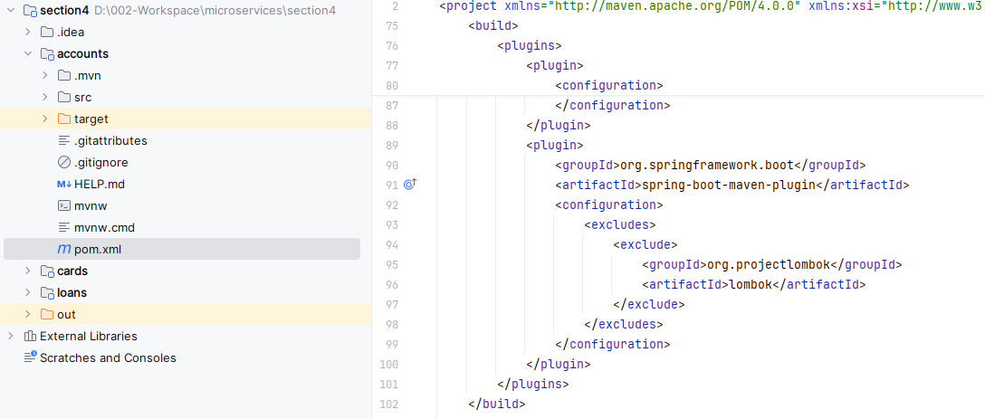

Let's try to validate the same. So as soon as I execute this command you can see my spring boot application is being started and it started at the port 8080.

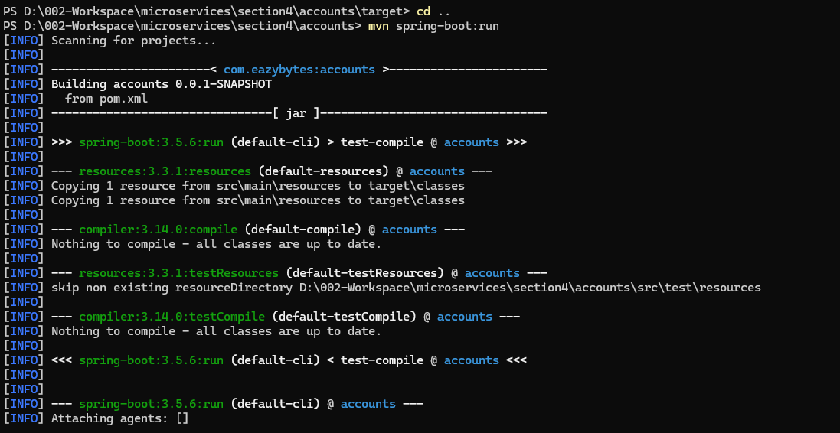

If port is already in use

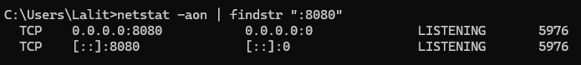

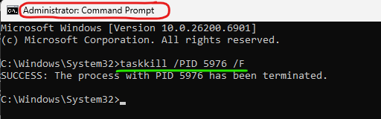

I can also test my accounts microservice for the same here inside my postman. I'm going to create an new account by passing a request. You can see I'm getting a successful response. I can also try to run one more API, which is fetch API and you can also see I'm getting a successful response. So this confirms our Accounts microservice is successfully started with the help of a Maven command. Now let me stop my accounts microservice by pressing control C. You can also try to press control C together and that will stop your running instance inside your terminal. Now I'm clearing the console. This time I'm going to show you a Java command instead of a Maven command. Since inside Docker image, we don't want to unnecessarily install the Maven. So that's why I'm going to show you how to run your spring boot application with the help of a Java command. The command is java -jar and my jar is present inside the target folder. That's why I need to give this target/ and the jar name is accounts 0.0.1-snapshot.jar.

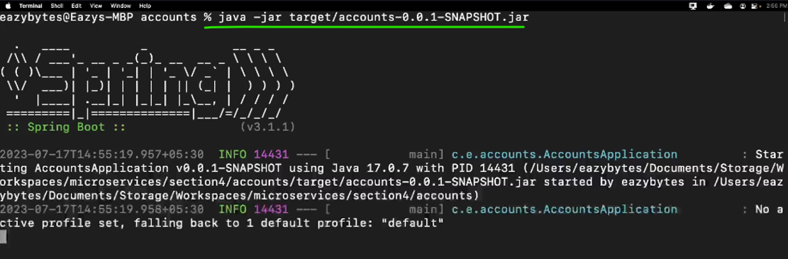

So this is the command that I'm trying to execute Whenever I try to run this Java command, you can see the same effect. Like my web application will start at the port 8080. The reason why I'm trying to show a demo of all these commands is, this knowledge is going to help you to write a Docker file.

Let's try to write a Docker file for our accounts Microservice. make sure you also started the Docker.

You can see my docker is already running. Now as a next step, like I said, first we need to create a Docker file. So right click on your Accounts Microservice folder and select the new file option. The file name has to be Docker file. Please make sure you are following the exact file name because Docker will look for the exact file with the name Docker file and this should not have any extension. That's why I don't give .txt or .xml or .yml. There is no need of any extension.

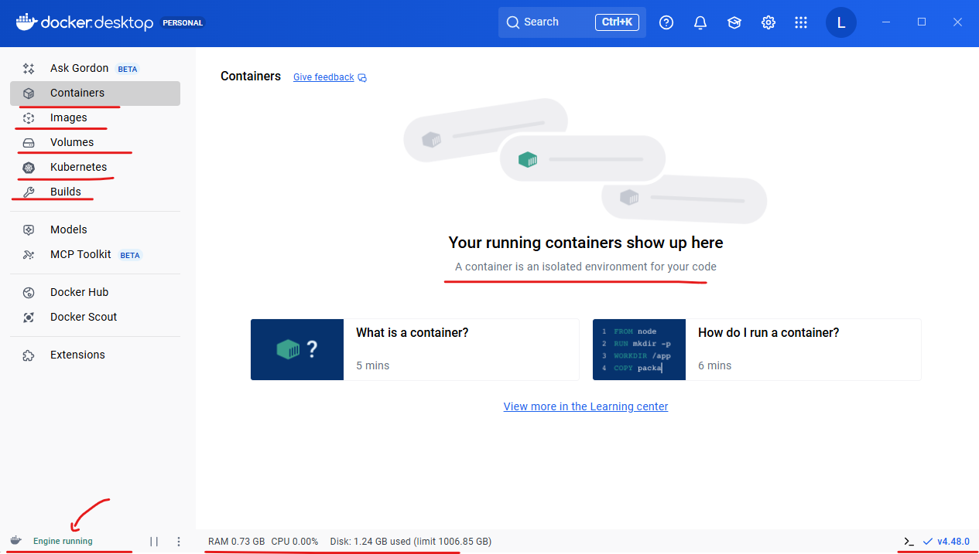

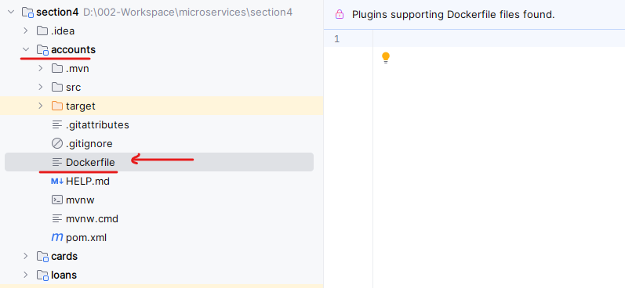

You can simply create a docker file without any extension with a name docker file. So I'm just pressing enter now inside this docker file, we need to write instructions that can be used to generate a Docker image for my Accounts Microservice. In order to run my Accounts Microservice, any time whenever I want to run my Accounts Microservice, the very first basic requirement that I have is to install JRE or Java inside any system. That's why I should communicate the same to my docker, saying that my accounts docker image has a dependency on Java for the same, we are going to use a keyword from inside the docker using this from command, we are telling to Docker that my Docker image has a dependency on some other Docker image, so please import this base image into my Docker image. Whenever you are trying to generate a Docker image of my Accounts Microservice. So that's what we are trying to tell with this from command. So to this from command, we need to provide the base image inside this scenario, the base image is java for the same I'm going to mention openjdk: and post that I'm also going to tell what is the tag of that Docker image. So this is the image name like which is Open JDK and this is the tag name which is 17-jdk-slim. . Make sure there is a colon between Docker image name and the tag, tag is very similar to version. Since I want to use Java 17 version, I'm providing this 17-jdk-slim.

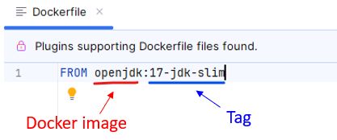

You can also search for these Docker image inside the Docker hub. So this is my Docker hub.

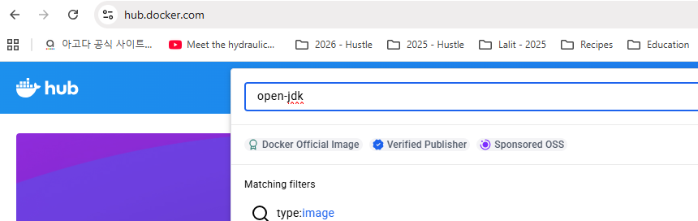

If I try to search for open JDK, you can see there is an Docker official image with the name Open JDK. Let's try to click on that.

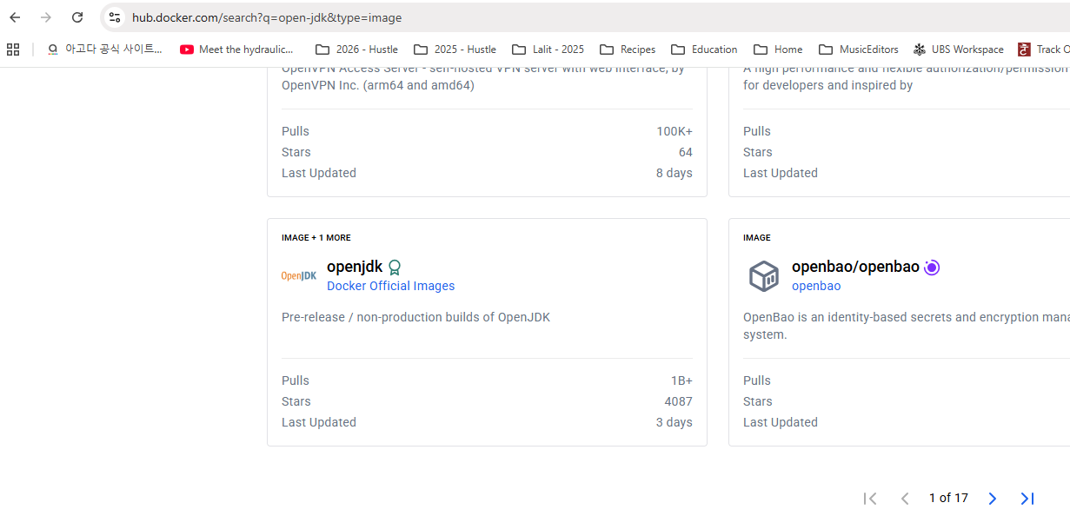

So whenever I want to use this Docker image as a base image for my own microservice, then we need to make sure we are providing the same Docker image name, which is open JDK. And if you click on this tags, there are many versions of Open JDK available with different, different tag names. So if you use this 22-slim-bullseye, you are going to use Java 22 version. So since we decided to use 17 version, I'm going with a tag which is 17-jdk-slim.

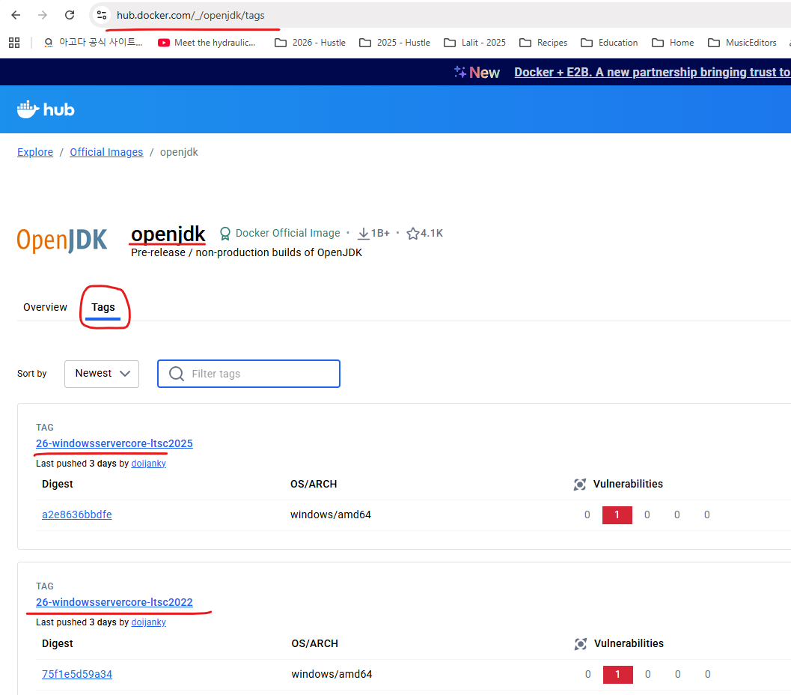

So let me also provide some comments here. So I just provided a comment saying that start with a base image containing Java runtime. So this is the base image for our accounts microservice. Post that I'm going to give a line space and this time I'm going to invoke a keyword which is maintainer. Using maintainer, we can provide the details of who is maintaining this docker image. So for now I'm just going to mention easybytes.com, so please make sure there is a space between maintainer and this easy bytes.com. So this tell to anyone who is trying to use my docker image that so and so person or so-and-so domain is the maintainer of the docker image that we are going to create. Now I'm going to provide a copy command post this copy command, I'm going to give a space and mention target folder and inside this target folder I have accounts-0 0.1-SNAPSHOT.jar. And I'll give a space and again I'm going to mention the same jar which is accounts-0.0.1-SNAPSHOT.jar.

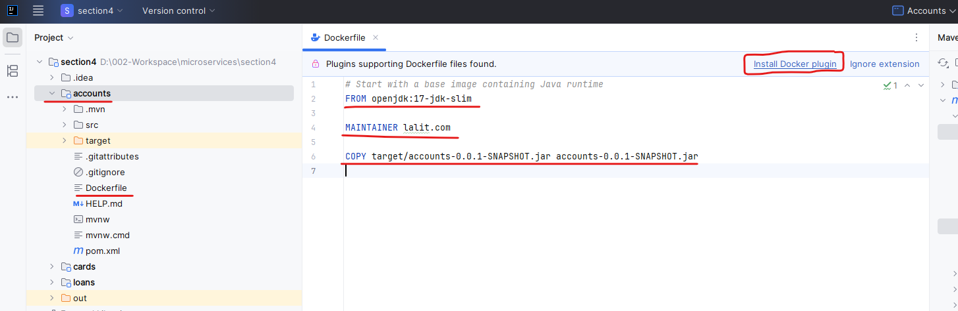

Dockerfile

# Start with a base image containing Java runtime

FROM openjdk:17-jdk-slim

MAINTAINER lalit.com

COPY target/accounts-0.0.1-SNAPSHOT.jar accounts-0.0.1-SNAPSHOT.jar

With this, what I'm trying to tell to my Docker server is, there is a jar inside my target folder with this name. So if you see this docker file is present inside my accounts project and inside the same accounts project, there is a target folder. Inside this target folder we have a jar. So this is the jar. So that's what I'm trying to say, please take the present inside my target folder and copy the same jar into my Docker image. When we generate a Docker image, it is going to have all the dependencies in a packaged form. So one dependency that we have is open JDK and the other dependencies that we have is accounts jar. Inside this account jar only, we have all the business code, all the boot related libraries. So we are trying to copy this from our local machine to the Docker image that is going to be generated. And at last we need to provide a command which is entry point. So please make sure you are also following these capital letters. So with these entry point, what we are telling is whenever someone is trying to generate a container from my docker image, please execute. So on, so command. So to this entry point. First I need to provide the square brackets and inside this square bracket I am going to provide multiple commands which is java again, double quotes hyphen jar post that comma and at last what is the jar name that I have, which is accounts-0.0.1-SNAPSHOT.jar. So this is I'm going to copy and mention here.



If you see this is the same command that we have used to start our spring boot application with the Java Command. So this is a command that we have used like Java Hyphen Jar and previously Account Jar is present inside the target folder. That's why we have given target folder. But inside my Docker image it is present inside the root folder location only. That's why I don't need to provide target. And the reason why I have to provide all these commands separately in the double quotes comma separate is, since there is a space after each command, we need to follow this syntax whenever we are trying to give command instructions with the help of this entry point.

So behind the scenes, whenever I try to generate a Docker container from my Docker image, my Docker server is going to execute this command, which is java -jar and it is going to use this jar. So this is the Docker file that we have written. With this Docker file, now we should be able to generate a Docker image successfully. Before I try to do that, let me try to mention comments for your reference here. So on top of my engineer , I'm going to mention comments saying that information around who maintains the image. Similarly, on top of this copy command I'm going to mention add the applications jar to the image our application jar, we are copying to the image. And at last, on top of this entry point I'm going to mention, which is execute the application.

**Dockerfile**

# Start with a base image containing Java runtime

FROM openjdk:17-jdk-slim

#Information around who maintains this image

MAINTAINER lalit.com

# Add the applications jar to the image

COPY target/accounts-0.0.1-SNAPSHOT.jar accounts-0.0.1-SNAPSHOT.jar

# Execute the application

ENTRYPOINT["java", "-jar", "accounts-0.0.1-SNAPSHOT.jar"]

So now we have written successfully a Docker file in the next lecture using this Docker file, let's try to generate a Docker image.

Now we have this Docker file ready inside our accounts microservice. As a next step, we need to provide this Docker file to our Docker server. And with that my Docker server is going to generate a Docker image of accounts microservice by following all these instructions.

Inside your terminal. First, make sure you are running the Docker version command. This will make sure the Docker is installed and it is also started properly inside your local system. So both this is the client version and this is the server version that I have running inside my system.

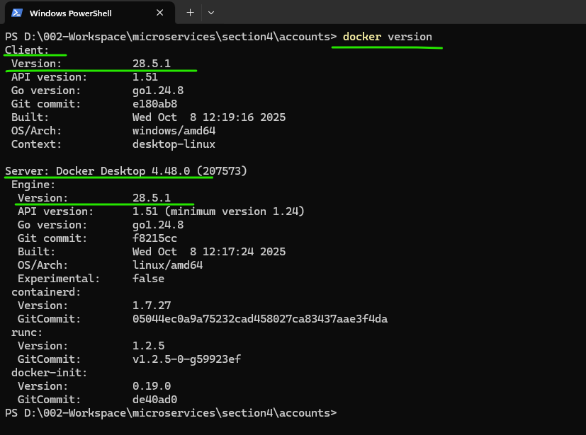

As a next step, we need to make sure you are running a Docker build command. The Docker Build command is docker build. Since my Docker file is present inside the same folder location of accounts from where I'm running this command, I don't need to provide any file name or any folder path, but if your Docker file is present inside some other folder, then you need to provide that exact path.

Since inside my scenario the Docker file is present inside the same folder. I need to give this dot symbol post that I'm going to do a space followed by -t, the t indicates tag. After this tag we need to give what is a Docker image name that we want to consider for our Accounts. Microservice. So whenever you are trying to give a Docker image name, you need to follow a standard format. The format is first, we need to make sure we are providing the Docker account username. So the Docker account username is eazybytes, so please make sure you are also providing your own Docker account username. Post that, what is the name that you want to give for your Accounts Microservice. So the name that I want to give here is accounts followed by Colon and what is the version are the tag name of your Docker image. So right now I want to give as S4, S4 for indicates section for since we are into a section 4, I'm going to create a Docker image with the tag name and version name as S4.



PS D:\002-Workspace\microservices\section4\accounts> docker build . -t lalitrnagpal/accounts:s4

And this lalitrnagpal is my docker account username which I have created inside my Docker hub. If you see here, this is my docker username that you can see inside hub.docker.com. So you need to make sure you are giving your own username because we have the intentions to store all our Docker images inside this Docker hub. That's why we need to give our username as well, which will be helpful for us in future when we are trying to push our Docker images. If you don't give your Docker username then it's going to create some problems, whenever you're trying to store your Docker images inside the remote repository. So that's why please make sure you are providing this prefix which is your Docker account username followed by slash, followed by what is your microservice name, which is accounts followed by colon and S4, S4 is a tag name or the version number that I'm considering here So with this Docker build command we are telling to Docker server, there is a Docker file inside this folder. Please use that instructions and generate a Docker image with the name eazybytes/accounts:S4.

So this is my CLI. So since I'm using command line interface, this is my docker client or docker CLI from the CLI I'm giving instructions to my Docker server running inside my local system. So let me execute this command. With that, you can see behind the scenes my Docker server is trying to generate a Docker image. The very first step that it has done is it downloaded the base image which is openjdk17-slim from the remote repository which is docker.io library. So once it downloaded that base image post that only it is going to look for the next instructions. So let this download complete When you are running this Docker build command, please make sure your Docker server is running. Otherwise your Docker build command is not going to work.

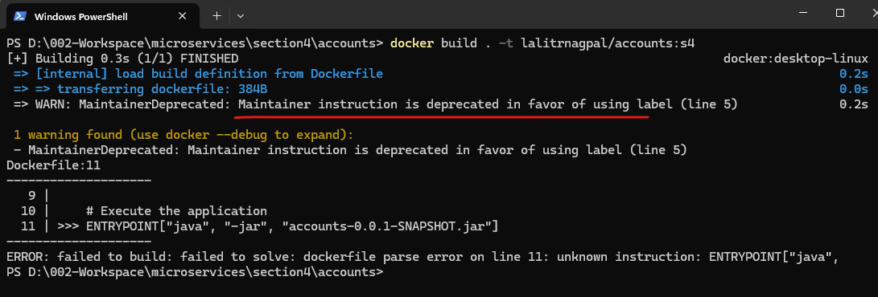

**Dockerfile**

# Start with a base image containing Java runtime

FROM openjdk:17-jdk-slim

#Information around who maintains this image

LABEL maintainer=lalit.com \

version=s4 \

description="Accounts Microservice"

# Add the applications jar to the image

COPY target/accounts-0.0.1-SNAPSHOT.jar accounts-0.0.1-SNAPSHOT.jar

# Execute the application

ENTRYPOINT ["java", "-jar", "accounts-0.0.1-SNAPSHOT.jar"]

Not only Docker build any other command that you are going to run will only work if your Docker server is running inside your local system. So now you can see my Docker image is generated with the name docker.io/eazybytes/account/S4.

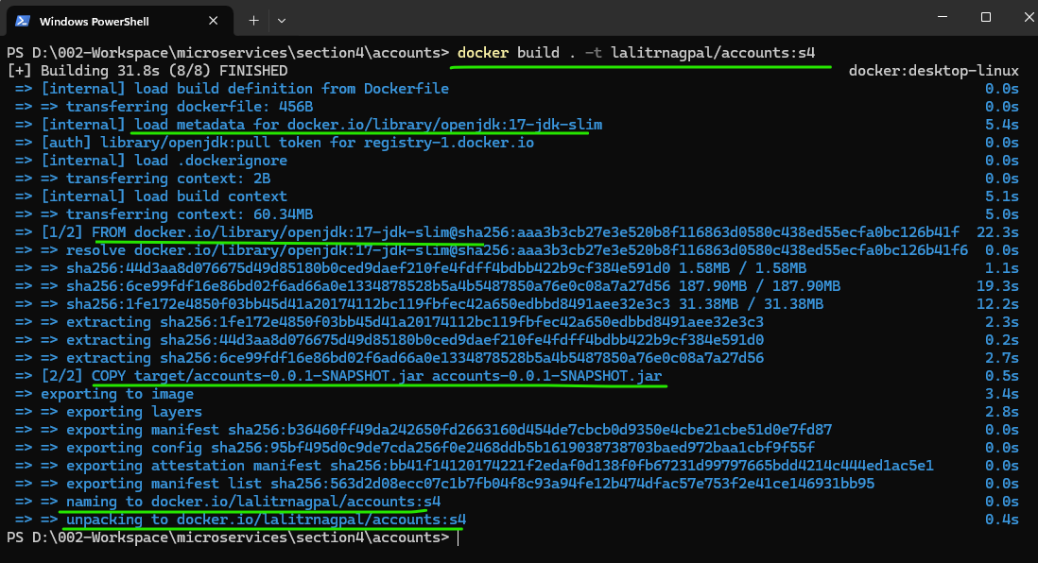

You can also see the steps that it has followed. In the very first step, it downloaded the base image, which is open JDK and in the second step it copied the accounts jar from my local system inside the target folder into my Docker image.

So now if I try to execute a command which is Docker images, this will list all the images right now inside my local system. Here you can search for a Docker image with the name accounts. So there are many other Docker images inside my system. You may not have such images inside your system. Don't worry. The main image that you need to look is accounts. So if you see this is the Docker image that I have generated with the name accounts and the tag is S4 .

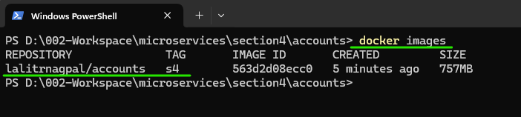

This is the image ID and it is created a minute ago and the size it has is 456 MB. If I try to inspect this image by running a command docker inspect image. And what is the image ID. The image ID, this is the image ID, you don't have to mention the entire image ID.

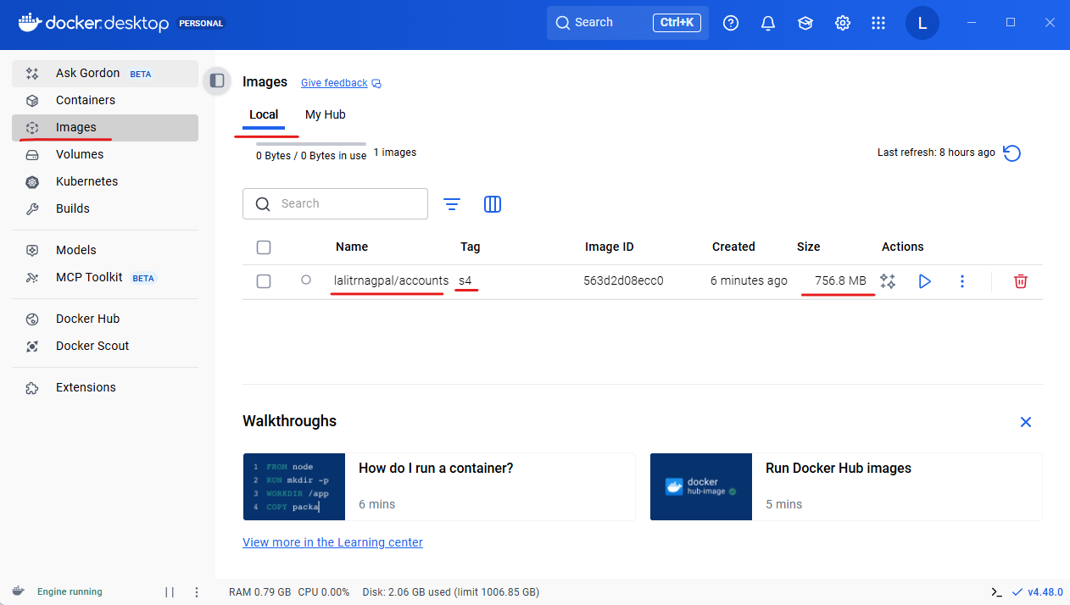

Instead, you can simply mention the initial few 3 or 4 characters.

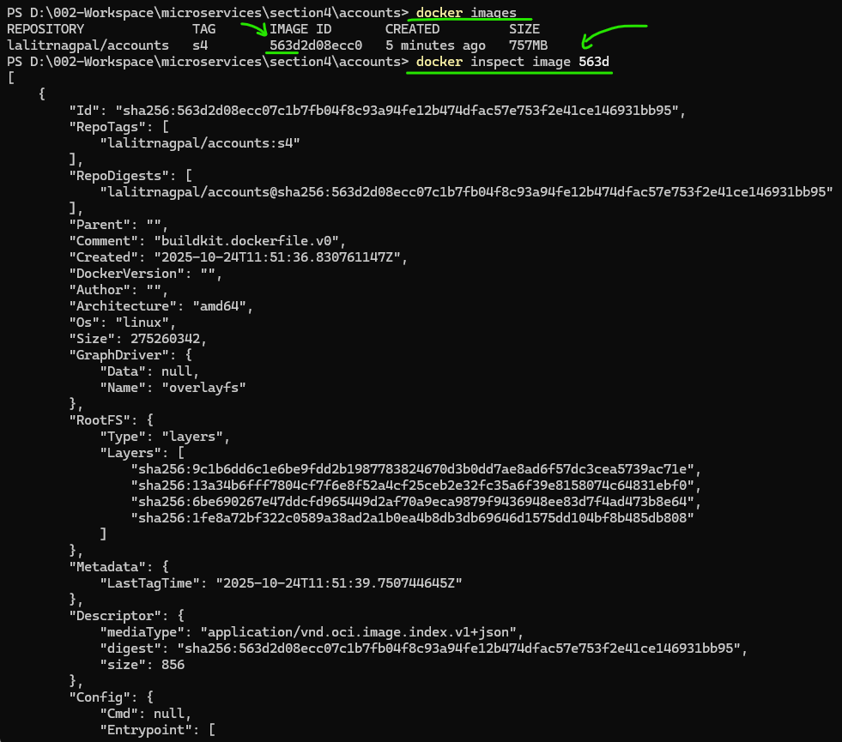

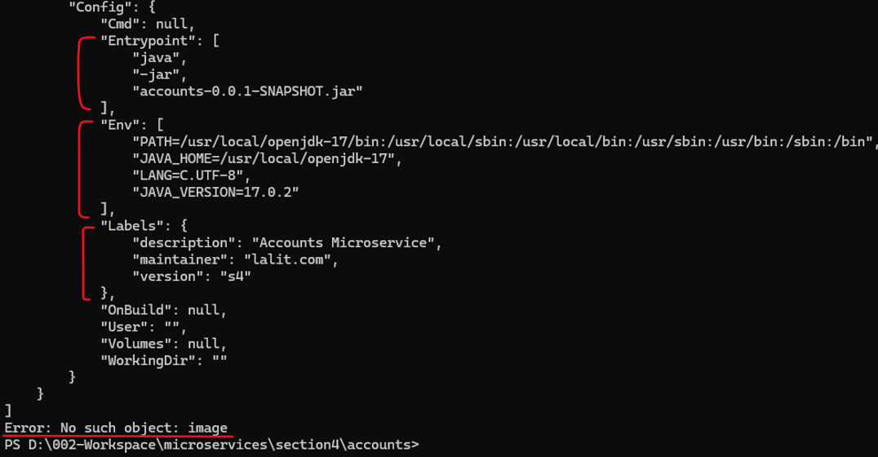

So I'm just mentioning the same and trying to run this. So if you try to see the inspect command, you'll get all the details about your Docker image. So there'll be some interesting information inside this output. First is the author is eazybytes.com, which is coming from the maintainer and post that you can see. The JAVA_HOME is set to the open JDK 17 because we have mentioned that base image as open JDK 17. So behind the scenes since your accounts microservice need JAVA_HOME to be set and all that is taken care by the Docker server during the Docker image generation. And at last you can see the entry point to generate a container from your docker image is java_jar and this is the accounts related jar. So we provided this information also inside our Docker file and the operating system is Linux. Like I said, all the Docker concepts are going to work based upon the Linux concepts like namespaces and control groups. So that's why behind the scenes it is going to follow the Linux operating system only. So these are important information that you can see. You can also explore more details about your image from your Docker desktop. If you go to the Docker desktop and click on this images, there is a image with the name accounts.

PS D:\002-Workspace\microservices\section4\accounts> docker build . -t lalitrnagpal/accounts:s4

[+] Building 1.6s (7/7) FINISHED docker:desktop-linux

=> [internal] load build definition from Dockerfile 0.0s

=> => transferring dockerfile: 484B 0.0s

=> [internal] load metadata for docker.io/library/openjdk:17-jdk-slim 1.3s

=> [internal] load .dockerignore 0.0s

=> => transferring context: 2B 0.0s

=> [internal] load build context 0.0s

=> => transferring context: 84B 0.0s

=> [1/2] FROM docker.io/library/openjdk:17-jdk-slim@sha256:aaa3b3cb27e3e520b8f116863d0580c438ed55ecfa0 0.0s

=> => resolve docker.io/library/openjdk:17-jdk-slim@sha256:aaa3b3cb27e3e520b8f116863d0580c438ed55ecfa0 0.0s

=> CACHED [2/2] COPY target/accounts-0.0.1-SNAPSHOT.jar accounts-0.0.1-SNAPSHOT.jar 0.0s

=> exporting to image 0.1s

=> => exporting layers 0.0s

=> => exporting manifest sha256:51ae8d1242abf86f31dbec6f4c7771c65d1b174c496f4a6d5cb5c85efb95e861 0.0s

=> => exporting config sha256:9966441459d6cd6da7311cdcb54589df4759ff294c3bbc71b80c91a71a1e23cd 0.0s

=> => exporting attestation manifest sha256:97e2d326fd23425e4ccbe4596c3b1daf8b7bf32342d376464fcbcec6f2 0.0s

=> => exporting manifest list sha256:462f26de6f452519d18bc5e12e1d01d8506c5c33148812a57a43ee8e186d8d7a 0.0s

=> => naming to docker.io/lalitrnagpal/accounts:s4 0.0s

=> => unpacking to docker.io/lalitrnagpal/accounts:s4

0.0s

PS D:\002-Workspace\microservices\section4\accounts> docker images

REPOSITORY TAG IMAGE ID CREATED SIZE

lalitrnagpal/accounts s4 462f26de6f45 15 minutes ago 757MB

PS D:\002-Workspace\microservices\section4\accounts> docker inspect image 462f

[

{

"Id": "sha256:462f26de6f452519d18bc5e12e1d01d8506c5c33148812a57a43ee8e186d8d7a",

"RepoTags": [

"lalitrnagpal/accounts:s4"

],

"RepoDigests": [

"lalitrnagpal/accounts@sha256:462f26de6f452519d18bc5e12e1d01d8506c5c33148812a57a43ee8e186d8d7a"

],

"Parent": "",

"Comment": "buildkit.dockerfile.v0",

"Created": "2025-10-24T11:51:36.830761147Z",

"DockerVersion": "",

"Author": "",

"Architecture": "amd64",

"Os": "linux",

"Size": 275260384,

"GraphDriver": {

"Data": null,

"Name": "overlayfs"

},

"RootFS": {

"Type": "layers",

"Layers": [

"sha256:9c1b6dd6c1e6be9fdd2b1987783824670d3b0dd7ae8ad6f57dc3cea5739ac71e",

"sha256:13a34b6fff7804cf7f6e8f52a4cf25ceb2e32fc35a6f39e8158074c64831ebf0",

"sha256:6be690267e47ddcfd965449d2af70a9eca9879f9436948ee83d7f4ad473b8e64",

"sha256:1fe8a72bf322c0589a38ad2a1b0ea4b8db3db69646d1575dd104bf8b485db808"

]

},

"Metadata": {

"LastTagTime": "2025-10-24T12:07:04.859869318Z"

},

"Descriptor": {

"mediaType": "application/vnd.oci.image.index.v1+json",

"digest": "sha256:462f26de6f452519d18bc5e12e1d01d8506c5c33148812a57a43ee8e186d8d7a",

"size": 856

},

"Config": {

"Cmd": null,

"Entrypoint": [

"java",

"-jar",

"accounts-0.0.1-SNAPSHOT.jar"

],

"Env": [

"PATH=/usr/local/openjdk-17/bin:/usr/local/sbin:/usr/local/bin:/usr/sbin:/usr/bin:/sbin:/bin",

"JAVA_HOME=/usr/local/openjdk-17",

"LANG=C.UTF-8",

"JAVA_VERSION=17.0.2"

],

"Labels": {

"AUTHOR": "lalitnagpal",

"DESCRIPTION": "Accounts Microservice",

"MAINTAINER": "lalit.com",

"VERSION": "s4"

},

"OnBuild": null,

"User": "",

"Volumes": null,

"WorkingDir": ""

}

}

]

Error: No such object: image

PS D:\002-Workspace\microservices\section4\accounts>

So these are accounts image and the tag is S4. You can click on this name which will show all the layers available inside your Docker image. This confirms that our Docker image is successfully created based upon the Docker file that we have provided. Now we are ready to convert this Docker image into a Docker container. In the next lecture, let's try to generate a Docker container for our accounts microservice and try to test few scenarios.

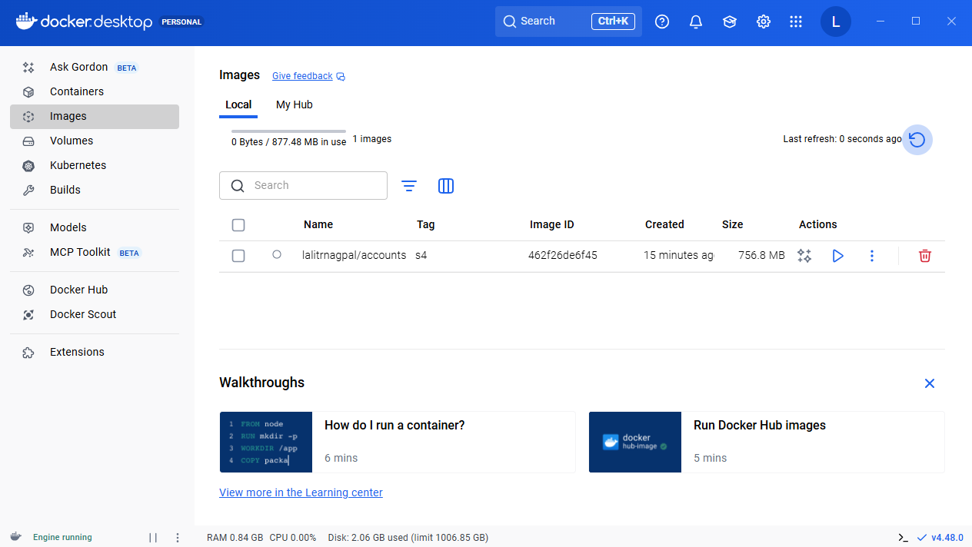

Don't worry about the Docker images. As you practice and run these commands multiple times, you're going to remember them easily.

#### Running Accounts Microservice as Docker Container

We build this Docker image with the help of Docker Build command. Very similarly, using Docker run command, we can run a container from our Docker image. So this Docker run command is similar to new Operator inside Java. Just like with the help of new operator, we can create any number of instances or objects of our class. Very similarly, with the help of this Docker run command, we can create any number of containers from our Docker image. After giving this Docker run command, we need to give -p, p indicates port with the help of this port, we need to provide a port mapping. Like I said before, by default, all your Docker containers, they are going to start inside their own isolated network and we can't access the services inside your Docker network because since it is deployed inside its own private network. So that's why not to get them access from the external network, like from your local system or from any other system, you need to expose them explicitly with the help of this port mapping. That's why here I'm going to give a port mapping, which is 8080 with the 8080. With this, what I'm telling to my Docker server is my Docker container is going to start at a port 8080. Like, you know, our accounts microservice is going to start at the port 8080. That's why we need to mention the port at which the container is going to start with the help of the second port. Whereas with this first port mapping, which is 8080 like I highlighted with that, we are telling to the docker, please expose the container to the outside of the Docker network at the port 8080.

PS D:\002-Workspace\microservices\section4\accounts> docker run -p 8080:8080

So anyone who wants to communicate with this container from outside of the Docker network, they have to use a port which is 8080. So here, just to avoid confusion, I'm using the same port number like where the Docker container is going to start. So once we provide these port mapping, we need to provide what is a Docker image name. So from which Docker image name, we want to create a Docker container. So the Docker image is eazybytes/accounts:S4. So this is a complete Docker image name.

PS D:\002-Workspace\..\accounts> docker run -p 8080:8080 lalitrnagpal/accounts:s4

So as soon as I try to execute this command, you can see my Docker container is being started, which means my accounts microservice behind the scenes is getting started at the port 8080 and with this we are able to successfully start our Docker image as a Docker container. I can also go to the postman and try to validate this container, here I'm trying to invoke this create API.

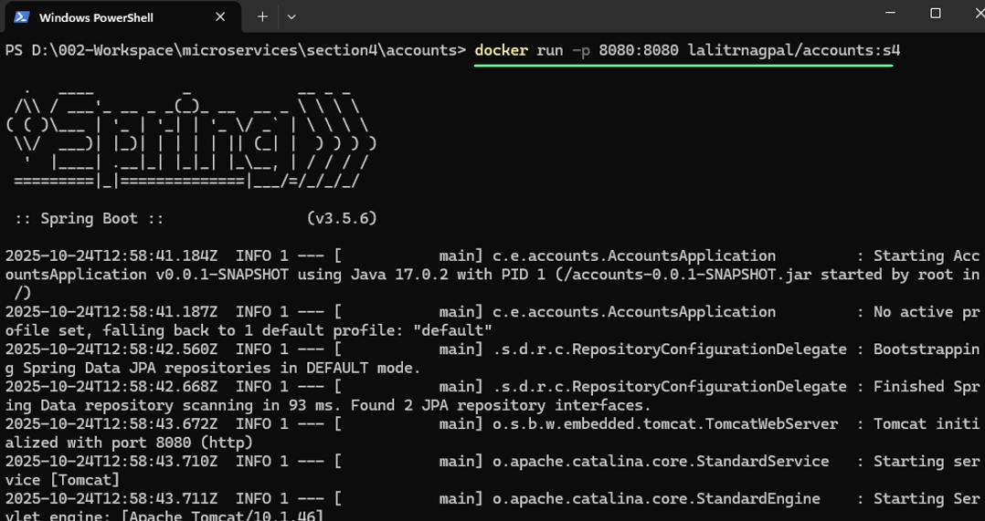

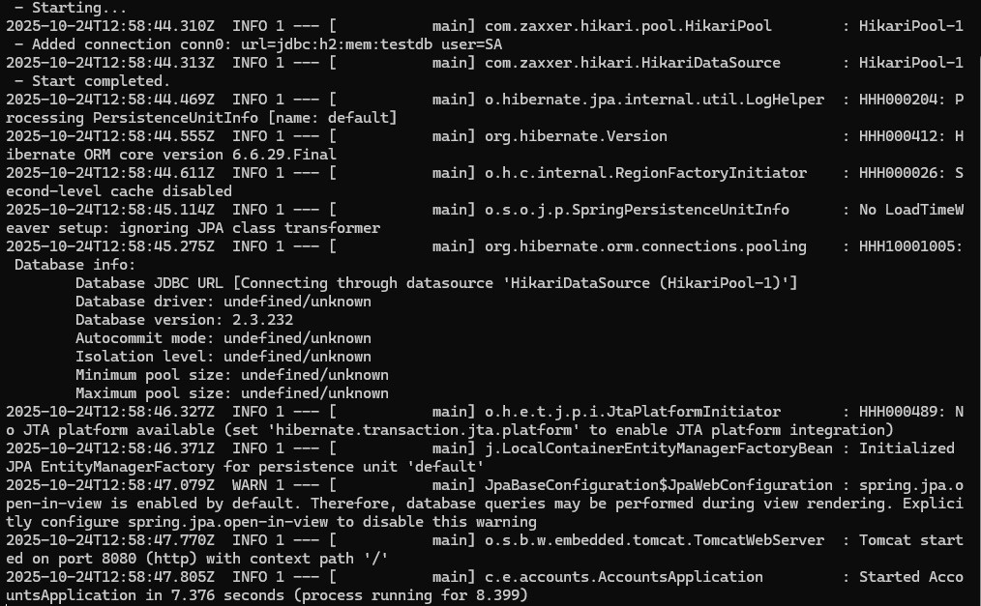

I'm just clicking on the send button. You can see I'm getting a successful response.

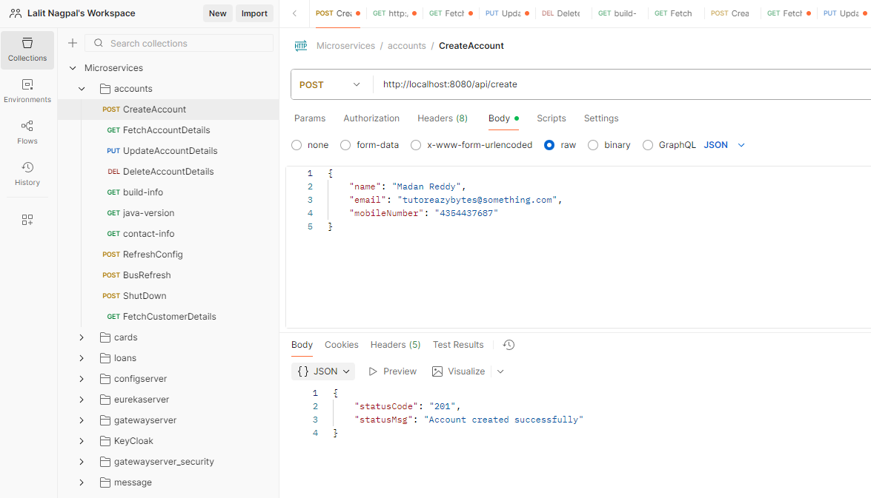

Now you can see the Docker container is running and I will not be able to run any other Docker command or any other command inside my terminal. So this kind of a inconvenience to the developers. That's why we can start the container in a detached mode for the same first, let me try to kill this container or stop this container by pressing Ctrl C. So with that, my container right now it is stopped.

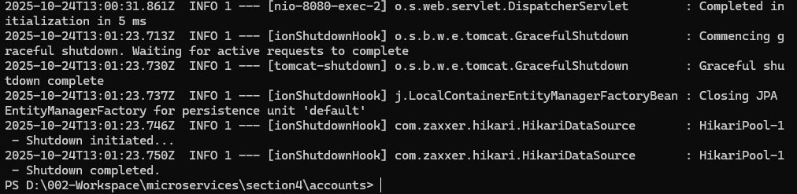

So let me clean the console. After this I need to execute the same command which is docker run -p 8080:8080. And what is the Docker image name. Inside this command? Just after the run I'm going to give a new flag which is -d. This d indicates detached mode. So I'm telling to my Docker server to run the container behind the scenes in a detached mode and I don't want to see any logs inside my terminal. So as soon as I execute this command you can see a container ID is displayed like this is the container ID behind the scenes it is running.

PS D:\002-Workspace\...\accounts> docker run -d -p 8080:8080 lalitrnagpal/accounts:s4

19dba6b8daf8dd3bb07ba61ad986c2b4962a838442b5918bdc5696b52854fcca

PS D:\002-Workspace\microservices\section4\accounts>

And now I can also run any other Docker commands inside my terminal. So we can also see all the existing running containers with the help of docker ps. So if I try to run this docker ps, you will see what are the existing containers that are right now running inside my system. So this is the image, this is the container ID, this is the command that it has used to run as a container. It is created 23 seconds ago and this is a port mapping. You can also validate all the running containers inside your Docker desktop. Inside your Docker desktop, if you go to the containers here, you can see right now my Docker container of eazybytes accounts is in running status.

PS D:\002-Workspace\microservices\section4\accounts> docker ps

CONTAINER ID IMAGE COMMAND CREATED STATUS PORTS NAMES

19dba6b8daf8 lalitrnagpal/accounts:s4 "java -jar accounts-…" About a minute ago Up About a minute 0.0.0.0:8080->8080/tcp, [::]:8080->8080/tcp crazy_lamport

I can also stop this running container from my Docker desktop by clicking on the stop button.

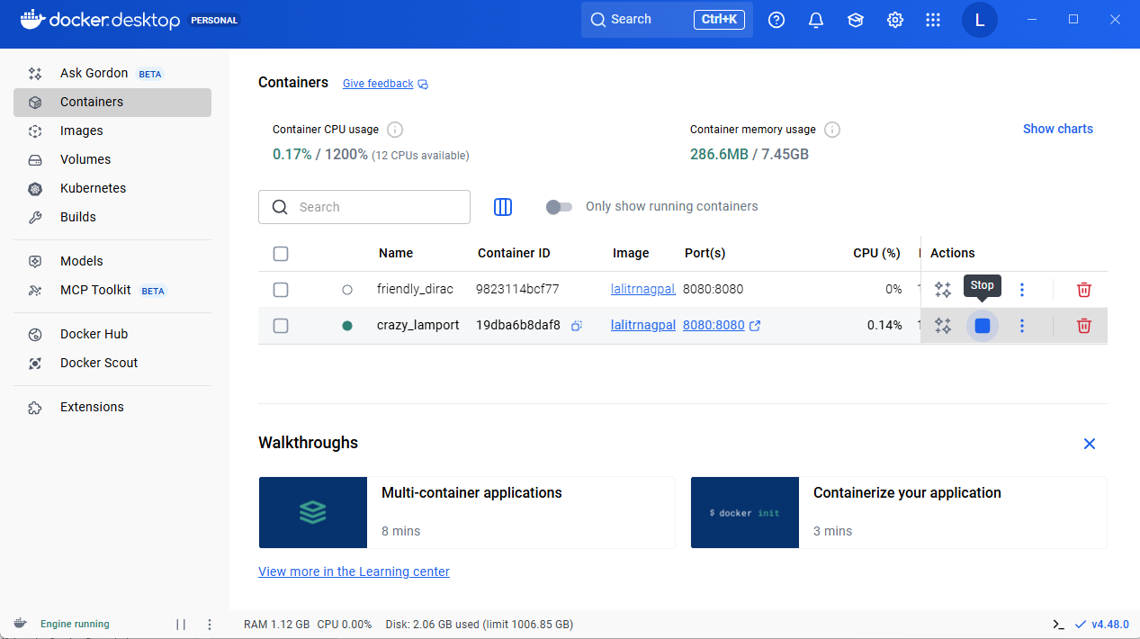

Right now if I go and execute the docker ps command, you will not be able to see this container under the list of **running** containers. So let me run the docker ps command.

PS D:\002-Workspace\microservices\section4\accounts> docker run -d -p 8080:8080 lalitrnagpal/accounts:s4

93dc6d62ae38c2945d110d3183a5d4f8f8524684d46aad23d2aaf053132cac5c

PS D:\002-Workspace\microservices\section4\accounts> docker ps

CONTAINER ID IMAGE COMMAND CREATED STATUS PORTS NAMES

93dc6d62ae38 lalitrnagpal/accounts:s4 "java -jar accounts-…" 12 seconds ago Up 12 seconds 0.0.0.0:8080->8080/tcp, [::]:8080->8080/tcp competent_driscoll

PS D:\002-Workspace\microservices\section4\accounts>

You can see right now it is empty. If you have a scenario where you want to see all the stopped containers, you can see them inside the Docker desktop or you can also see inside your terminal by running a command docker ps -a. So with this, it is going to display all type of containers that right now are in stopped status.

PS D:\002-Workspace\microservices\section4\accounts> docker ps -a

CONTAINER ID IMAGE COMMAND CREATED STATUS PORTS NAMES

19dba6b8daf8 lalitrnagpal/accounts:s4 "java -jar accounts-…" 14 minutes ago Exited (143) 56 seconds ago crazy_lamport

9823114bcf77 lalitrnagpal/accounts:s4 "java -jar accounts-…" 19 minutes ago Exited (130) 16 minutes ago friendly_dirac

So you can see these are all the containers right now inside my system that are in stopped status. I hope this is clear. Now, if I try to issue the same command, which is docker run -d -p 8080:8080 eazybytes/accounts:S4. It is going to start a container again from the Docker image. Now if I try to run the docker ps command, you'll be able to see a container right now in a running status. So now if I go to my Docker desktop, you can see right now the Docker container is in running status. You can also have a filter here which you can select that will show you only the running containers. So now if we try to click on this running container, like this is the random name that is given to your container by your Docker server. So if you try to click on this, you'll be able to see the logs of your container. Like these are all the spring boot startup logs. And if you try to invoke your rest APIs and if they generate any logs, you can see them here.

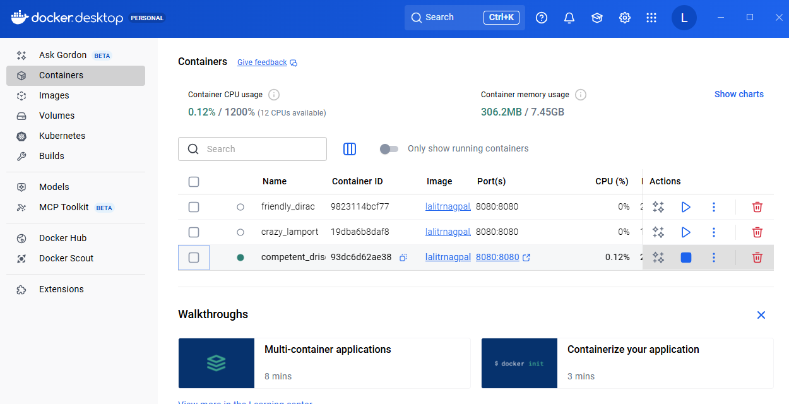

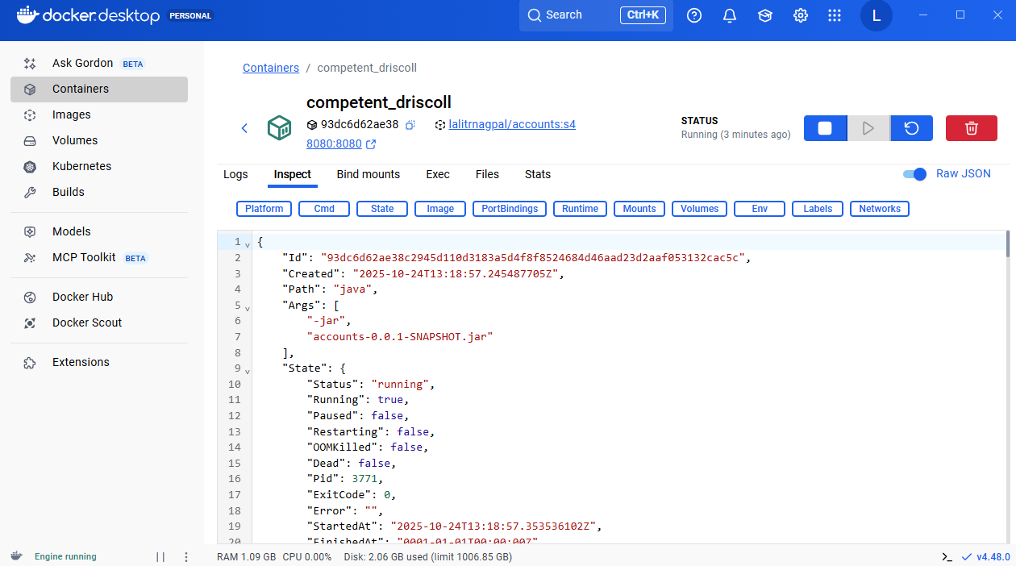

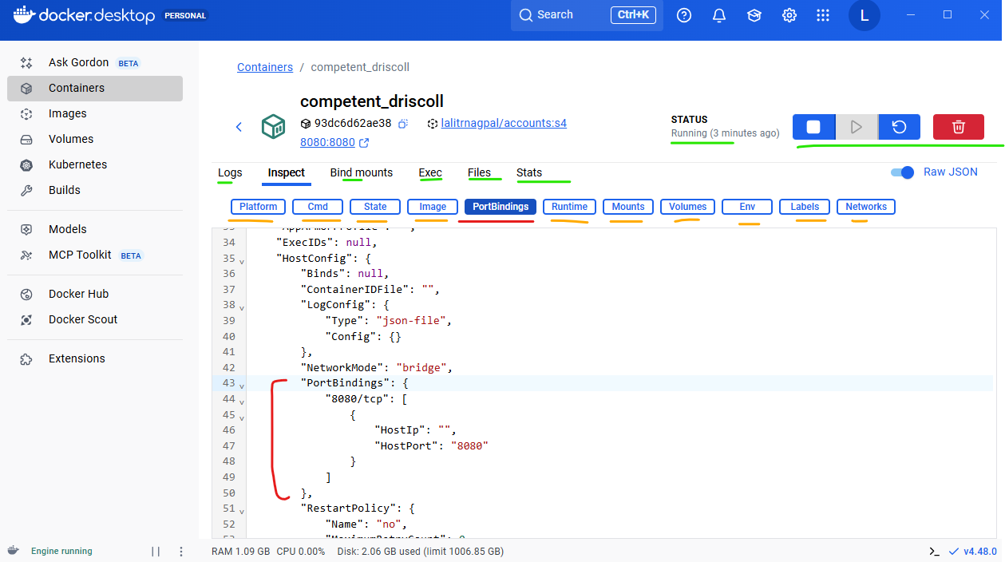

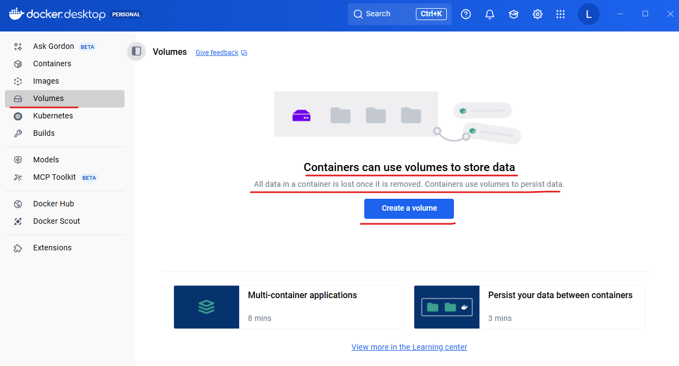

And of you try to inspect, you will be able to see details about your container. What is the JAVA_VERSION, what is the JAVA_HOME and what is the port where it is being started? And similarly, if you go to files, you'll be able to see all the files inside your Docker image. You can see we copied the account jar into the root location of our Docker image. That's why you can see these accounts are inside the root location of our Docker image. And similarly, if you go and check inside the inspect, the JAVA_HOME path is user local openjdk.

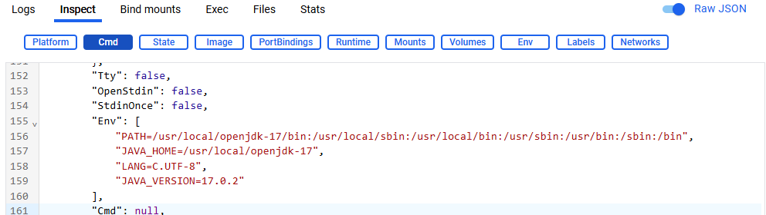

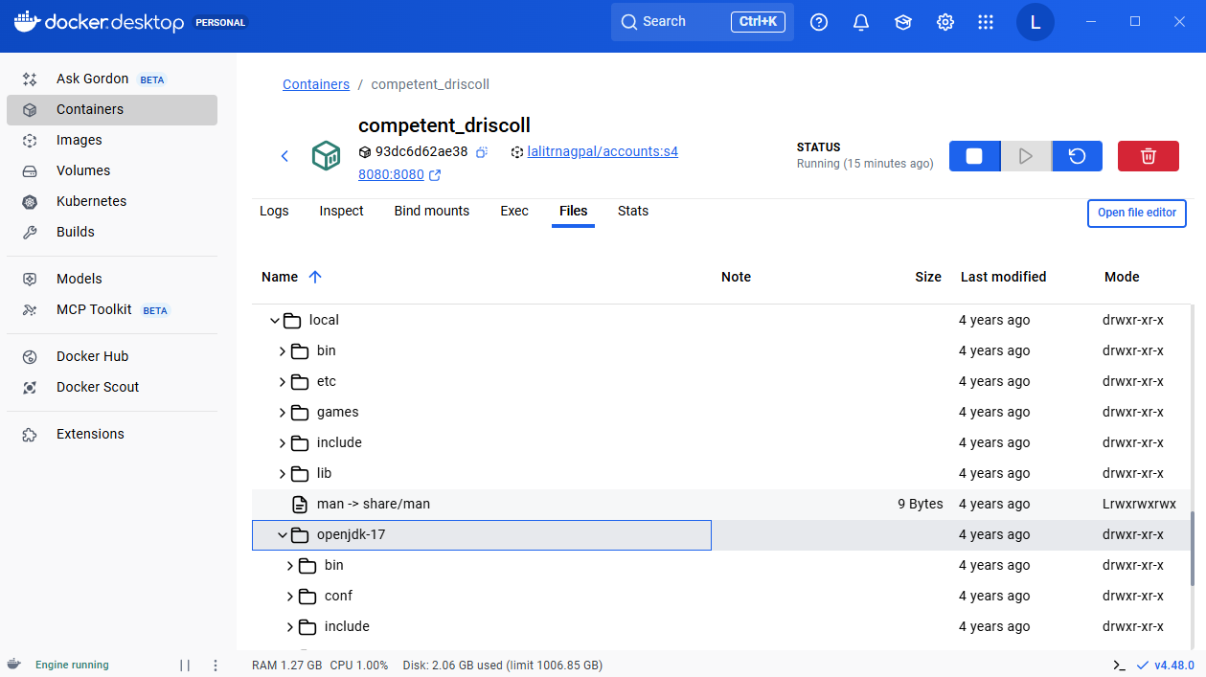

You can also validate the same by going to the files and click on user post that you can look for local inside which the openjdk related libraries are available.

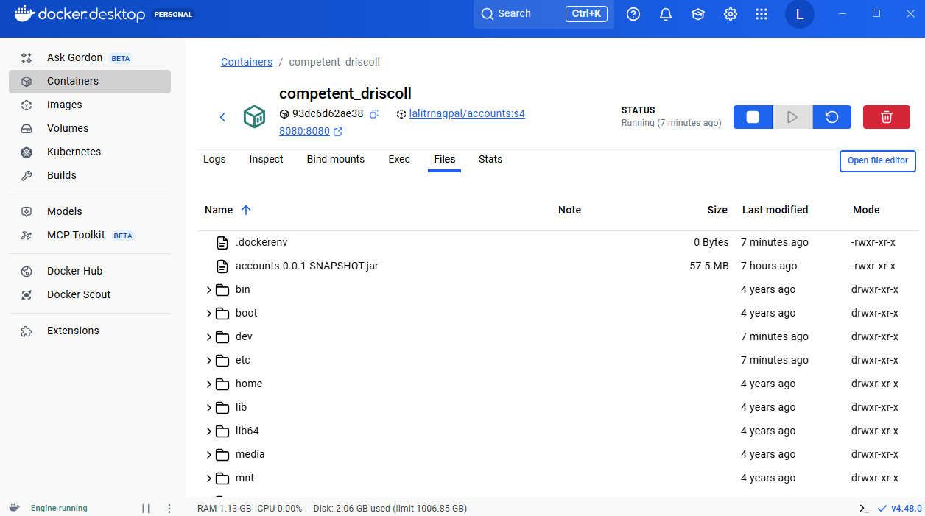

This way you can always inspect the files inside your Docker image from your Docker desktop itself. Like under the logs, you can always see the logs

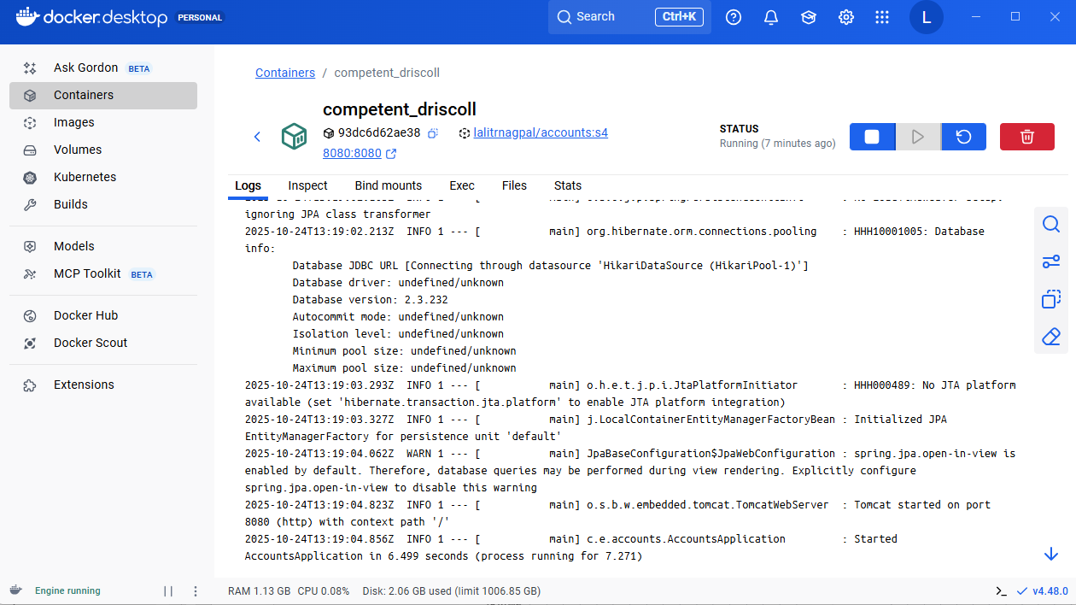

At the same time you can also click on these statistics which will show the CPU usage memory usage and other related resource usages from your container.

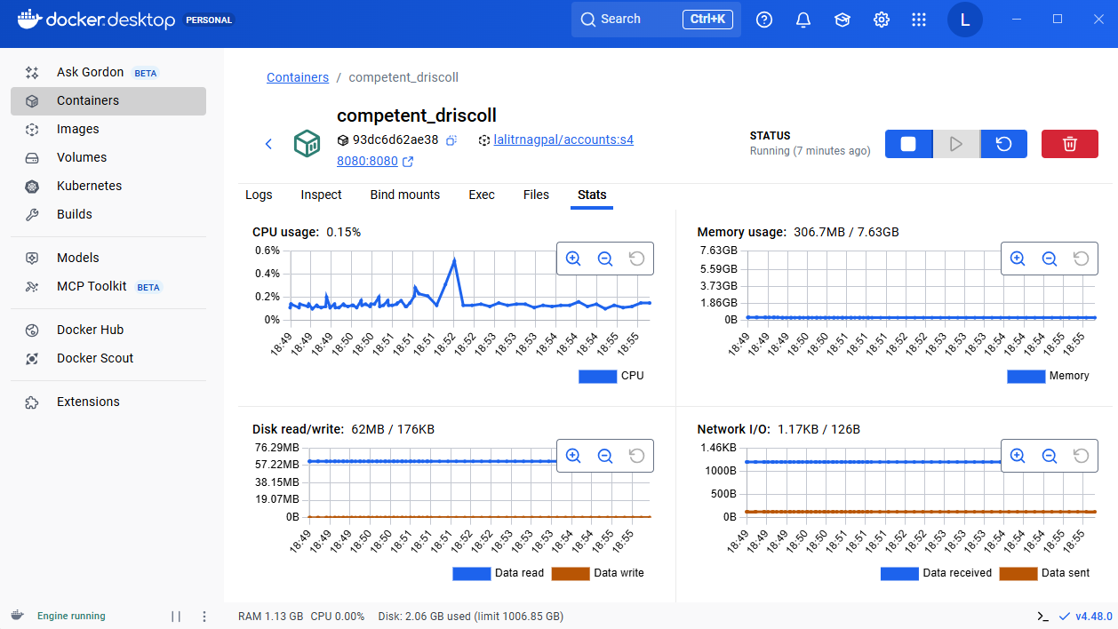

And at last there is a terminal also, when you click on this terminal, you are actually inside the Docker running container. So if I try to run a present working directory, you can see right now I'm at the root location.

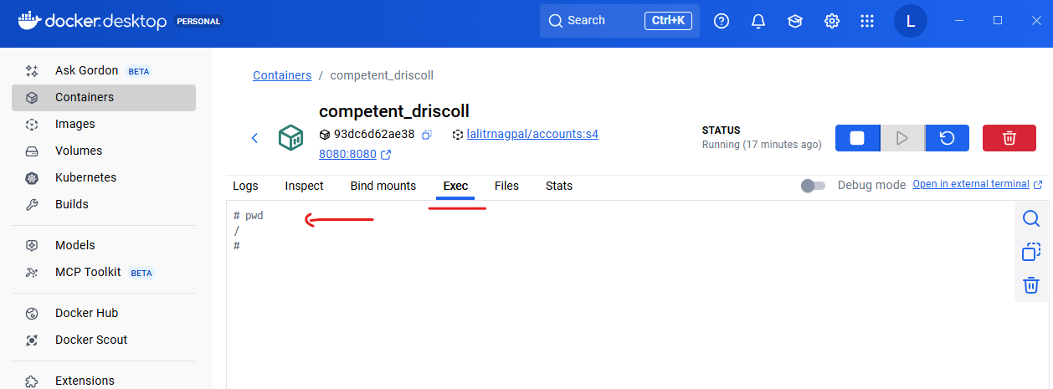

This way, whenever you want to run some commands inside your running container, you can always come to this terminal and execute some commands. I hope you are clear with all these steps that we have under the containers. So let's go back to the containers under the Docker desktop and flip this filter. With that, we'll be able to see all other containers inside your system. You can also see here there are other containers of the same image, which means whenever I tried to create a container with the help of Docker image and the Docker run command, a new container is going to be created. If you don't want that, you can also start the existing containers. So for that, let me try to stop this container. So I'm just clicking on the stop button and I'm also copying this container ID, So now you can come to the terminal.

**Other Docker commands I tried**

PS D:\002-Workspace\microservices\section4\accounts> docker images

REPOSITORY TAG IMAGE ID CREATED SIZE

lalitrnagpal/accounts s4 5741ab9c4734 38 hours ago 757MB

PS D:\002-Workspace\microservices\section4\accounts> docker image list

REPOSITORY TAG IMAGE ID CREATED SIZE

lalitrnagpal/accounts s4 5741ab9c4734 38 hours ago 757MB

PS D:\002-Workspace\microservices\section4\accounts> docker image ls

REPOSITORY TAG IMAGE ID CREATED SIZE

lalitrnagpal/accounts s4 5741ab9c4734 38 hours ago 757MB

PS D:\002-Workspace\microservices\section4\accounts> docker rmi lalitrnagpal/accounts:s4

Error response from daemon: conflict: unable to delete lalitrnagpal/accounts:s4 (must be forced) - container e11d0b1e2517 is using its referenced image 5741ab9c4734

PS D:\002-Workspace\microservices\section4\accounts> docker ps

CONTAINER ID IMAGE COMMAND CREATED STATUS PORTS NAMES

PS D:\002-Workspace\microservices\section4\accounts> docker ps -a

CONTAINER ID IMAGE COMMAND CREATED STATUS PORTS NAMES

127da4e677bc lalitrnagpal/accounts:s4 "java -jar accounts-…" 3 minutes ago Exited (143) 2 minutes ago laughing_solomon

09049f99043f lalitrnagpal/accounts:s4 "java -jar accounts-…" 4 minutes ago Exited (143) 3 minutes ago happy_roentgen

e11d0b1e2517 lalitrnagpal/accounts:s4 "java -jar accounts-…" 11 minutes ago Created dreamy_chaum

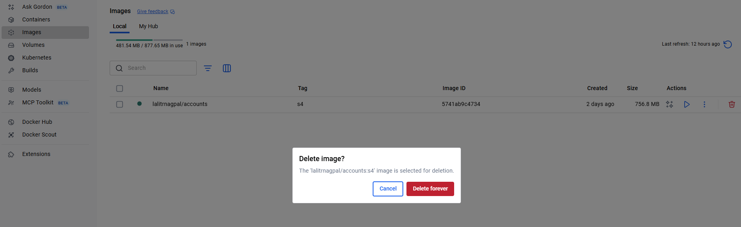

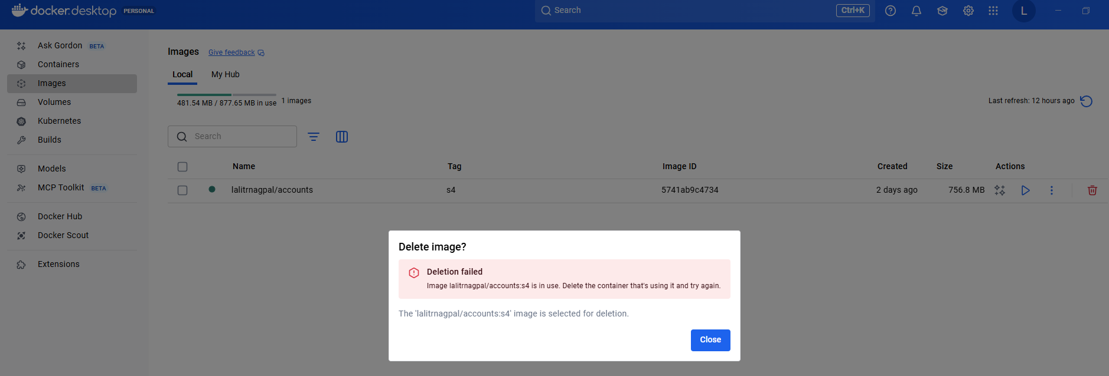

PS D:\002-Workspace\microservices\section4\accounts> docker ps -a

CONTAINER ID IMAGE COMMAND CREATED STATUS PORTS NAMES

127da4e677bc lalitrnagpal/accounts:s4 "java -jar accounts-…" 7 minutes ago Exited (143) 6 minutes ago laughing_solomon

09049f99043f lalitrnagpal/accounts:s4 "java -jar accounts-…" 7 minutes ago Exited (143) 7 minutes ago happy_roentgen

e11d0b1e2517 lalitrnagpal/accounts:s4 "java -jar accounts-…" 15 minutes ago Created dreamy_chaum

PS D:\002-Workspace\microservices\section4\accounts> docker rm e11d0b1e2517

e11d0b1e2517

PS D:\002-Workspace\microservices\section4\accounts> docker rmi lalitrnagpal/accounts:s4

Error response from daemon: conflict: unable to delete lalitrnagpal/accounts:s4 (must be forced) - container 09049f99043f is using its referenced image 5741ab9c4734

PS D:\002-Workspace\microservices\section4\accounts> docker rm 09049f99043f

09049f99043f

PS D:\002-Workspace\microservices\section4\accounts> docker rmi lalitrnagpal/accounts:s4

Error response from daemon: conflict: unable to delete lalitrnagpal/accounts:s4 (must be forced) - container 127da4e677bc is using its referenced image 5741ab9c4734

PS D:\002-Workspace\microservices\section4\accounts> docker rm 127da4e677bc

127da4e677bc

PS D:\002-Workspace\microservices\section4\accounts> docker rmi lalitrnagpal/accounts:s4

Untagged: lalitrnagpal/accounts:s4

Deleted: sha256:5741ab9c473446562719e229ea8965f07619bc509a11284d970e3f7101dadbfa

PS D:\002-Workspace\microservices\section4\accounts>

And here if I try to execute docker ps, it will not display any running containers because there are no running containers. So now I can also run a command which is docker start and what is the container ID? So this is my container ID if needed. You can also give first four digits or first four characters as well. So as soon as I run this command, you should be able to see that existing container might have started. So you can see right now the status converted into running status. So very similarly, you can also issue docker stop and what is the container ID? And with that your container is going to be stopped. We can also validate by running the docker ps command and there are no running containers.

Now what I'm going to do is first I'll try to delete all my existing containers off accounts. For the same inside my Docker desktop. I'm going to select all the containers related to the accounts image and clicking on this delete button. Now I'm going to create the containers again.

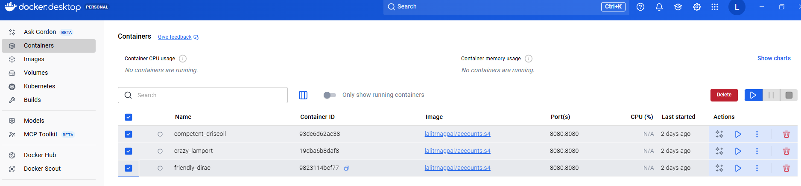

For the same I'm going to run a command docker run -d -p 8080:8080 lalitrnagpal/accounts:s4 ( case sensitive ). So if I try to run this command, a new container is created that you already aware. Very similarly, I can also create any number of containers so I can try to run the same command again. But please make sure you are giving a different port number which is 8081. The reason why we can't give the same port number is we already started and exposed a container at the port 8080 inside your system and we can't reuse the same busy port inside your system. That's why we need to mention a new port number like 8081.

PS D:\002-Workspace\microservices\section4\accounts> docker ps -a

CONTAINER ID IMAGE COMMAND CREATED STATUS PORTS NAMES

PS D:\002-Workspace\microservices\section4\accounts> docker run -d -p 8080:8080 lalitrnagpal/accounts:s4

Unable to find image 'lalitrnagpal/accounts:s4' locally

docker: Error response from daemon: failed to resolve reference "docker.io/lalitrnagpal/accounts:s4": docker.io/lalitrnagpal/accounts:s4: not found

Run 'docker run --help' for more information

PS D:\002-Workspace\microservices\section4\accounts> docker build . -t lalitrnagpal/accounts:s4

[+] Building 2.6s (8/8) FINISHED docker:desktop-linux

=> [internal] load build definition from Dockerfile 0.0s

=> => transferring dockerfile: 484B 0.0s

=> [internal] load metadata for docker.io/library/openjdk:17-jdk-slim 1.8s

=> [auth] library/openjdk:pull token for registry-1.docker.io 0.0s

=> [internal] load .dockerignore 0.0s

=> => transferring context: 2B 0.0s

=> [1/2] FROM docker.io/library/openjdk:17-jdk-slim@sha256:aaa3b3cb27e3e520b8f116863d0580c438ed55ecfa0bc126b41f6 0.0s

=> => resolve docker.io/library/openjdk:17-jdk-slim@sha256:aaa3b3cb27e3e520b8f116863d0580c438ed55ecfa0bc126b41f6 0.0s

=> [internal] load build context 0.0s

=> => transferring context: 84B 0.0s

=> CACHED [2/2] COPY target/accounts-0.0.1-SNAPSHOT.jar accounts-0.0.1-SNAPSHOT.jar 0.0s

=> exporting to image 0.5s

=> => exporting layers 0.0s

=> => exporting manifest sha256:51ae8d1242abf86f31dbec6f4c7771c65d1b174c496f4a6d5cb5c85efb95e861 0.0s

=> => exporting config sha256:9966441459d6cd6da7311cdcb54589df4759ff294c3bbc71b80c91a71a1e23cd 0.0s

=> => exporting attestation manifest sha256:2b7ee00b0b33918bffd9dac70f0087545c9ba8164302783ec426e511df75436c 0.0s

=> => exporting manifest list sha256:3f3d9823ad720db3d8513d81013fe47214bde3674d471d679eb02f611b33ef44 0.0s

=> => naming to docker.io/lalitrnagpal/accounts:s4 0.0s

=> => unpacking to docker.io/lalitrnagpal/accounts:s4 0.4s

PS D:\002-Workspace\microservices\section4\accounts>

PS D:\002-Workspace\microservices\section4\accounts> docker run -d -p 8080:8080 lalitrnagpal/accounts:s4

f47fbc6f92a1f4edc8120c4387f214f37a9625183926adba6c5a9ce771d4ff62

PS D:\002-Workspace\microservices\section4\accounts> docker run -d -p 8081:8080 lalitrnagpal/accounts:s4

a87699958df9abb88f83fcd77d42f49abf1312d951c54530cc2e98dabbe7b705

And here you may have a question like then why you are not changing the second port number inside the command. Like I said, the second port number inside the command indicates the port number where your container is going to start inside the Docker network. So this container and the second container will have their own isolated network, which means they can use the same port numbers and it will not create any issues. Whereas this port like 8080 and 8081, it is going to be exposed into your local system, your local system. Everything is the same network and that's why you can't reuse the same port number. So now if I try to execute this command, a different container is going to start. Let me run the docker ps command. Now you can see there are two running containers with the port mapping 8080:8080 and 8081 and 8080. The same can be confirmed inside the Docker desktop. So you can see there are two running containers. Now, I can also validate these containers by invoking few REST APIs. So here first I'm trying to test my container one, which is exposed at 8080. So let me invoke this.

PS D:\002-Workspace\microservices\section4\accounts> docker ps -a

CONTAINER ID IMAGE COMMAND CREATED STATUS PORTS NAMES

a87699958df9 lalitrnagpal/accounts:s4 "java -jar accounts-…" 6 seconds ago Up 5 seconds 0.0.0.0:8081->8080/tcp, [::]:8081->8080/tcp happy_roentgen

f47fbc6f92a1 lalitrnagpal/accounts:s4 "java -jar accounts-…" 12 seconds ago Up 12 seconds 0.0.0.0:8080->8080/tcp, [::]:8080->8080/tcp great_dhawan

PS D:\002-Workspace\microservices\section4\accounts>

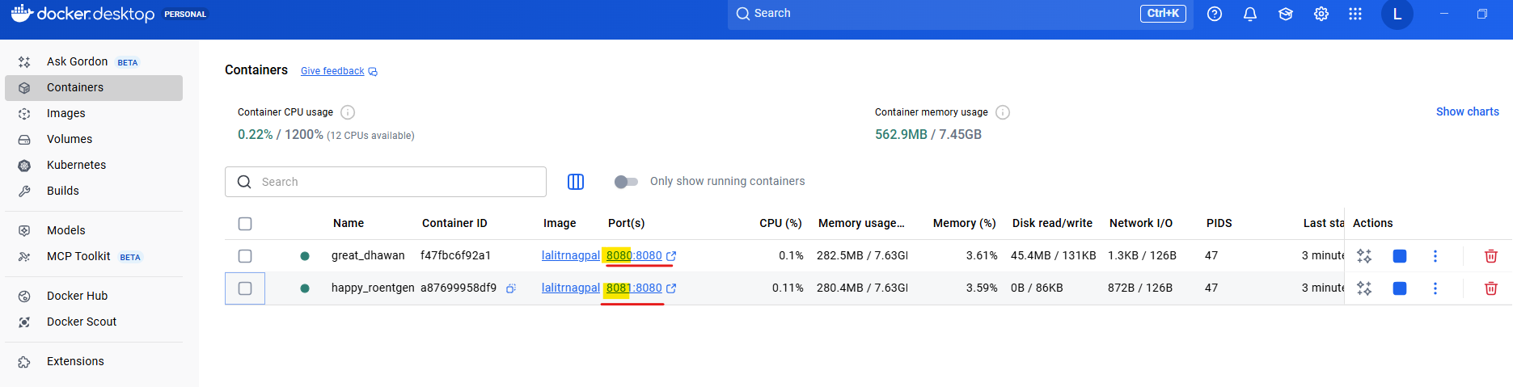

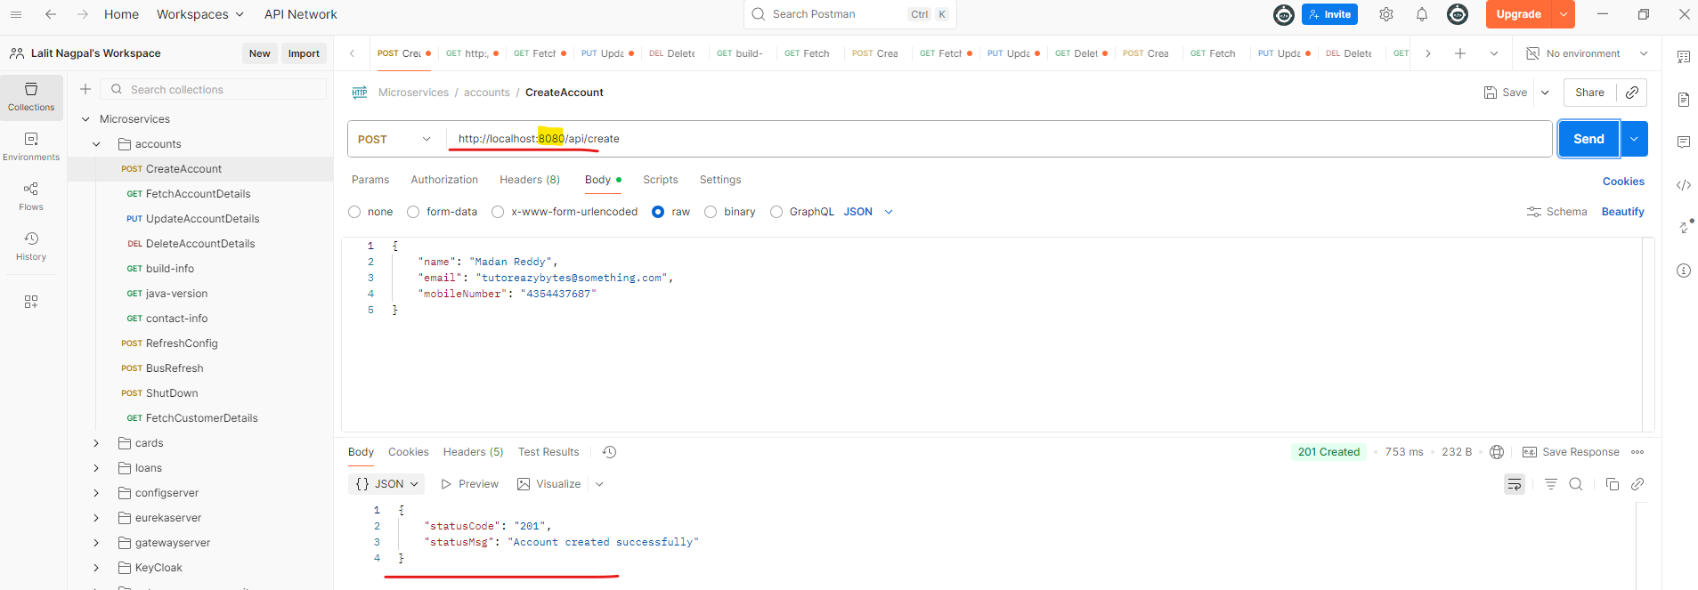

Similarly, I can also test my second container, which is exposed at 8081, so I'm also validating the same. So this way we can create any number of containers. And I'm assuming you also understand how this is going to solve our deployment portability and scalability issues. You can see how easily I'm able to scale the application from one instance to two instance.

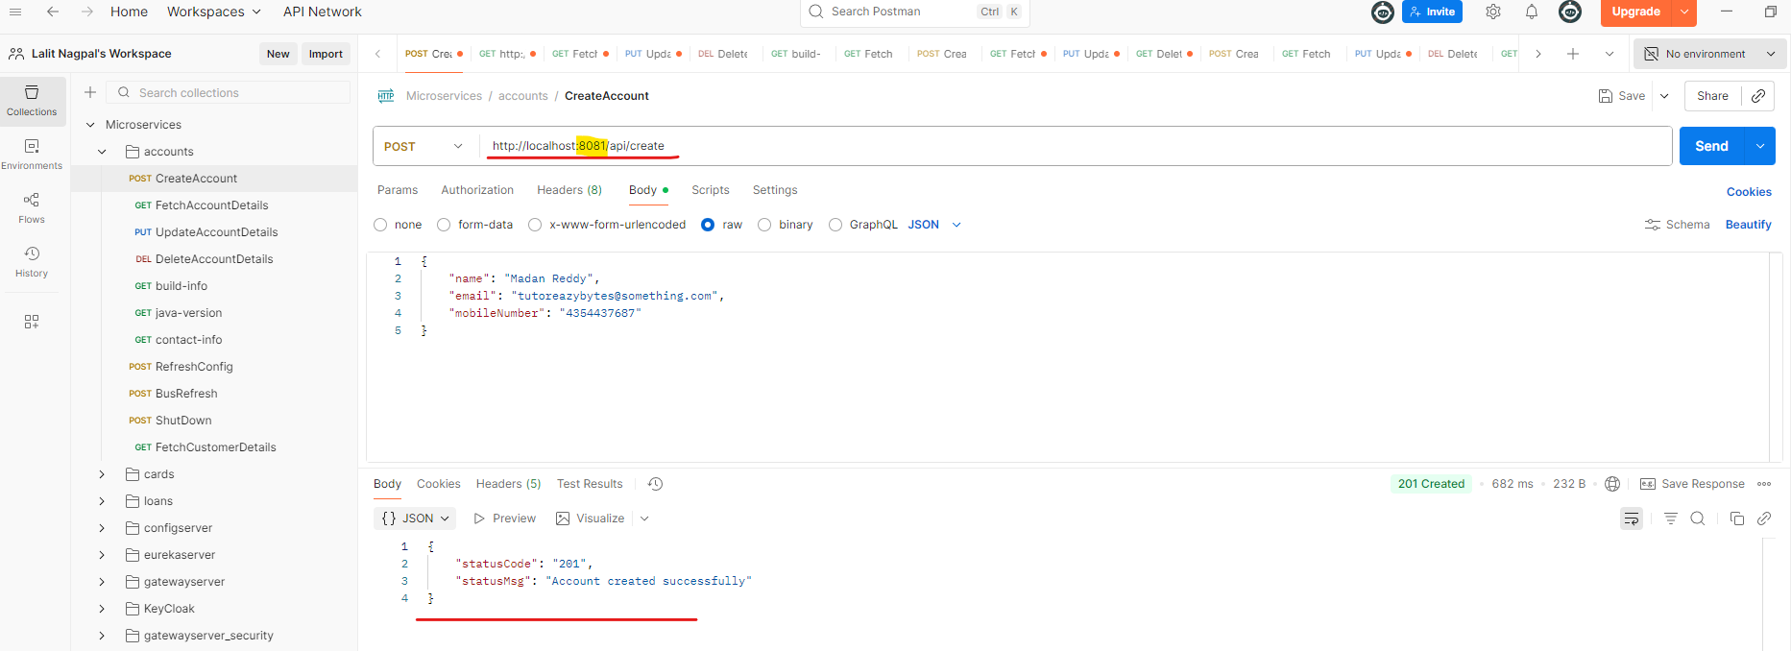

Very similarly, I can create any number of instances and coming to the portability, the same Docker image can be taken by anyone as long as they have the docker installed inside the system, they are good and the same application is going to work very similarly like it did inside my local system. And with this Docker image, they don't have to install any JDK, they don't have to download any spring boot, they don't have to download any maven. All the setup is already included inside your Docker image. You just have to run the Docker run command and do a port mapping and provide your Docker image name. With that, the portability issue also resolved and coming to the deployment. Like I said, the same Docker image you can deploy inside your local system, inside a virtual machine, inside a cloud server, wherever you are trying to deploy, the command is going to be the same. The Docker image is going to same, nothing is going to change. And this will make very easy in terms of deployment whenever you are trying to move your microservice from one environment to other environment.

Port Mapping

Now, quickly, let me explain you how port mapping works inside Docker. I already explained it. I know you may have some confusion as some questions, so let's try to formally discuss about them. If you see here, the very first question is what is port mapping or port forwarding or port publishing?

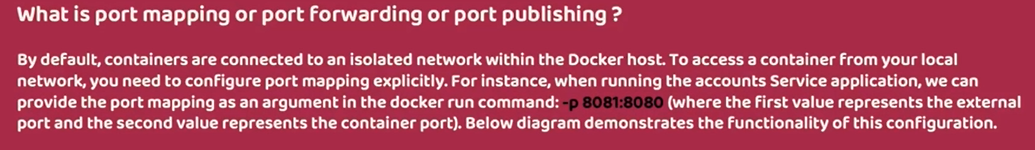

We can also call the port mapping as port forwarding and port publishing. So what is this concept is by default, the containers are connected to an isolated network within the Docker host, to access a container from your local network or from your local system. You need to configure this port mapping explicitly. And I have also given an example where my accounts microservice is running inside a Docker network as a Docker container at the port 8080. If I want to expose that to the outside world with the Port 8081, I need to use this -p 8081:8080. . Always remember the very first port number indicates the value where you want to expose to the external local system or external network. And the second value represents the container port where your container started. I can also show you this in a diagram. First, as soon as the container started, it is going to start inside a Docker network Like you can see the accounts microservice container started at a port 8080. This I cannot access from my outside Docker network.

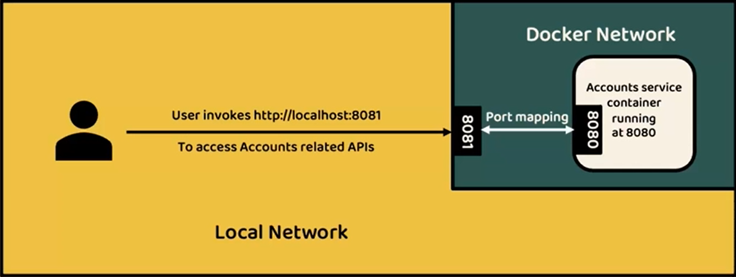

That's why we need to expose this Docker container to the outside world with the help of port mapping. And with that I should be able to access my account microservice, which is deployed inside a Docker network from my local network. So anyone who wants to communicate with my accounts, microservice container, they need to send a traffic request at the port 8081. So this is how port mapping or port forwarding or port publishing will work. I hope you are clear. So these are all the concepts on how to convert your Docker image to your Docker container. So for the accounts microservice, we have followed the very first approach, which is with the help of Docker files. So let me try to revise the list of steps that we have followed very quickly. So in order to run a spring boot application as a container using Docker file, you need to follow the following steps. The very first one is you need to run a Maven command, which is mvn clean install from the location where pom.xml is present and this will generate a fat jar of your application inside the target folder post that you need to define a Docker file. Once the Docker file is created with the set of instructions on the right hand side, you can generate a Docker image for your application by running a docker build command along with what is a tag name that you want to use for your Docker image.

|  |  |
| --- | --- |
|  |  |

For example eazybytes/accounts:S4. is a complete Docker image name that I should provide inside the docker build command. And once the Docker image is generated, the very next step is to create a container from the Docker image. For the same, I need to run the Docker run command and to this Docker run command I should pass the what is a port forwarding requirements that I have along with the Docker image name. With that, I should be able to have a running container inside my local system.

#### Challenges with Dockerfile

Lets delete the containers because we do not need them now, we can create them later

PS D:\002-Workspace\microservices\section4\accounts> docker ps

CONTAINER ID IMAGE COMMAND CREATED STATUS PORTS NAMES

PS D:\002-Workspace\microservices\section4\accounts> docker ps -a

CONTAINER ID IMAGE COMMAND CREATED STATUS PORTS NAMES

a87699958df9 lalitrnagpal/accounts:s4 "java -jar accounts-…" 2 hours ago Exited (143) 22 minutes ago happy_roentgen

f47fbc6f92a1 lalitrnagpal/accounts:s4 "java -jar accounts-…" 2 hours ago Exited (143) 22 minutes ago great_dhawan

PS D:\002-Workspace\microservices\section4\accounts> docker rm a87699958df9

a87699958df9

PS D:\002-Workspace\microservices\section4\accounts> docker rm f47fbc6f92a1

f47fbc6f92a1

PS D:\002-Workspace\microservices\section4\accounts> docker ps -a

CONTAINER ID IMAGE COMMAND CREATED STATUS PORTS NAMES

PS D:\002-Workspace\microservices\section4\accounts>

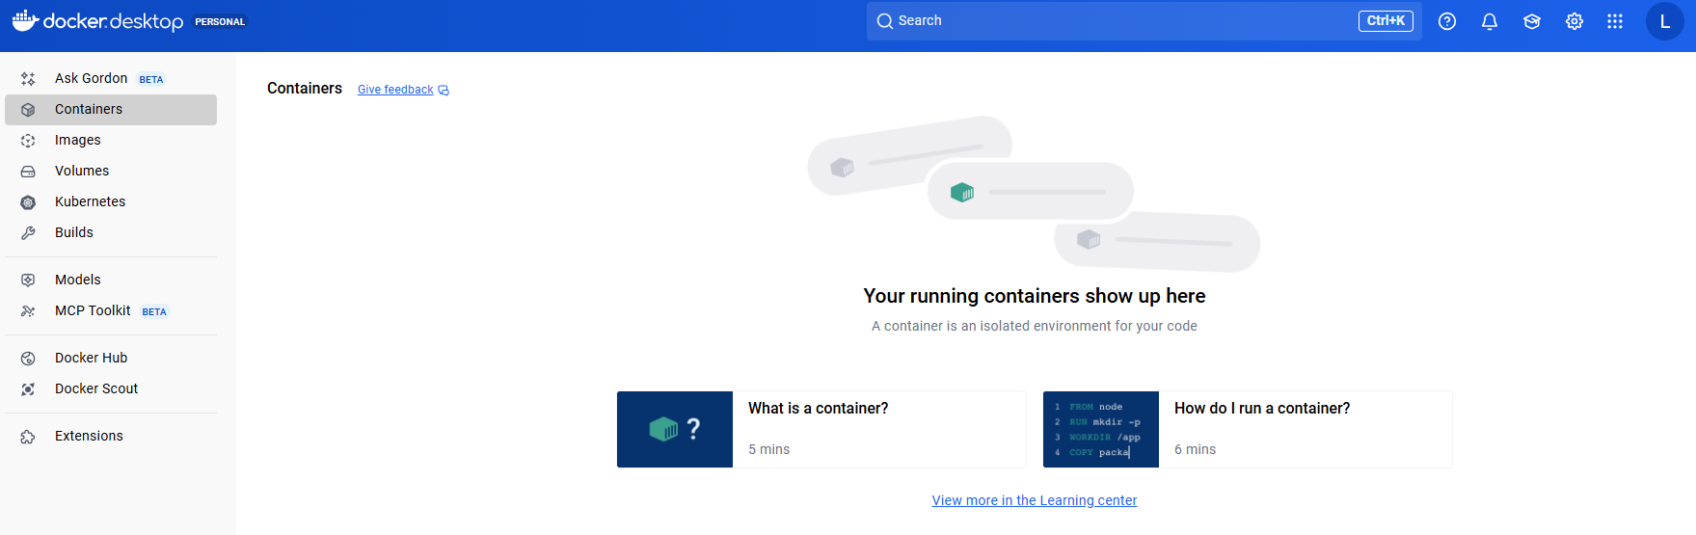

So please do this occasionally and make sure you are deleting any unused containers so that the memory usage and the storage usage inside your system will be used properly. Otherwise your system is going to get hanged. If you are using a system which has very low storage and a low ram memory. Now coming to the disadvantages of Docker file, the very first disadvantage is in order to write a Docker file, you need to be an expert of Docker concepts. So right now we have very basic Docker file where I have given very basic Docker instructions and I told you like you need to use the so and so keyword, you need to mention so and so docker image, you need to give so and so copy commands or entrypoint commands.

**Dockerfile**

# Start with a base image containing Java runtime

FROM openjdk:17-jdk-slim

#Information around who maintains this image

LABEL MAINTAINER=lalit.com \

VERSION=s4 \

DESCRIPTION="Accounts Microservice" \

AUTHOR=lalitnagpal

# Add the applications jar to the image

COPY target/accounts-0.0.1-SNAPSHOT.jar accounts-0.0.1-SNAPSHOT.jar

# Execute the application

ENTRYPOINT ["java", "-jar", "accounts-0.0.1-SNAPSHOT.jar"]

But in real projects, if your application is large, this simple Docker file may not work for you. So to convert your microservices a Docker image, you need to learn a lot of Docker concepts and you need to learn a lot of instructions on how to provide them with the help of Docker file. So there is a lot of learning curve involved for that developer. Why should developers should learn everything about Docker? Because he's not a DevOps person, because he's not a platform team member. So that's why this option is not good for developers because it involves a lot of learning curve. And at the same time, apart from learning the concepts of Docker, you should also follow the best practices when you try to generate a Docker image. The best practices like your Docker image should be as small as possible. You should try to use lot of caching compression while generating the docker image so that the process is going to be super quick and the Docker image is going to be super small, which will improve your overall microservices setup. And apart from these standards, we should also not ignore any security related concept. We should make sure our Docker image is perfectly secured and there are no security vulnerabilities inside our Docker image. So there is a lot of standards that you need to follow. And in order to implement all these standards and in order to follow all these best practices, you need to put a lot of efforts, you need to learn Docker concept, you need to learn Docker best practices, post that only you can implement all of them inside a Docker file.

And the same Docker file you need to maintain for all kind of microservices like accounts, loans, cards. If you have 100 different microservices, you need to maintain 100 different Docker files for them. And maintaining all these Docker files is another nightmare and there will be other challenges like versioning. So there are many challenges that you are going to face with this approach. That's why developers are always looking for an approach where a Docker image is going to be generated automatically without writing any low level instructions inside a Docker file. That's where we have solutions like Buildpacks and Google Jib came into picture. Since developers are facing all these challenges, these two products are built over the years and the same are being used extensively by the developers and the platforms teams these days. So that's why let's try to learn these two different approaches. One is Buildpacks and the other one is Google Jib. First, we'll try to learn Buildpacks. While trying to learn these Buildpacks, I'll be showing you how to generate a Docker image with the help of Buildpacks. And in the same process you will be seeing how easy it is compared to the Docker file approach. I hope you are with me on this. And what are the disadvantages with this Docker file approach and with these disadvantages it should be pretty clear for you that we are not going to use this Docker file approach anymore inside the course because it has a lot of disadvantages and it requires a lot of time to set up. So right now we have only two options Buildpacks and Google Jib. Let's explore both of them and choose one of them that is best suitable for us.